Lesson Observation Record
Trainee:
School:
Class:
Pupil Context:
Subject / Topic:
Observer:
Date:
Target(s) from last observation
Fully Met | Partially Met |  |  | Not Met | No Evidence
Focus of Observation
Agreed Targets (no more than 3) |  |  |  |  |  | AOF

Record of formative evaluation
Exceeding | Meeting | Within | Towards | Risk of Failure

AOF 1 | 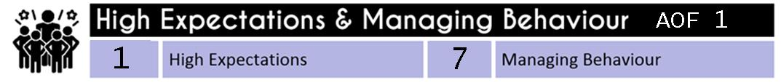
 | 1 - * Communicated a belief in the academic potential of all pupils. * Demonstrated consistently high behavioural expectations. |  | 7 - * Developed a positive, predictable and safe environment for pupils. * Established effective routines and expectations.*Built trusting relationships.* Motivated pupils.
 |  |  |  |  |  | E
 |  |  |  |  |  | M
 |  |  |  |  |  | W
 |  |  |  |  |  | T
 |  |  |  |  |  | ROF
AOF 2 | 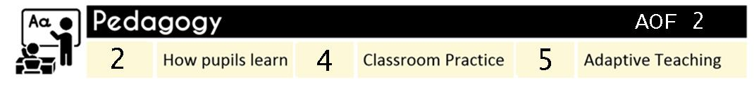
 | 4 -* Avoided overloading working memory. * Built on pupil’s prior knowledge. * Increased the likelihood of material being retained. | 4 - * Planned effective lessons. * Made good use of expositions, * Modelled effectively. * Stimulated pupil thinking and checked for understanding. |  | 5 - *Developed an understanding of different pupil needs. *Provided opportunity for all pupils to experience success. *Met individual needs without creating unnecessary workload. *Grouped pupils effectively.
 |  |  |  |  |  | E
 |  |  |  |  |  | M
 |  |  |  |  |  | W
 |  |  |  |  |  | T
 |  |  |  |  |  | ROF
AOF 3
 | 3 – *Delivered a carefully sequenced and coherent curriculum. *Supported pupils to build increasingly complex mental models. *Developed fluency. *Helped pupils apply knowledge and skills to other contexts. *Developed pupils’ literacy.
 |  |  |  |  |  | E
 |  |  |  |  |  | M
 |  |  |  |  |  | W
 |  |  |  |  |  | T
 |  |  |  |  |  | ROF
AOF 4 | 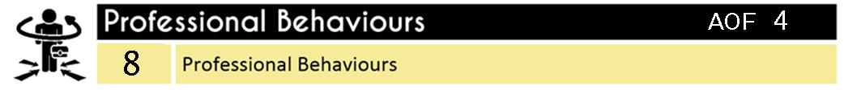
 | 8- *Developed as a professional. *Built effective working relationships. *Managed workload and wellbeing.
 |  |  |  |  |  | E
 |  |  |  |  |  | M
 |  |  |  |  |  | W
 |  |  |  |  |  | T
 |  |  |  |  |  | ROF
AOF 5
 | 6 *Avoided common assessment pitfalls, *Checked prior knowledge and understanding during lessons. *Provided high-quality feedback. *Made marking manageable and effective.
 |  |  |  |  | E
 |  |  |  |  | M
 |  |  |  |  | W
 |  |  |  |  | T
 |  |  |  |  | ROF

Record of Evidence
Planning
Starter
Activities

Main Teaching Activities

Assessment / Plenary

