Module Handbook

Institute of Childhood and Education

School of Secondary Education

Leeds Trinity University in collaboration with regional SCITT partners
Module: 7363 – Supporting Individual Learners

2022-23

Welcome to the PGCert Supporting Individuals, Module 1.
Hello.
A very warm welcome to the PGCert in Education.
We hope that you find this Module Handbook helpful in supporting your studies and that it provides you with all the information you need to know about Module 1 and its corresponding assignment on Supporting Individuals. This handbook will guide you through the first of two modules, helping you understand how it fits in with the other elements of your training, and set out what is expected of you in terms of assessment.
The programme, across two modules, asks you to carry out two professional enquiries. On this module, you will consider and research how to best support the learning in your subject of students with a specific learning or inclusion need, allowing you to focus on a chosen aspect of inclusion that links to your practice in school. The assignment asks you to focus on developing teaching and scaffolding strategies with students, try these out and evaluate their impact on students’ developing knowledge and understanding.
This module will, with other elements across the SCITT programme, enable you to meet the expectations detailed in the DfE’s Initial Teacher Training (ITT) Core Content Framework (CCF). As an M level qualification, the course highlights the value of professional studies during the induction phase and, to future professional practice, as an important element of continuing professional development.

During the year, two L7 modules will require you to reflect professionally on recommended and independently sourced resources to inform your emerging practice. You are asked to write critically, analysing, and synthesizing information. Taught sessions and tutorials will support you in this, highlighting the relevance of pedagogy to practice, preparing you to adapt knowledgeably and flexibly to the demands of the profession.

In line with the practice in other parts of the UK and international systems acknowledged to be excellent, teachers in England should be qualified a Masters’ level. Achieving an M Level qualification in your ITE year offers a strong basis for ongoing professional development in the induction phase and as an element of continuing professional development.

This L7 piece of writing is completed during the first term and makes up 50% of your Post Graduate Certificate in Education

Claire Palmer-Jones
LTU SCITT Tutor (Secondary)

MODULE GUIDE

Module Code and Title:
SED 7363, Supporting Individual Learners
Where and When:
As detailed by your SCITT lead
Module Leader:
Claire Palmer -Jones
C.Palmer-Jones@leedstrinity.ac.uk
Programme Leader:
Email: c.bell@leedstrinity.ac.uk

Summary of Content:
This module requires and enables you to consider and research how to best support the learning in your subject of students with a specific learning or inclusion need. It allows you to focus on a chosen aspect of inclusion that links to your practice in school. The assignment asks you to focus on developing teaching and scaffolding strategies with students, try these out and evaluate their impact on students’ developing knowledge and understanding.

Learning and Teaching Strategies
Our Learning, Teaching and Assessment Strategy 2020-23 delivers excellence by providing the framework for:

- high quality teaching
- an engaging and inclusive approach to learning, assessment, and achievement
- a clear structure through which you progress in your academic studies, your personal development and towards professional-level employment or further study.
It ensures you engage and connect with Leeds Trinity University’s mission, vision, and values. Our values manifest themselves in the strategy in the following ways:

- Care - you are valued and supported throughout their studies
- Integrity - we commit to open and honest conversations and transparency around our processes
- Excellence - we aspire to the highest standards and support you to achieve to the best of your abilities
- Inclusivity - you all have the same rights, status, and opportunities to contribute and thrive
- Collaboration - you are partners in learning and benefit from our partnerships with employers

How the strategy works through your programme

At postgraduate level and through work-based learning programmes, we work to build, apply and exchange knowledge, expertise and skills in a range of specialist fields.

How your Module is Delivered
Please see details of in-person study days, including pre and post session tasks. You will receive formative support from your tutor, including tutorials, and post assignment formative feedback to apply to the next assignment or further study, e.g., ECT and masters level assignments.
Submission, including Deadlines
The assignment will be submitted via Turnitin.
Submission deadlines will be confirmed during induction sessions.
Students will be reminded of deadlines during study days and tutorials.
Assessment
Component form  (e.g., Essay or Online test) | Magnitude  (e.g., 2,000 words  or 2 hours) | Weighting  and/or  Pass/Fail | Deadline | Objective(s) assessed
Essay Assignment | 5,000-word essay; and  Appendix part 1 - Your Lesson Plans and specific resources (equivalent to 1,000 words)  Appendix part 2 – up to 4 examples of students work or other responses. | 50% of programme  30 Credits towards your PGCert Qualification | To be confirmed at Induction session

Your assignment essay will be marked and the appendices used as evidence to support evaluations, assertions, and reflections in the main body of your work.

You will receive some summative feedback on each assignment, and some formative ‘feedforward’ designed to help you continue to develop your academic writing or any future professional enquiry you make into your practice.

Any mark you receive in your initial feedback will be subject to moderation and confirmation at an examination board. You will be notified of your confirmed marks using Evision – our information portal. You will be reminded to visit this portal via text.

Module 1: Supporting Individuals
This module requires you to research and consider how to best support individual students with specific education or other inclusion needs, and allows you to research one aspect of inclusion, probably focused on a small selection of pupils within one class (or possibly just one pupil).
This assignment will allow you to show that you can
- Use knowledge of specific pedagogic techniques and technologies to help individual pupils to overcome specific barriers to understanding and learning relevant to your subject the context in you have been working.
- Use a structured and systematic approach to small-scale enquiry, selecting appropriate data gathering strategies, make supported analysis of this data, and then evaluate and synthesise your findings in the light of the literature you have read.
- Undertake critical analysis of the relationship between policy, theoretical models and professional perspectives and their application and impact in particular classrooms, as well as apply such analysis in your own practice.
- Deploy strategies to create, collate, interpret, and react to various forms of evidence relating to pupil’s knowledge, understanding and difficulties through adaptation of your professional teaching, assessment, and preparation activities.

Aspects of inclusive teaching and learning that you could consider as a focus are:  - Overcoming barriers to learning  - Potential pupil marginalisation  - Issues of exclusion and underachievement  - The context of your school setting  - Recognising difference, needs and strengths  - Supporting and increasing pupil learning and participation  - Developing teaching strategies and approaches that are inclusive of all learners | Aspects of inclusion needs that you could consider in your assignment are:  - Linguistic  - Social  - Cultural  - Ethnic  - Gender  - SEND (different cognitive abilities, different sensory and physical capabilities)
Examples of an assessment focus for the above two themes that could be explored in your ‘Supporting Individuals’ assignment are:
- Students with Special Educational Needs (physical, sensory, processing, ADHD, autism or otherwise)
- Socially disadvantaged students
- Minority ethnic/social/cultural students
- Bi-lingual pupils or students with EAL
In every case you will need to relate this focus to learning the subject concepts being taught.

A timeline for completing the Supporting Individuals Assignment:

September
- Discuss this assignment with your School Mentor and your Lead Tutor, to see if they can suggest a possible focus for your study – the school/department may well have identified certain group/s or individuals that are struggling, or topics that some pupils find hard.
- Select the class, group or individual that will be the focus of your L7 ‘Supporting Individuals’ enquiry.
- Reflect on and read about how different professionals (the teachers and support staff you are working with focus their planning for pupil/s to enable formal and informal inclusive learning to occur.

October
- Research and read about how teachers have thought about and tried to address the inclusion or SEND needs you have identified.
- Observe your chosen pupil or group in a range of learning contexts (subject classes, special needs unit, extra-curricular groups, pastoral setting) to enable you to ask questions of teachers and literature about inclusive learning across contexts; and
- Review and re-draft a lesson plan or sequence of learning. In what ways have you already sought to deal with these specific needs or issues? What does the literature suggest you might want to change or further develop?
- With your S.I. class, plan and start to teach a short series of learning activities with clear subject specific learning objectives and outcomes, paying particular attention to planning for inclusive learning.

November – December
- Continue to research and read about how teachers have thought about and tried to address the inclusion or SEND needs you have identified.
- Continue to teach and observe the selected class/group paying attention to clear subject specific learning objectives and outcomes and paying particular attention to the ways in which experienced teachers enable inclusive learning, especially in relation to your diversity focus.
- Conduct regular evaluations on the lessons taught and observed, and on the selected pupils’ outcomes, especially in relation to the chosen diversity focus.
- Collate lesson plans, resources, evaluations, and pupil data/evidence. This should be clearly sequenced and numbered to aid cross-referencing and submitted as an appendix to your assignment.
- Write up your assignment. There is lot of help and advice about how to get this done on the next few pages.

Writing and Submitting your Supporting Individuals Assignment
The written assignment consists of the following sections:
Justification for your Study (c.500 words): as an introduction, explain your focus and the context of the study Identify your aims and what it is you hope to achieve in terms of acknowledging the need to support individuals’ learning.
Literature Review (c.2,000 words) Explain what you have found in your reading relating to the specific learning or inclusion needs that similar pupil face when studying your subject. You should organise the review in themes or important ideas that have emerged from your reading. Explain how the approaches you decided to use in your teaching relate to that literature, or where you have followed other ideas. (Suitable sources include relevant texts, journals, curriculum documentation, Ofsted reports, subject association journals and papers).
Reflective Evaluation (c.2,000 words) includes findings, conclusions, and impact on your practice and that of the experienced teachers you observed. Reflect upon and evaluate the approaches that you took using evidence of their impact on your learners.
Discuss your overall findings in relation to the themes that emerged during your literature review. Substantiate your reflections with reference to relevant evidence from work your pupils did, or things they said in reaction to your teaching.
Conclusion (c.500 words) Draw out some conclusions from your study related to the themes in your analysis and consider the implications of these for your future teaching.
Reference List (this does not count towards your word limit) a full list of works that you cited in your assignment (not the ones you happened to read) should also be included at the end of your assignment. The APA referencing system must be used for all citation, quotation and referencing. You can find a guide to APA referencing on the library web page.
Appendix (does not count towards word limit but counts towards your assignment) You should include here your lesson plans and any resources you made specifically to support your pupil’s learning. You can also include examples (up to 4 pieces) of pupil work, that you want to be able to point out specific features of to the person reading your assignment. Please do not pack the appendix with things just to fill up space.

What you will hand in:
- Your written assignment – 5,000 words
- Appendix part 1 - Your Lesson Plans and specific resources (equivalent to 1,000 words)
- Appendix part 2 – up to 4 examples of students work or other responses.

The Supporting Individuals (5,000 word essay and Appendices) assignment Should be uploaded to Moodle before the deadline

Assessment Criteria Grid

Classification:  Criterion: | Exceptional Distinction  100, 95, 92, 88, 85, 82 | Distinction  78, 75, 72 | Merit  68, 65, 62 | Pass  58, 55, 52 | Fail  48, 45, 42 | Significant Fail  35, 25, 10, 0
Disciplinary Knowledge & Understanding | Exceptional and nuanced understanding of developments at the forefront of the discipline. Astute and authoritative approach to complexity. | Comprehensive, in-depth, and evaluative understanding, including engagement with recent developments in the discipline. Informed and confident approach to complexity. | Wide-ranging and detailed understanding. Engagement with recent developments in the discipline. Awareness of complexity of the discipline. | Broad understanding of key concepts and issues. Some engagement with recent developments in the discipline. Some awareness of complexity of the discipline. | Limited understanding of key concepts and issues. Insufficient engagement with debates. Little awareness of complexity of the discipline. | Little or no understanding of key concepts and issues. Little or no engagement with debates in the discipline. Simplistic or erroneous understanding of the discipline.
Research | Outstanding and purposeful systematic use of primary and secondary sources. Sustained independent thought, innovative and methodological sophistication. | Purposeful and systematic use of primary and secondary sources. Independent thought and methodological sophistication. | Purposeful and wide-ranging use of primary and secondary sources. Evidence of independent thought and methodological sophistication. | Relevant use of primary and secondary sources. Some evidence of independent thought. Justified use of methodological approaches. | Insufficient or inappropriate selection of primary and secondary sources. Little evidence of independent thought. Limited justification for methodological approaches. | Irrelevant or out of date selection of primary and secondary sources. No evidence of independent thought. No justification for methodological approaches, or failure to engage with methodology.
Application and evaluation | Extensive, selective, and evaluative use of evidence. Rigorous and sustained application of research evidence to impact on practice. | Thorough, selective, and evaluative use of evidence. Careful and sustained application of research evidence to impact on practice. | Focused, selective and evaluative use of evidence. Careful attention to the application of research evidence to impact on practice. | Some selection and evaluation in the use of evidence. Some attention to the application of research evidence to impact on practice. | Insufficient selection and evaluation in the use of evidence. Little application of research evidence to impact on practice. | Poor selection of evidence and little or no evaluation. Little or no application of research evidence to impact on practice.
Language and communication | Sophisticated and nuanced over-arching argument or structure. Perceptive, insightful, and creative synthesis. Professional and discerning writing, appropriate to the audience and discipline. | Highly effective over-arching argument or structure. Clear, insightful, and creative synthesis. Professional and discerning writing, appropriate to the audience and discipline | Effective over-arching argument or structure. Clear synthesis with some insights. Fluent writing style appropriate to the audience and discipline | Sound basic argument or structure. Attempts at synthesis with some insights. Accurate writing showing an awareness of audience and discipline | Flawed basic argument or structure. Little attempt at synthesis. Flawed and inaccurate writing with limited awareness of audience and discipline. | Lack of argument or structure. No attempt at synthesis. Poor writing style.
Analysis and Critique | Original, detailed, and perceptive analysis. Rigorous and sustained critical appraisal. Convincing conclusions. | Detailed and perceptive analysis with some originality. Rigorous and sustained critical appraisal. Persuasive conclusions. | Some detailed and perceptive analysis. Wide-ranging critical appraisal. Consistently logical conclusions. | Some detailed analysis. Some critical appraisal and application to conclusions. | Mainly descriptive approach. Inconclusive argument or inadequately supported conclusions. | Predominantly descriptive approach. No clear argument or erroneous conclusions.
Presentation and academic Conventions, | Highly developed understanding of the appropriate genre.  Flawless referencing or technical skills. | Highly developed understanding of the appropriate genre.  Flawless referencing or technical skills. | Very good understanding of the appropriate genre.  Accurate referencing or technical skills. | Good basic understanding of the appropriate genre.  Generally accurate referencing or technical skills. | Little understanding of the appropriate genre.  Inaccurate referencing or technical skills. | Little or no understanding of the appropriate genre.  Absent or largely inaccurate referencing.
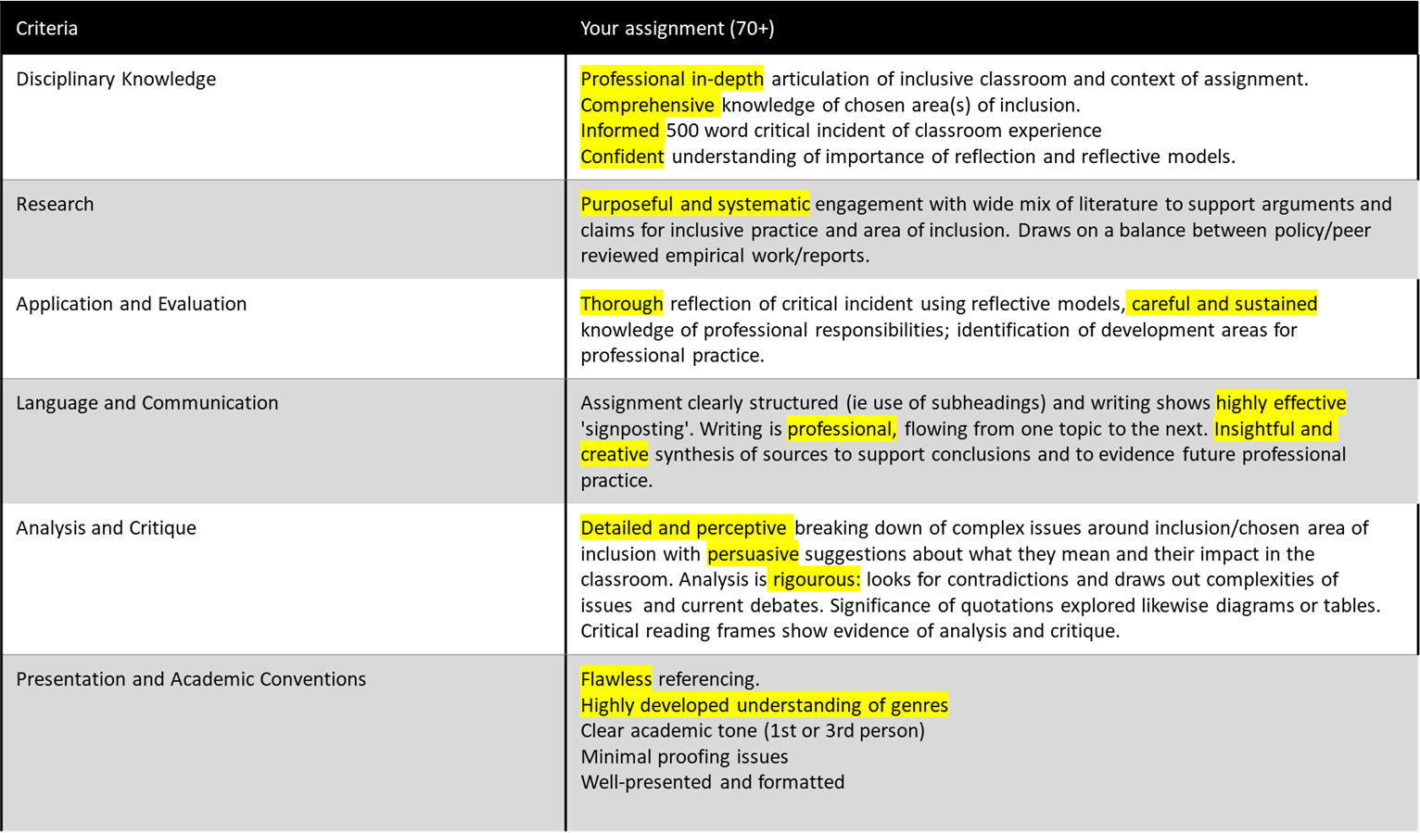
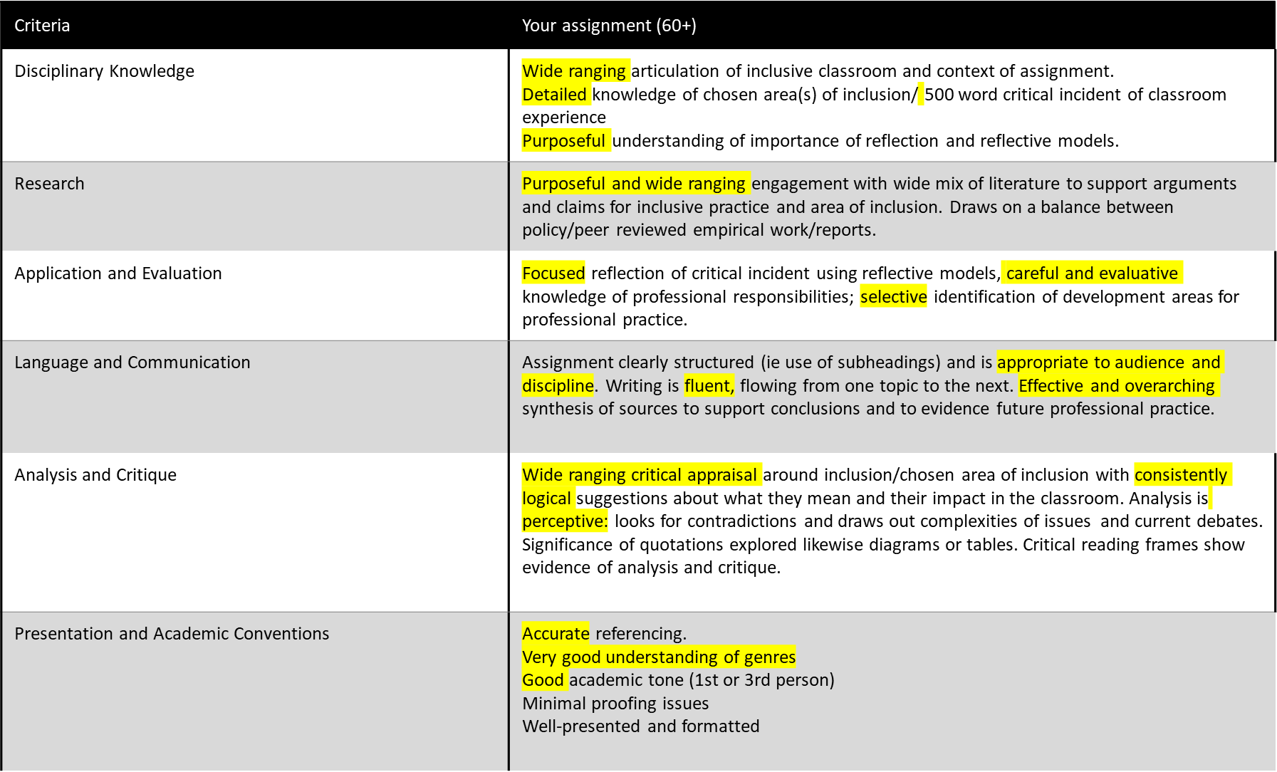

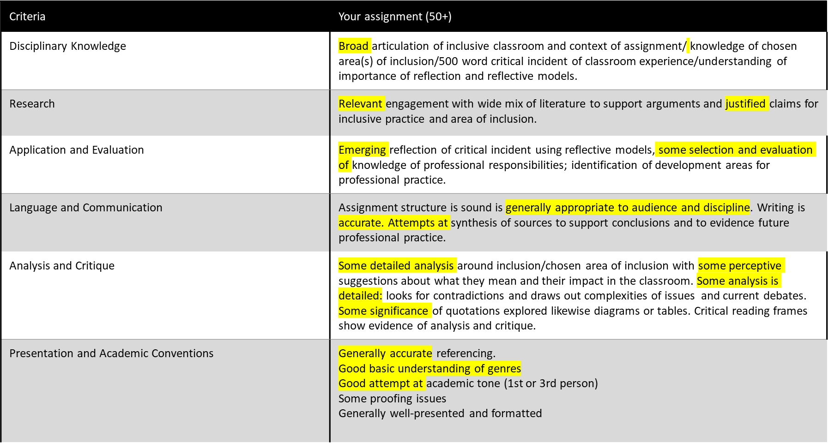

12. Resources
Pre-Course Indicative Reding:

https://www.suttontrust.com/wp-content/uploads/2019/12/What-makes-great-teaching-FINAL-4.11.14-1.pdf

https://my.chartered.college/impact/ Please join in advance of the Induction Day – it is free to trainee teachers

https://my.chartered.college/research-hub/research-informed-practice-developing-an-evidence-search-strategy/

Recommended Course Reading:

Bartlett, J. (2016) Outstanding Differentiation for Learning in the Classroom, Oxon: Routledge.

Hudson, D. (2015) Specific Learning Difficulties – What Teachers Need to Know, London: Jessica Kingsley Publishers.

Peacey, N. (2013) An Introduction to Inclusion, Special Educational Needs and Disability. In: Capel, S., Leask, M. and
Turner, T. eds. Learning to teach in the secondary school: a companion to school experience. Sixth Edition. pp. 285-306.
Oxon: Routledge.

Westwood, P. (2005) Adapting Curriculum and Instruction In Topping, K. and Maloney, S. eds. The RoutledgeFalmer
Reader in Inclusive Education. pp. 145-149. Oxon: Routledge.

Westwood, P. (2015) Commonsense Methods for Children with Special Educational Needs. Seventh Edition. Oxon:
Routledge.

Useful Links:

The Equality Act and Inclusivity:

https://assets.publishing.service.gov.uk/government/uploads/system/uploads/attachment_data/file/315587/Equality_Act_Advice_Final.pdf

https://www.gov.uk/government/publications/equality-act-2010-schedule-19-consolidated-april-2011

https://assets.publishing.service.gov.uk/media/5c6eb77340f0b647b214c599/374_Implementing_Inclusive_Education.pdf

SEND Code of Practice:

https://assets.publishing.service.gov.uk/government/uploads/system/uploads/attachment_data/file/398815/SEND_Code_of_Practice_January_2015.pdf

https://assets.publishing.service.gov.uk/government/uploads/system/uploads/attachment_data/file/349053/Schools_Guide_to_the_0_to_25_SEND_Code_of_Practice.pdf

Mainstream Core Standards:

https://www.kelsi.org.uk/__data/assets/pdf_file/0011/121205/Introduction-to-Mainstream-Core-Standards.pdf

https://www.kelsi.org.uk/__data/assets/pdf_file/0004/117256/Special-educational-needs-mainstream-core-standards.pdf

https://www.england.nhs.uk/wp-content/uploads/2015/10/ld-nat-imp-plan-oct15.pdf

SEND and Inspections:

https://assets.publishing.service.gov.uk/government/uploads/system/uploads/attachment_data/file/926253/The_framework_for_the_inspection_of_local_areas_effectiveness_in_identifying_meeting_needs_children_who_have_SEND.pdf

https://www.cqc.org.uk/news/stories/update-special-educational-needs-disability-send-inspections
Dyslexia:

https://educationhub.blog.gov.uk/2022/03/16/how-we-help-schools-and-colleges-support-pupils-with-dyslexia/

Autism Spectrum Disorder:

https://www.autismandneurodiversitytoolkit.org/government-department

https://www.rcpsych.ac.uk/mental-health/parents-and-young-people/information-for-parents-and-carers/autism-for-parents-carers

https://www.autism.org.uk/

Pedagogy:

https://aeon.co/ideas/why-schools-should-not-teach-general-critical-thinking-skills

https://www.aft.org/sites/default/files/periodicals/dunlosky.pdf

https://my.chartered.college/impact_article/six-ways-visuals-help-learning/

https://www.researchgate.net/publication/249039450_The_Myth_of_Learning_Styles/link/0046353c694205e957000000/download

https://my.chartered.college/impact_article/what-is-a-knowledge-rich-curriculum/

https://my.chartered.college/impact_article/the-relative-advantages-and-disadvantages-of-paper-and-digital-media-in-education/

https://www.theguardian.com/education/2016/mar/19/brain-training-should-you-believe-the-hype

https://my.chartered.college/impact_article/the-problematic-interface-between-research-policy-and-practice-the-case-of-attainment-grouping/

https://teachlikeachampion.com/blog/blooms-taxonomy-pyramid-problem/

https://schoolsweek.co.uk/what-does-the-research-say-about-marking-and-feedback/

https://my.chartered.college/impact_article/revisiting-growth-mindset/

https://www.teachwire.net/news/classroom-practice-why-the-bananarama-principle-can-show-us-what-works/

https://overpractised.wordpress.com/2022/01/09/how-retrieval-practice-works-part-1/

https://my.chartered.college/early-career-hub/getting-started-with-challenging-more-able-learners/

https://www.christletonhigh.co.uk/pdf/teaching-and-learning/section-6-getting-the-most-out-of-the-most-able-students.pdf

Academic Support
The LTU Library and Learning Hub will provide online support for this module (please see course induction).
Tutorials are built into this module. This provides an excellent opportunity to ask questions and receive support.
Consult the module Moodle page for further course details, including further recommended reading, and information as well as the Module FAQs.
Please consult the FAQs page on Moodle before contacting your tutor.
Marks are always moderated before being returned. Should you have any queries over your feedback, please contact your marker in the first instance.
The Learning Hub also provide support in responding to and learning from feedback
Action taken/Changes made in response to student feedback
We value student feedback greatly. In previous years, students have stated that they preferred in-person teaching as well as more time for individual feedback during the module. Students have benefitted greatly from taking up small group or individual tutorials. Students have found the reading materials to be helpful and we hope the incorporated click links this year make recommended journal articles easier to access.

Essential Library and Learning Resources
SCITT students are entitled to use campus facilities, including Leeds Trinity’s Library. This is based in the Andrew Kean Learning Centre (AKLC). In it, you will find:
- Friendly, helpful staff
- Books to support your studies
- Group, quiet and silent study spaces
- PCs
- Laptops for loan
- A café where you can relax
- A 24-hour IT room
- Student Information Point

The Library Website: access either by clicking on the Library icon on MyLTU or go to
Home - LTU Library - Leeds Trinity University Library at Leeds Trinity University
From here you can:
- Find and access print and electronic books
- Research a specific topic
- Access subject specific resources
- Get information on referencing
- Check our latest opening hours
- Access library help and support
- Book a study room
- Use our ‘Request’ service to suggest an item for the library to purchase

For help with using the Library, contact the Library Helpdesk:
- Email:libraryenquiries@leedstrinity.ac.uk
- Phone: 0113 283 7244
To access Moodle: access either by clicking on the Moodle icon on MyLTU or go to https://moodle.leedstrinity.net/

You can also make an appointment with your Liaison Librarian, Sarah Munks who will help you get the most out of the library during your time at Leeds Trinity. Sarah delivers teaching sessions and offers 1-2-1 appointments to help you develop your research and referencing skills.
E mail: s.munks@leedstrinity.ac.uk

IT Support ( including Moodle):

IT Contact Details
- Tel: 0113 2837 223
- Email: helpdesk@leedstrinity.ac.uk
- Facebook: /LeedsTrinityIT
- Twitter: @LeedsTrinity_IT

Please see the useful guides in the link below if you are struggling with your IT sign on :
IT Services - Leeds Trinity University

Formatting of your Level 7 – PGCert Assignment.
Your assignment should be submitted electronically to Moodle, ideally as one document ( including appendices) and converted to a pdf if possible. See the handbook for exact date and time. Please follow the following conventions:

- Font: Use either Arial or Calibri

- Font size: 10- or 11-point size

- Line spacing: Use 2.0

- Margins: Use default margin or no less than 2.5 cm

- Single sided A4

- Preferably use left and right justified text

- All pages should be numbered

- Also number your appendices and refer to the specific page number in your assignment

Referencing and writing your Reference List:
Please make sure you use the help detailed in the LTU Library Home - LTU Library - Leeds Trinity University Library at Leeds Trinity University or this site : Reference examples (apa.org).
We follow the APA 7th , the referencing used by the American Psychological Association (APA).

Frequently Asked Questions

- What do I need my LTU Student Card for?

You will need your student card if you visit LTU’s library, on campus.

- Who do I contact for support with my assignment in the school holidays?
Learning Hub: https://www.leedstrinity.ac.uk/study/academic-facilities-and-support/learning-support/

- Where do I find out about referencing my work?
Home - LTU Library - Leeds Trinity University Library at Leeds Trinity University

- Can I write in the first-person, in my assignment?

Yes. It is acceptable to use the first-person in this assignment as it is a reflective account.

- How do I request an assignment hand-in extension date?
A five- day extension can be requested through evision – please watch the video:
Watch 'Mitigating Circumstances & Extensions' | Microsoft Stream
A further five days can be requested in the same way ( though this will need tutor sign off) and mitigating circumstances can also be requested through evision.
- How should I manage my time between academic work and school placement expectation?

The training year can be challenging in terms of workload. For your academic work, aim to set aside some time each week and map this time out across the weeks you have up to the submission date. Much of your assignment can, and should be, considered during your working day; make sure you have an assignment notebook to hand as regular note taking will be beneficial when it comes to producing a first draft.

NOTES

