“One looks back with appreciation to the brilliant teachers, but with gratitude to those who touched our human feelings. The curriculum is so much necessary raw material, but warmth is the vital element for the growing plant and for the soul of the child.”
Carl Jung

Training Handbook

Autumn 1
Primary

Trainee: Mentor: Main School:

Table of Contents
General Information
Primary Handbook Guidance for Professional Tutors and Mentors
Core Training Requirements
Grading Trainees Pupil Progress and Trainee Assessment
Training Programme Spring Overview
Training Programme Autumn 1 Overview
Training Programme Teaching and Training Schedule

PT/Mentor Meetings
Weekly Training Guidance Key and Acronyms
Weekly Training Guidance Ongoing Weekly Tasks (for Mentor Training)
Training Week 1
Training Week 2
Training Week 3
Training Week 4
Training Week 5
Training Week 6
Training Week 7

Appendices
Appendix 1 CTTP Primary Calendar Overview
Appendix 2 What do Trainees Need to Do on a Weekly Basis?
Appendix 3.1 Observation Guidelines: Behaviour Management (Week 1)
Appendix 3.2 Observation Guidelines: Principles of Instruction (Week 2)
Appendix 3.3 Observation Guidelines: Engaging the Learner (Week 3)
Appendix 3.4 Observation Guidelines: Adaptive Teaching (Week 6)
Appendix 3.5 Observation Guidelines: Behaviour Management (Week 7)
Appendix 4.1 Bitesize Summary: The Science of Learning
Appendix 4.2 Bitesize Summary: Principles of Instruction
Appendix 4.3 Bitesize Summary: What Makes Great Teaching
Appendix 5 Practical advice and Targets for Trainees to try in lessons
Appendix 6a /6b Weekly Reflection – Impact Questions and Exemplification
Appendix 7 Core Content Framework

Primary Handbook Guidance
for Professional Tutors and Mentors

Trainee Name:
School:
Professional Tutor:
Mentor:
 Key Information
Carmel CTTP documentation : https://carmelteachertraining.com/documentation
Monica Shepherd: ITT Director and Secondary Lead
 01325 523 460  mshepherd@carmel.bhcet.org.uk
Iain Knox: Primary Lead
 01325 523 460  iknox@carmel.bhcet.org.uk
Lily Bonas Teaching School Administrator
 01325 523 474  lbonas@carmel.bhcet.org.uk

Core Training Requirements
- Professional Tutor (PT) to monitor and quality assure the trainee’s experiences and development throughout the training year.
- PT to facilitate opportunities for the Mentors to meet, support and observe their trainees on a weekly basis, as outlined in the School Agreement and PT/Mentor Handbooks.
- Mentor to meet with their trainee for a minimum of one hour’s training per week to review progress and set weekly targets as outlined in the PT/Mentor Handbooks.
- PT/Mentor Handbooks to be used by all schools.
- ITT Core Content Framework to be embedded in all aspects of training (school-based and central) https://www.gov.uk/government/publications/initial-teacher-training-itt-core-content-framework
- Clear links to be drawn between audits, central and school-based training.
- Class teacher (CT) or Mentor to be present in the classroom with the trainee for the first term and in second school placement for the first week as a minimum, unless salaried. CT or Mentor to offer support and feedback both formally and informally.
- Assessment strategies to be included in all curriculum-based training.
- Ongoing reflections and evaluations of training and classroom practice (recorded in Reflective Journals, in lesson evaluations and post training evaluations).
- Academic study time to be protected.
- PT to check that all documents are completed and signed off before the final PLT visit in May and final submission.

Suggested teaching commitment for this half term- approximately 20% timetable allocation that is, 2-4 planned and taught lessons inclusive of small groups and whole classes per week, based on 4 days not 5.

Trainee progress


CTTP consider that the quality of trainees’ teaching is judged by the impact they
have on pupil progress and learning over time.
When grading trainees assess them with specific reference to pupil progress over
time.

Pupil Progress  |  | Identifying trainee progress throughout the year
 | Pupils  do not make adequate progress |  | Risk of Failure  Elements of concern
 | Pupil progress  not secure |  | Towards  Towards trainee expectation
 | Pupil progress mostly as expected  but not always consistent |  | Within  Working within the trainee expectation
 | Pupil progress  as expected over time |  | Meeting  Meeting trainee expectation
 | Pupil progress  good or better over time |  | Exceeding  Exceeding trainee expectation

Training Programme
Overview
CTTP Spiral Curriculum
School-Based Training
Follow-Up Mentor Meeting
School-Based Training
Focused Observation
Academic Study
Pre-Reading
Academic Study
Follow-Up Reading
Central Training
Training Session
Central Training
Consolidation
Training Session
PT
Mentor

The Role of the Mentor/PT
School-Based Training | - Organise focused observations (joint when possible)  - Review focused observations and deconstruct observed approaches.  - Using PT/Mentor handbook, review central training sessions and discuss academic reading. Review impact of central training on trainee’s Teaching and Learning.  - Rehearse, practise and give feedback on related skills.
Academic Study | - Protect directed study time (2 hour / week)  - Be aware of and familiar with trainee’s reading list (see handbooks).
Central Training | - Be aware of weekly training focus.  - Check training files half-termly.

Training Programme
Autumn 1 Overview
Autumn 1 Training Focuses
Core Area 1  Behaviour Management & High Expectations  1, 7)  - Behaviour Theory | Core Area 2  Pedagogy  (2, 4, 5) | Core Area 3  Curriculum  (3) | Core Area 5  Professional Behaviours (8)
 | - Educational & Cognitive Load Theory  - PGCE: Supporting Individual Needs  - Engaging the Learner  - EYFS: Pedagogy & Play | - English  - Maths  - PGCE Induction  - Educational Research | - Welcome & Professionalism  - Safeguarding & Prevent Agenda
Autumn 1 Training Schedule
 | Focused Observation  to be conducted by the trainee | Central Training Sessions | Assigned  Reading  Pre-Reading  Follow-up Reading | Training Focus suggestions for mentor training | Monitoring
Week 1  c/ 05/09 | Behaviour Management: Establishing Expectations | □ Welcome & Professionalism  □ Safeguarding & Prevent | □ KCSIE, 2021  □ Promoting Fundamental British Values, 2014 | Professional Behaviours | Review INA  Review Subject Audits  Review Pre-Course Tasks  Complete ITP
 |  | □ Educational Theory & Cognitive Load Theory
Week 2  c/ 12/09 | Principles of Instruction | □ PGCE Master Induction | □ The Science of Learning, 2015  □ Principles of Instruction, 2012 | Behaviour Management (Introduction)
Week 3  c/ 19/09 | Engaging the Learner | □ Educational Research | □ Engaging with Evidence, 2019  □ What Makes Great Teaching, 2014 | Principles of Instruction | Engagement Task
 |  | □ Engaging the Learner
Week 4  c/ 26/09 | Teaching Maths | □ Maths (1) | □ KS1/2 Maths NC, 2013  □ SEN in Primary Maths, 2009 | Engaging the Learner | Joint QA Observation (Mentor-PT/Mentor-CT)
Week 5  c/ 03/10 | Teaching English | □ English (1): all strands with emphasis on reading | □ KS1/2 English NC, 2013  □ SEN in Primary English, 2009 | Teaching Maths | PLT1 Window  Professional Skills: Numeracy Audit
Week 6  c/ 10/10 | Adaptive Teaching (Supporting Individual Needs) | □ PGCE (1): Supporting Individual Needs  □ EYFS (1): Pedagogy and Play | □ EYFS Statutory Framework, 2021  □ Good Practice in the EYFS, 2009 | Teaching English | PLT 1 Window Professional Skills: Literacy Audit
Week 7  c/ 17/10 | Behaviour Management | □ Behaviour Theory | □ The Beginning Teacher’s Behaviour Toolkit, 2016  □ Establishing behaviour systems and routines | Adaptive Teaching (Supporting Individual Needs) | Complete Trainee Progress Report
Training Programme
Teaching and Training Schedule
Suggested teaching commitment for this half-term:
(to be progressively built into the timetable over the half-term)
● 20% timetable allocation (approx. 2-4 60-min. planned and taught lessons / week or equivalent).

Timetable requirements:
● 2 hours protected Academic Study Time
● 1 hour protected Mentor Training
PLT Visit Window:
● Monday 3rd October – Friday 14th October 2022 (exc. Fridays)

Include a focused observation: Behaviour Management (Establishing Expectations) Appendix 3.1
Week 1 | Lesson 1 | Lesson 2 | Lesson 3 | Lesson 4 | Lesson 5
Monday
Tuesday
Wednesday
Thursday
Friday | Central Training: Educational Theory □ Cognitive Load Theory

Include a focused observation: Principles of Instruction Appendix 3.2
Week 2 | Lesson 1 | Lesson 2 | Lesson 3 | Lesson 4 | Lesson 5
Monday
Tuesday
Wednesday
Thursday | Central Training: Educational Research □ Engaging the Learner
Friday

Include a focused observation: Engaging the Learner Appendix 3.3
Organise to Observe a Short Engagement Task: Mentor (Feedback to CTTP)
Week 3 | Lesson 1 | Lesson 2 | Lesson 3 | Lesson 4 | Lesson 5
Monday
Tuesday
Wednesday
Thursday
Friday | Central Training: PGCE Master Induction at Carmel

Include a focused observation: Teaching Maths See Maths Audit
Organise QA Lesson Observation: Mentor-CT or Mentor-PT
Week 4 | Lesson 1 | Lesson 2 | Lesson 3 | Lesson 4 | Lesson 5
Monday
Tuesday
Wednesday
Thursday
Friday | Central Training: Maths (1)

Include a focused observation: Teaching English See English Audit
PLT Visit 1 Window | Week 5 | Lesson 1 | Lesson 2 | Lesson 3 | Lesson 4 | Lesson 5
 | Monday
 | Tuesday
 | Wednesday
 | Thursday
 | Friday | Central Training: English (1): All strands with emphasis on reading

Include a focused observation: Adaptive Teaching (Supporting Individual Needs) Appendix 3.6
Include a focused observation: Teaching EYFS – See EYFS audit
PLT Visit 1 Window | Week 6 | Lesson 1 | Lesson 2 | Lesson 3 | Lesson 4 | Lesson 5
 | Monday
 | Tuesday | Central Training: PGCE (1): Supporting Individual Needs
 | Wednesday
 | Thursday
 | Friday | Central Training: EYFS (1): Pedagogy & Play

Include a focused observation: Behaviour Management Appendix 3.7
Week 7 | Lesson 1 | Lesson 2 | Lesson 3 | Lesson 4 | Lesson 5
Monday
Tuesday
Wednesday | Central Training: Behaviour Theory
Thursday
Friday | Bishop Hogarth Trust-wide training day

Weekly Training Guidance
Key and Acronyms
Key
 Weekly Tasks
◻ Training Focus
 Discussion
☹ Review of Focused Observation
 Suggested Reading
 To do this week
↓ Task for the Trainee

Acronyms
CCF  CTTP  DFE  ECF  GPS  INA  ITP  (SC)ITT  KCSIE  FTE  LO  LP  NQT | Core Content Framework  Carmel Teacher Training Partnership  Department for Education  Early Career Framework  General Professional Studies  Initial Need Analysis  Individual Training Plan  (School-Centred) Initial Teacher Training  Keeping Children Safe in Education  Full Time Equivalent  Lesson Observation  Lesson Plan  Newly Qualified Teacher | MA  PGCE  PLT  PT  QA  QTS  RJ  SA  SK  SMU  SSP  TPR  TS | Master’s  Post-Graduate Certificate in Education  Partnership Link Tutor  Professional Tutor  Quality Assurance  Qualified Teacher Status  Reflective Journal  Subject Audit  Subject Knowledge  St Mary’s University  Second School Placement  Trainee Progress Report  Teachers’ Standards

Weekly Training Guidance
Ongoing Weekly Tasks (for Mentor Training)
 | Weekly Tasks: | 
1. Teaching and Learning (Target Review and Setting)
 Discuss and review trainee’s teaching experiences this week and review last session’s targets.
Check Reflective Journal and sign off last session’s targets. Ensure congruence with Mentor Handbook.
Add review comment and evidence in Mentor Handbook.
Discuss and agree new targets for the week ahead based on:
□ their teaching and learning for that week (lesson observations),
□ a discussion regarding pupil progress as directed in the PT/Mentor Handbook,
□ their audit and post training task targets.
Discuss strategies to achieve these and define clear actions and success criteria as well as the support that will be made available to the trainee.
Record the targets in the PT/Mentor Handbook. The trainee needs to record the same targets in their Reflective Journal AND record the minutes of their mentor meeting with you.
2. On-going Trainee Standards’ Evidence Record Autumn Term Gateway 1
There is an expectation that all trainees will have met the standards within Gateway 1, at least at a minimum level by Christmas (PLT 2 visit). Trainees and mentors are encouraged to use this document to support their development and formative assessment of progress.
 Review and discuss this week’s recorded evidence. Ensure it is accurate, relevant, specific and dated.
If your trainee is struggling to meet the standards at a minimum level, please notify the Central CTTP team and highlight your cause for concern.
3. Impact and Outcomes of Central Training / Audits
 Discuss with trainee the impact and outcomes of their central training.
Review post training task , targets set and agree with the trainee how to consolidate and continue this training in school - to be reflected in targets set by and for trainees.
4. Pupil Progress Tracking
Support trainee to track, evaluate and evidence the impact of their teaching on pupil progress and learning over time.
The trainee is required to select a minimum of 3 pupils who display a range of ability, educational needs and language differences and track, over the half term, their academic progression through assessment. They will need to evaluate and evidence the impact of their teaching on pupil progress and learning over time. Over the period of tracking the trainee is to identify the barriers to learning and critically evaluate in their Reflective Journal strategies to overcome these.
 Advise ‘how’ to track the pupils and encourage the trainee to speak to the class teacher, plus additional adults such as learning support assistants/ teaching assistants who may also be supporting the pupil.
5. Wellbeing and Workload
 Discuss wellbeing, time and workload management with trainee.
Consider the trainees workload overall – lesson planning and teaching, academic study and strategies to manage a work /life balance.
Target Setting
Support for Mentors
Targets . . . Make them SMART – Use Impact questions to focus
Specific | Measurable | Accepted |  | Realistic | Time
Don’t make them too broad. Focus in on the granular elements that will allow trainees to experience success and build on this to achieve their overall goal. | Consider how will the target be met. | Decided on and understood by all participants in the process. |  | Consider using support if it can’t be achieved independently but it must be achievable. | Think short term rather than long term. If it can’t be achieved, break it down into its component parts to make it achievable to allow for success to be celebrated.
Actions and Support to access Target |  |  | Success Criteria |  |  | Related
Direct the trainee what to do specifically to meet the target, where and who to use to help them. Use specialists where appropriate to support. |  |  | Success criteria identifies the small steps to help a trainee teacher to realise how to achieve their target. |  |  | Link to specific areas. If it doesn’t match at all, is that a relevant target ?
Review comment |  |  | Evidence
Have the met the target ? How do you know ? |  |  | What evidence can be found to show the target has been met – lesson plan, lesson observation, lesson evaluation, lesson resources, photographs.

Target 1 (Focus on maximising impact of teaching on pupil achievement) - High expectations (1) / How pupils learn (2) / Assessment (6)
Look at the Impact questions with exemplification of the Core Content Framework strategies. This will help to focus in on what elements could support the trainee to maxmimise impact of teaching on pupil progress.

Target 2 (Focus on teaching and learning skills) – Subject and curriculum (3) / Classroom Practice (4) / Adaptive teaching (5) / Managing behaviour (7) / Professional Standards (8)
Look at the Impact questions with exemplification of the Core Content Framework strategies. This will help to focus in on what elements could support the trainee to develop their teaching and learning.

Target 3
Focus on what the trainee needs to support their development. Targets could come from subject knowledge, teaching and learning, academic reading or procedural elements.

Training Week 1
Week commencing 05/09/22
Professional Tutor

To Do This Week | 
1. School information and organisation for trainee as they start their Main Placement
☐  Discuss with trainee:
The school
- The catchment area / schools context;
- Ofsted Report and School Prospectus;
- Classes within the school and year structures;
- Health and Safety information- procedures: fire, accident, injury and security;
- Safeguarding and Child Protection policies and procedures /child welfare;
- Professional expectations
The classes
- General information: daily organisation and routines, school resources, website, access to computers etc..
- The teaching timetable and why it is organised as it is;
- Administrative routines and tasks for example, marking the attendance register, letters from parents, notes for other staff.
The wider life of the school and professional values
- Extra-curricular activities, such as, clubs, teams and any links with the local community;
- The school’s expectations of staff to be fully involved in the life of the school.
☐
2. Admin
☐ Ensure a signed copy of the Partner School Agreement has been sent to CTTP.
☐ Complete the Mentor/PT Profile:
https://forms.office.com/Pages/ResponsePage.aspx?id=-OvlemCWl0mB-Fxg9M2FOLVy7N9CoQJGtMtQAWaLdgJUMDNDM0c4T0xaM0hFSldaRzZNQThNNjRXVS4u

Training Week 1
Week commencing 05/09/22
Mentor

This Week’s Training Focus

Core Training Focus | ◻
Focus: Professional Behaviours
Discuss with trainee:
□ Staffing: staff structure and staff responsibilities within the school and their responsibilities which will help answer the question: ‘Who do I go to for /if …?’
□ The curriculum and timetable including classes to be taught.
□ Resources available and access arrangements.
□ School routines.
□ Professional expectations - as a class teacher, a team member /colleague, dress code.
□ Keeping Children Safe in Education Part One (KCSIE Part 1)
□ On-going Trainee Standards’ Evidence Record Autumn Term Gateway 1: Trainees and mentors are encouraged to use this document to support their development and formative assessment of progress.
□ Reflective Journal: is for your trainee to record ‘analytical reflections’ of their experiences each week (it is not a diary of the week).
□ Lesson Observation Matrix (Matrix A): in which your trainee will record the grading of their weekly formal observations.
Direct trainee to:
□ School Information: Familiarise themselves with the school information, organisation, code of conduct and policies (incl. safeguarding and behaviour).
□ Safeguarding Checklist: Complete the Safeguarding Checklist (pink sheet) following your discussion of KCSIE Part 1. Remind them to bring it to their first Central Training session.
□ Subject Audits & Initial Needs Analysis: In preparation for the course, your trainee should have completed their Initial Needs Analysis as well as the Baseline for all the subject audits (incl. the accompanying pre-course tasks). Together in discussion, review their experience in each subject area and moderate their baseline judgments. This may involve changing some judgements. Then set targets with the trainee to ensure development in subject knowledge.
Assigned Reading
□ Pre-Reading: Part 1: Keeping Children Safe in Education, DfE, 2021 (pp. 7-23)
https://assets.publishing.service.gov.uk/government/uploads/system/uploads/attachment_data/file/1007260/Keeping_children_safe_in_education_2021.pdf
□ Follow-up Reading: Promoting fundamental British values as part of SMSC in schools, DfE, 2014
https://assets.publishing.service.gov.uk/government/uploads/system/uploads/attachment_data/file/380595/SMSC_Guidance_Maintained_Schools.pdf

To Do This Week | 
Weekly Tasks: (full guidance on page 12)
☐ Teaching and Learning (target setting).
☐ Discuss well-being and workload.
☒ Discuss central training, post training task evaluations and targets.
1. Admin
☐Complete the Mentor/PT Profile (unless completed in July 2021):
https://forms.office.com/Pages/ResponsePage.aspx?id=-OvlemCWl0mB-Fxg9M2FOLVy7N9CoQJGtMtQAWaLdgJUMDNDM0c4T0xaM0hFSldaRzZNQThNNjRXVS4u
2. Focused Observation: Principles of Instructions (Appendix 3.2)
☐ Organise for the trainee to observe in Week 2 (jointly with mentor if possible) a lesson or part of a lesson in which an expert colleague will demonstrate some of the key principles of instruction:
- How to introduce new content in small steps and then build in opportunities for independent practice
- How to make effective use of modelling and questioning
- How to check understanding

Notes:

Training Week 1
Trainee Target Setting and Review
To progress fully, a trainee teacher needs exposure to all areas of the Core Content Framework and ultimately meet the Teachers’ Standards. SMART Targets should therefore focus on all aspects. Use Appendix 6a and 6b to help you inform your choice of targets.
Target 1 (Focus on maximising impact of teaching on pupil achievement) High expectations (1) / How pupils learn (2) / Assessment (6)
Actions and Support to access Target | Success Criteria | Related
Review comment | Evidence
Target 2 (Focus on teaching and learning skills) Subject and curriculum (3) / Classroom Practice (4) / Adaptive teaching (5) / Managing behaviour (7) / Professional Standards (8)
Actions and Support to access Target | Success Criteria | Related TS
Review comment | Evidence
Target 3
Actions and Support to access Target | Success Criteria | Related TS
Review comment | Evidence
Training Week 2
Week commencing 12/09/22
Professional Tutor

To Do This Week | 
 Weekly Tasks:
☐ Review the On-going Trainee Standards’ Evidence Record Autumn Term Gateway 1.
If your trainee is struggling to meet the standards at a minimum level, please notify the Central CTTP team and highlight your cause for concern.
☐ Discuss wider reading/writing carried out this week.
How does their study relate to and impact on their practice? Remind trainee that they have access to all online library resources through Leeds Trinity University, Carmel Learning Resource Centre and Chartered College Resources
1. Settling-in catch-up
☐ Discuss trainee’s experience to date in school, how they are settling into the school and managing the course (well-being).

Mentor

Core Training Focus | ◻
Focus: Behaviour Management (Establishing Expectations)
Review Focused Observation from Week 1 on Behaviour Management and deconstruct with trainee the various approaches they observed (Appendix 3.1)
Discuss with trainee:
□ the school Behaviour Policy and how trainees should be using this.
□ the impact of a whole school behaviour policy and the trainee’s understanding of this.
□ the strategies the trainee observed in school. What works? Why? For example, what sanctions and rewards systems have they observed?
- who to ask for support when required (right to support)
- the importance of demonstrating, teaching and rigorously maintaining clear high behavioural expectations.
- how establishing and reinforcing routines, especially at the beginning of the school year (both in classrooms and around the school), including through positive reinforcement, can help create an effective learning environment.
- how to establish a supportive and inclusive environment with a predictable system of reward and sanction in the classroom.
□ Future training needs in this area (record in the ITP).
Direct trainee to:
□ read the Behaviour Policy and continue to observe policy in practice within the school throughout the day; lessons, break times, assemblies, lunch hour, after school clubs etc. This will be discussed in Week 7.

Assigned Reading
□ Pre-Reading: The Science of Learning, Deans for Impact, 2015
https://deansforimpact.org/wp-content/uploads/2016/12/The_Science_of_Learning.pdf
Bitesize Summary in Appendix 4.1.
□ Follow-up Reading: Principles of Instruction, B. Rosenshine, 2012
https://files.eric.ed.gov/fulltext/EJ971753.pdf
Bitesize Summary in Appendix 4.2.
Notes:

To Do This Week | 
 Weekly Tasks: (full guidance on page 12)
☐ Teaching and Learning (target review and setting).
☐ Review the On-going Trainee Standards’ Evidence Record Autumn Term Gateway 1.
☐ Discuss central training, post training task evaluations and targets.
☐ Discuss Pupil Progress Tracking.
☐ Discuss well-being and workload.
1. Engagement Task
☐ Organise for the trainee to plan and deliver a short engagement task (min. 20 minutes) in Week 3.

2. Focused Observation: Engaging the Learner (Appendix 3.3)
☐ Organise for the trainee to observe in Week 3 (jointly with mentor if possible) a lesson or part of a lesson in which an expert colleague will demonstrate how to establish a stimulating environment through engaging and challenging activities which promote promote a love of learning and children’s intellectual curiosity.
Notes:

Training Week 2
Trainee Targets and Review
To progress fully, a trainee teacher needs exposure to all areas of the Core Content Framework and ultimately meet the Teachers’ Standards. SMART Targets should therefore focus on all aspects. Use Appendix 6a and 6b to help you inform your choice of targets.
Target 1 (Focus on maximising impact of teaching on pupil achievement) High expectations (1) / How pupils learn (2) / Assessment (6)
Actions and Support to access Target | Success Criteria | Related
Review comment | Evidence
Target 2 (Focus on teaching and learning skills) Subject and curriculum (3) / Classroom Practice (4) / Adaptive teaching (5) / Managing behaviour (7) / Professional Standards (8)
Actions and Support to access Target | Success Criteria | Related TS
Review comment | Evidence
Target 3
Actions and Support to access Target | Success Criteria | Related TS
Review comment | Evidence
Training Week 3
Week commencing 19/09/22
Professional Tutor

To Do This Week | 
 Weekly Tasks:
☐ Review the On-going Trainee Standards’ Evidence Record Autumn Term Gateway 1.
If your trainee is struggling to meet the standards at a minimum level, please notify the Central CTTP team and highlight your cause for concern.
☐ Discuss wider reading/writing carried out this week.
How does their study relate to and impact on their practice? Remind trainee that they have access to all online library resources through Leeds Trinity University, Carmel Learning Resource Centre and Chartered College Resources

Mentor

Core Training Focus | ◻
Focus: Principles of Instruction
Review Focused Observation from Week 2 on Principles of Instruction and deconstruct with trainee the various approaches they observed (Appendix 3.2)
Discuss Impact of Central Training from Week 1 on Educational Theory and Cognitive Load Theory and identify future training needs in this area and record in ITP.
Discuss their Follow-up Reading “What Makes Great Teaching”. What will be the impact on their practice?
Discuss with trainee:
□ lesson planning and how to complete CTTP Lesson Plan templates.
□ how to plan lessons that:
- break down new complex material into smaller steps to avoid overloading pupils’ working memory.
- build opportunities for independent and purposeful practice.
□ how to deliver lessons which make effective use of:
- modelling (to make activities, new ideas and processes more concrete and accessible)
- questioning (to check understanding, pinpoint knowledge gaps, break down complex problems, scaffold learning, stretch and challenge and model the teacher’s own thinking)

Direct trainee to:
□ plan a lesson, together with their mentor, which will be co-delivered by them and their Mentor / a Class Teacher or taught independently (based on the trainee’s confidence and readiness).

Assigned Reading
□ Pre-Reading: Engaging with Evidence, Institute for Effective Education, 2019
https://the-iee.org.uk/wp-content/uploads/2019/03/Engaging-with-Evidence.pdf

□ Follow-up Reading: What makes great teaching: review of the underpinning research, R. Coe, C. Aloisi, S. Higgins, L.E. Major, 2014
http://bit.ly/2OvmvKO
Bitesize Summary in Appendix 4.3.

Notes:

To Do This Week | 
 Weekly Tasks: (full guidance on page 12)
☐ Teaching and Learning (target review and setting).
☐ Review the On-going Trainee Standards’ Evidence Record Autumn Term Gateway 1.
☐ Discuss central training, post training task evaluations and targets.
☐ Discuss Pupil Progress Tracking.
☐ Discuss well-being and workload.

1. Organisation Check
☐ Check the trainee’s file are set up - physical and online as required.
☐ Check they have familiarised themselves with the On-going Trainee Standards’ Evidence Record Autumn Term Gateway 1 and understand how to complete it.
2. Quality assurance – Joint Observation Mentor/Class Teacher or Mentor/PT
☐ Organise a Joint Observation with a Class Teacher or Professional Tutor to be carried out in Week 4.
3. Engagement Task Observation and Feedback
☐ Observe the trainee’s Engagement Task.
If areas of concern are identified, contact CTTP to discuss additional support required.
4. Focused Observation: Teaching Maths (Appendix 3.4)
☐ Organise for the trainee to observe in Week 4 (jointly with mentor if possible) a lesson or part of a lesson in which an expert colleague delivers a Maths lesson in which all pupils, including Disadvantaged pupils, pupils with SEND, EAL Learners and More Able pupils, are able to access the learning, be stretched and challenged and make good progress.

Training Week 3
Trainee Targets and Review
To progress fully, a trainee teacher needs exposure to all areas of the Core Content Framework and ultimately meet the Teachers’ Standards. SMART Targets should therefore focus on all aspects. Use Appendix 6a and 6b to help you inform your choice of targets.
Target 1 (Focus on maximising impact of teaching on pupil achievement) High expectations (1) / How pupils learn (2) / Assessment (6)
Actions and Support to access Target | Success Criteria | Related
Review comment | Evidence
Target 2 (Focus on teaching and learning skills) Subject and curriculum (3) / Classroom Practice (4) / Adaptive teaching (5) / Managing behaviour (7) / Professional Standards (8)
Actions and Support to access Target | Success Criteria | Related TS
Review comment | Evidence
Target 3
Actions and Support to access Target | Success Criteria | Related TS
Review comment | Evidence
Training Week 4
Week commencing 26/09/22
Professional Tutor

To Do This Week | 
 Weekly Tasks:
☐ Review the On-going Trainee Standards’ Evidence Record Autumn Term Gateway 1.
If your trainee is struggling to meet the standards at a minimum level, please notify the Central CTTP team and highlight your cause for concern.
☐ Discuss wider reading/writing carried out this week.
How does their study relate to and impact on their practice? Remind trainee that they have access to all online library resources through Leeds Trinity University, Carmel Learning Resource Centre and Chartered College Resources.

1. Preparations for PLT 1 Visit
☐ Ensure trainees are prepared for their PLT visit and that all files and paperwork are up-to-date (both electronic and hard copies) and organised. Ensure all documents have been completed checked, verified and signed off:
- Partner School Agreement
- Teaching Schedule (an overview of which year groups the trainee will be teaching in during their training year)
- Lesson Observation Matrix (former Matrix A)
- On-going Standards’ Evidence Record Autumn Term Gateway 1
Take some time to familiarise yourself with this document prior to the PLT visit. During this first half term, start to review your trainee’s progress against the standards in this document.

☐ Look out for an email from your Partnership Link Tutor who will contact you to arrange a school visit. The completed documents will be reviewed with your Professional Link Tutor during their first visit and a copy returned to Carmel TTP.
☐ Check what class trainees are going to teach for the PLT joint observation (30 min.) and what resources they will need. Advise the trainee as appropriate in preparing their lesson.
☐ Agree who will do the joint observation (30 min.) with the PLT - you or the Mentor?

2. Wellbeing and Workload
☐ Consider the trainees workload overall - lesson planning and teaching, academic study and a pending PLT visit! (Work-life balance)

Mentor

This Week’s Training Focus

Core Training Focus | ◻
Focus: Engaging the Learner
Review Focused Observation from Week 3 on Engaging the Learner and deconstruct with trainee the various approaches they observed (Appendix 3.3)
Discuss Impact of Central Training from Week 3 on Engaging the Learner and identify future training needs in this area and record in ITP.
Discuss with trainee:
□ a range of activities to engage the learner (Magenta Principles, Kagan Collaborative Learning, etc.)
□ a range of teaching resources and material, incl. digital resources, textbooks, games, etc.
□ how to make effective use of ICT to engage the learner (EEF Bitesize Summary: https://educationendowmentfoundation.org.uk/public/files/Publications/digitalTech/EEF_Digital_Technology_Summary_of_Recommendations.pdf)
□ how to manage timings during lesson to maintain an appropriate pace throughout the lesson.
□ how to appeal to pupils’ intrinsic and extrinsic motivation by using a range of strategies from praise to rewards.
□ how to increase pupil engagement by engaging parents and carers in the learning (EEF Bitesize Summary: https://educationendowmentfoundation.org.uk/public/files/Publications/ParentalEngagement/EEF_Parental_Engagement_Summary_of_recommendations.pdf)
□ how to group pupils to maximise attainment and motivation.
Direct trainee to:
□ identify and complete Pre-training task Maths SK Audit in preparation for Week 4 Central Training.
Assigned Reading
□ Pre-Reading: Mathematics programmes of study: key stages 1 and 2, DfE, 2013
https://assets.publishing.service.gov.uk/government/uploads/system/uploads/attachment_data/file/335158/PRIMARY_national_curriculum_-_Mathematics_220714.pdf
□ Follow-up Reading: Including pupils with SEN and/or disabilities in primary mathematics, TDA, 2009
https://dera.ioe.ac.uk/13798/1/mathematics.pdf

Notes:

To Do This Week | 
 Weekly Tasks: (full guidance on page 12)
☐ Teaching and Learning (target review and setting).
☐ Review the On-going Trainee Standards’ Evidence Record Autumn Term Gateway 1.
☐ Discuss central training, post training task evaluations and targets.
☐ Discuss Pupil Progress Tracking.
☐ Discuss well-being and workload.

1. Quality assurance – Joint Observation Mentor/Class Teacher or Mentor/PT
☐ Carry out a joint observation with a Class Teacher or Professional Tutor.

2. Preparations for PLT 1 Visit
☐ Work with the Professional Tutor to ensure key documents listed in PT section are in place.
☐ Ensure your trainee is prepared for their PLT visit and that all files and paperwork are up-to-date and organised. Ensure all documents have been completed checked, verified and signed off.
☐ Check what class trainees are going to teach for the PLT joint observation (30 min.) and what resources they will need. Advise the trainee as appropriate in preparing their lesson.
☐ Agree who will do the joint observation (30 min.) with the PLT - you or the Professional Tutor?

3. Focused Observation: Teaching English (Appendix 3.5)
☐ Organise for the trainee to observe in Week 5 (jointly with mentor if possible) a lesson or part of a lesson in which an expert colleague delivers an English lesson in which all pupils, including Disadvantaged pupils, pupils with SEND, EAL Learners and More Able pupils, are able to access the learning, be stretched and challenged and make good progress.

Notes:

Training Week 4
Trainee Targets and Review
To progress fully, a trainee teacher needs exposure to all areas of the Core Content Framework and ultimately meet the Teachers’ Standards. SMART Targets should therefore focus on all aspects. Use Appendix 6a and 6b to help you inform your choice of targets.
Target 1 (Focus on maximising impact of teaching on pupil achievement) High expectations (1) / How pupils learn (2) / Assessment (6)
Actions and Support to access Target | Success Criteria | Related
Review comment | Evidence
Target 2 (Focus on teaching and learning skills) Subject and curriculum (3) / Classroom Practice (4) / Adaptive teaching (5) / Managing behaviour (7) / Professional Standards (8)
Actions and Support to access Target | Success Criteria | Related TS
Review comment | Evidence
Target 3
Actions and Support to access Target | Success Criteria | Related TS
Review comment | Evidence
Training Week 5
Week commencing 03/10/22
PLT 1 Visit Window
Professional Tutor

To Do This Week | 
 Weekly Tasks:
☐ Review the On-going Trainee Standards’ Evidence Record Autumn Term Gateway 1.
If your trainee is struggling to meet the standards at a minimum level, please notify the Central CTTP team and highlight your cause for concern.
☐ Discuss wider reading/writing carried out this week.
How does their study relate to and impact on their practice? Remind trainee that they have access to all online library resources through Leeds Trinity University, Carmel Learning Resource Centre and Chartered College Resources.

Mentor

Core Training Focus | ◻
Focus: Teaching Maths
Review Focused Observation from Week 4 on Teaching Maths and deconstruct with trainee the various approaches they observed (Appendix 4.3)
Discuss Impact of Central Training from Week 4 on Teaching Maths and identify future training needs in this area and record targets.
Discuss their Follow-up Reading “Including Pupils with SEN and/or Disabilities in Primary Maths”. What will be the impact on their practice?
Discuss with trainee:
□ the National Mathematics Programme of Study and the school’s Maths Curriculum.
□ a range of activities and resources available to engage the learner in maths.
□ how to plan a maths lesson, sequencing tasks logically and introducing content incrementally over time.
□ some common maths misconceptions and how to anticipate them.
Direct trainee to:
□ identify and complete 1 Post-training task from the Maths SK Audit.
□ identify and complete Pre-training task from the English SK Audit in preparation for Week 5 Central Training.

Assigned Reading
□ Pre-Reading: English programmes of study: key stages 1 and 2, DfE, 2013
https://assets.publishing.service.gov.uk/government/uploads/system/uploads/attachment_data/file/335186/PRIMARY_national_curriculum_-_English_220714.pdf

□ Follow-up Reading: Including pupils with SEN and/or disabilities in primary English, TDA, 2009
https://dera.ioe.ac.uk/13790/1/english.pdf

Notes:

To Do This Week | 
 Weekly Tasks: (full guidance on page 12)
☐ Teaching and Learning (target review and setting).
☐ Review the On-going Trainee Standards’ Evidence Record Autumn Term Gateway 1.
☐ Discuss central training, post training task evaluations and targets.
☐ Discuss Pupil Progress Tracking.
☐ Discuss well-being and workload.

1. Focused Observation: Adaptive Teaching (Supporting Individual Needs) (Appendix 4.6)
☐ Organise for the trainee to observe in Week 6 (jointly with mentor if possible) a lesson or part of a lesson in which an expert colleague will demonstrate the use of a range of adaptive teaching strategies and scaffolds to personalise learning and allow all pupils, including pupils with SEND, to access the learning, be stretched and challenged and make good progress.

Notes:

Training Week 5
Trainee Targets and Review
PLT 1 Visit Window
To progress fully, a trainee teacher needs exposure to all areas of the Core Content Framework and ultimately meet the Teachers’ Standards. SMART Targets should therefore focus on all aspects. Use Appendix 6a and 6b to help you inform your choice of targets.
Target 1 (Focus on maximising impact of teaching on pupil achievement) High expectations (1) / How pupils learn (2) / Assessment (6)
Actions and Support to access Target | Success Criteria | Related
Review comment | Evidence
Target 2 (Focus on teaching and learning skills) Subject and curriculum (3) / Classroom Practice (4) / Adaptive teaching (5) / Managing behaviour (7) / Professional Standards (8)
Actions and Support to access Target | Success Criteria | Related TS
Review comment | Evidence
Target 3
Actions and Support to access Target | Success Criteria | Related TS
Review comment | Evidence

Training Week 6
Week commencing 10/10/22
PLT 1 Visit Window
Professional Tutor

To Do This Week | 
 Weekly Tasks:
☐ Review the On-going Trainee Standards’ Evidence Record Autumn Term Gateway 1.
If your trainee is struggling to meet the standards at a minimum level, please notify the Central CTTP team and highlight your cause for concern.
☐ Discuss wider reading/writing carried out this week.
How does their study relate to and impact on their practice? Remind trainee that they have access to all online library resources through Leeds Trinity University, Carmel Learning Resource Centre and Chartered College Resources.

Mentor

Core Training Focus | ◻
Focus: Teaching English
Review Focused Observation from Week 5 on Teaching English and deconstruct with trainee the various approaches they observed (Appendix 4.4)
Discuss Impact of Central Training from Week 5 on Teaching English and identify future training needs in this area and record targets.
Discuss their Follow-up Reading “Including Pupils with SEN and/or Disabilities in Primary English”. What will be the impact on their practice?
Discuss with trainee:
□ the National English Programme of Study and the school’s English Curriculum.
□ a range of activities and resources available to engage the learner in English.
□ how to plan an English lesson, sequencing tasks logically and introducing content incrementally over time.
□ some common English misconceptions and how to anticipate them.
Direct trainee to:
□ identify and complete Post-training task from the English SK Audit.
□ identify and complete Pre-training task from the Science SK Audit in preparation for Week 8 Central Training.

Assigned Reading
□ Pre-Reading: Statutory framework for the early years foundation stage, DfE, 2021
https://assets.publishing.service.gov.uk/government/uploads/system/uploads/attachment_data/file/974907/EYFS_framework_-_March_2021.pdf
□ Follow-up Reading: Learning, Playing and Interacting Good practice in the Early Years Foundation Stage, Department for Children, Schools and Families, 2009
https://www.foundationyears.org.uk/wp-content/uploads/2011/10/Learning_Playing_Interacting.pdf

Notes:

To Do This Week | 
 Weekly Tasks: (full guidance on page 12)
☐ Teaching and Learning (target review and setting).
☐ Review the On-going Trainee Standards’ Evidence Record Autumn Term Gateway 1.
☐ Discuss central training, post training task evaluations and targets.
☐ Discuss Pupil Progress Tracking.
☐ Discuss well-being and workload.
1. Complete Trainee Progress Report
☐ Complete Trainee Progress Report, including specific evidence to support your comments, a grading for each standard and a Target Grade for the end of the course. Send it to your Professional Tutor.
Discuss the content of the report with your trainee, incl. areas of concern. There should not be surprises.
Do not share grading before it has been moderated by your Professional Tutor.

2. Focused Observation: Behaviour Management (Appendix 3.7)
☐ Organise for trainee to observe in Week 7 (jointly with mentor if possible) a lesson or part of a lesson in which an expert colleague will demonstrate how to establish a positive environment conducive to learning and how to effectively deploy a range of behaviour management strategies to maintain high expectations throughout a lesson.

Notes:

Training Week 6
Trainee Targets and Review
PLT 1 Visit Window
To progress fully, a trainee teacher needs exposure to all areas of the Core Content Framework and ultimately meet the Teachers’ Standards. SMART Targets should therefore focus on all aspects. Use Appendix 6a and 6b to help you inform your choice of targets.
Target 1 (Focus on maximising impact of teaching on pupil achievement) High expectations (1) / How pupils learn (2) / Assessment (6)
Actions and Support to access Target | Success Criteria | Related
Review comment | Evidence
Target 2 (Focus on teaching and learning skills) Subject and curriculum (3) / Classroom Practice (4) / Adaptive teaching (5) / Managing behaviour (7) / Professional Standards (8)
Actions and Support to access Target | Success Criteria | Related TS
Review comment | Evidence
Target 3
Actions and Support to access Target | Success Criteria | Related TS
Review comment | Evidence
Training Week 7
Week commencing 17/10/22
Professional Tutor

To Do This Week | 
 Weekly Tasks:
☐ Review the On-going Trainee Standards’ Evidence Record Autumn Term Gateway 1.
If your trainee is struggling to meet the standards at a minimum level, please notify the Central CTTP team and highlight your cause for concern.
☐ Discuss wider reading/writing carried out this week.
How does their study relate to and impact on their practice? Remind trainee that they have access to all online library resources through Leeds Trinity University, Carmel Learning Resource Centre and Chartered College Resources

1. Verify and send Trainee Progress Report (TPR)
☐ Check the Trainee Progress Report sent by the trainee’s mentor and moderate their grading. Send a copy of the moderated report to CTTP iknox@carmel.bhcet.org.uk , the trainee’s Partnership Link Tutor, their Mentor and the trainee.
If areas of concern are identified, contact CTTP to discuss additional support required.

2. Share PLT Report
☐ Ensure that Mentor and Trainee are emailed a copy of the completed PLT Report 1.

Mentor

Core Training Focus | ◻
Focus: Adaptive Teaching (Supporting Individual Needs)
Review Focused Observation from Week 6 on Adaptive Teaching (Supporting Individual Needs) and deconstruct with trainee the various approaches they observed (Appendix 4.5)
Discuss Impact of Central Training from Week 6 on Supporting Individual Needs (PGCE Module 1) and identify future training needs in this area and record in ITP.
Discuss with trainee:
□ the legislation regarding Special educational needs
□ the school context and provision (number of pupils on SEN register, where to find their information, etc.)
□ how to meet individual needs without creating unnecessary workload by:
- decide whether intervening within lessons with individuals and small groups would be more efficient and effective than planning different lessons for different groups of pupils.
- making use of well-designed resources (e.g. textbooks).
- planning to connect new content with pupils' existing knowledge or providing additional pre-teaching if pupils lack critical knowledge.
- building in additional practice or removing unnecessary expositions.
- reframing questions to provide greater scaffolding or greater stretch.
Direct trainee to:
□ meet with the SENCO, to identify a suitable pupil with a statement or special educational need within their class to observe and track. Over the period of tracking (1-3 days) the trainee is to identify the barriers to learning and critically evaluate strategies to overcome these. Advise ‘how’ to track the pupil and encourage the trainee to speak to the class teacher, plus additional adults such as learning support assistants/ teaching assistants who may also be supporting the pupil. Discuss their findings in Mentor Meeting in Week 11 (Focus on Teaching Pupils with SEN).
Assigned Reading
    □  The Beginning Teacher’s Behaviour Toolkit, 2016, Tom Bennett
https://tombennetttraining.co.uk/wp-content/uploads/2020/05/Tom_Bennett_summary.pdf

     □ Establishing behaviour systems and routines, Mill Primary Academy
https://my.chartered.college/research-hub/establishing-behaviour-systems-and-routines/

Notes:

To Do This Week | 
 Weekly Tasks: (full guidance on page 12)
☐ Teaching and Learning (target review and setting).
☐ Review the On-going Trainee Standards’ Evidence Record Autumn Term Gateway 1.
☐ Discuss central training, post training task evaluations and targets.
☐ Discuss Pupil Progress Tracking.
☐ Discuss well-being and workload.
1. Focused Observation: Teaching Science (Appendix 3.8)
☐ Organise for the trainee to observe in Week 8 (jointly with mentor if possible) a lesson or part of a lesson in which an expert colleague delivers a Science lesson in which all pupils, including Disadvantaged pupils, pupils with SEND, EAL Learners and More Able pupils, are able to access the learning, be stretched and challenged and make good progress.

Notes:

Training Week 7
Trainee Targets and Review
To progress fully, a trainee teacher needs exposure to all areas of the Core Content Framework and ultimately meet the Teachers’ Standards. SMART Targets should therefore focus on all aspects. Use Appendix 6a and 6b to help you inform your choice of targets.
Target 1 (Focus on maximising impact of teaching on pupil achievement) High expectations (1) / How pupils learn (2) / Assessment (6)
Actions and Support to access Target | Success Criteria | Related
Review comment | Evidence
Target 2 (Focus on teaching and learning skills) Subject and curriculum (3) / Classroom Practice (4) / Adaptive teaching (5) / Managing behaviour (7) / Professional Standards (8)
Actions and Support to access Target | Success Criteria | Related TS
Review comment | Evidence
Target 3
Actions and Support to access Target | Success Criteria | Related TS
Review comment | Evidence

Appendix 1
CTTP Primary Calendar Overview
* Correct at time of writing. Subject to changes during the year. All stakeholders will be notified by email of any changes to CTTP calendar.
Trainees are In School |  |  |  | Trainees are Off School |  |  | For PT/Mentor
Main Placement | Second School Placement | Assessment  Window | Online  Training | Central Training | Presentation Evening | Holiday | TPR Submission

Autumn 1
 | Week 1 | Week 2 | Week 3 | Week 4 | Week 5 | Week 6 | Week 7 | Week
 | c/ 5th Sept. | c/ 12th Sept. | c/ 19th Sept. | c/ 26th Sept. | c/ 3rd Oct. | c/ 10th Oct. | c/ 17th Oct. | c/ 24th Oct.
Monday |  |  | Engagement Task |  | PLT 1 | PLT 1 |  | October Half-Term |  | Min. teaching requirement:  20%  2-4 hours  Lessons are not graded
Tuesday |  |  | Engagement Task |  | PLT 1 | PLT 1
Wednesday |  |  | Engagement Task |  | PLT 1 | PGCE (1)
Thursday |  |  | Engagement Task |  | PLT 1 | PLT 1
Friday | Welcome & Professionalism – Educational theory | Engaging the Learner | PGCE Induction | Maths (1) | English (1) | EYFS (1) | Behaviour Theory
 |  |  |  |  |  |  | Submit TPR
Autumn 2
 | Week 8 | Week 9 | Week 10 | Week 11 | Week 12 | Week 13 |  | Week 14 | Week | Week
 | c/ 31st Oct. | c/ 7th Nov. | c/ 14th Nov. | c/ 21st Nov. | c/ 28th Nov. | c/ 5th Dec. |  | c/ 12th Dec. | c/ 19th Dec. | c/ 27th Dec.
Monday |  |  |  |  | PLT 2 | PLT 2 | PGCE Online Tutorials |  | Christmas Holiday |  | Min. teaching requirement:  30%  4-6 hours  1 Study Day WB 12/12
Tuesday |  |  |  |  | PLT 2 | PLT 2
Wednesday |  |  |  | PGCE (2) | PLT 2 | PLT 2
Thursday |  |  |  |  | PLT 2
Friday | Science (1) | RE & PSHEE | SEN | English (2) | Geography | History |  | Interviews & Applications
 |  |  |  |  | Submit TPR |  |  | PGCE1 Submission 20th Dec

Gateway 1

Spring 1 (Second School Placement)
 | Week 15 | Week 16 | Week 17 | Week 18 | Week 19 | Week 20 | Week 21 | Week
 | c/ 2nd Jan. | c/ 9th Jan. | c/ 16th Jan. | c/ 23rd Jan. | c/ 30th Jan. | c/ 6th Feb. | c/ 14th Feb. | c/ 20th Feb.
Monday | Bank holiday | PGCE Assignment 1 Submission |  |  | PLT 3 | PLT 3 |  | February Half-Term |  | Min. teaching requirement:  40%  6-8 hours
Tuesday |  |  |  |  | PLT 3 | PLT 3
Wednesday |  |  | PGCE (3) |  | PLT 3 | PLT 3
Thursday |  |  |  |  | PLT 3 | PLT 3
Friday | English (4) Phonics | English(3) | EYFS (2) | Maths (2) | Computing | PE | Maths (3)
 |  |  |  |  | Submit TPR
Spring 2
 | Week 22 | Week 23 | Week 24 | Week 25 |  | Week 26 | Week 27 | Week | Week
 | c/ 27th Feb. | c/ 6th Mar. | c/ 13th Mar. | c/ 20th Mar. |  | c/ 27th Mar. | c/ 3rd Apr. | c/ 10th Apr. | c/ 17th Apr.
Monday | EYFS (3) |  |  | PLT 4 Interim | PGCE Online Tutorials | PLT 4 Interim |  | Easter Holiday |  |  | Min. teaching requirement:  50%  8-10 hours  1 Study Day WB 27/3
Tuesday | EYFS (4) |  |  | PLT 4 Interim |  | PLT 4 Interim
Wednesday | PGCE (4) |  |  | PLT 4 Interim |  | PLT 4 Interim
Thursday | Science (2) |  |  | PLT 4 Interim |  | PLT 4 Interim
Friday | EAL & Diversity | Music | MFL | Art, Design & DT |  | PLT 4 Interim
 |  |  |  | Submit TPR |  |  | PGCE1 Submission 5th April

Gateway 2

Summer 1
 | Week 28 | Week 29 | Week 30 | Week 31 | Week 32 | Week
 | c/ 24th Apr. | c/ 1st May | c/ 8th May | c/ 15th May | c/ 22nd May | c/ 29th May
Monday |  | May  Bank Holiday |  | PLT 5 Final | PLT 5 Final | May  Half-Term |  |  |  | Min. teaching requirement:  60%  10-12 hours
Tuesday |  |  |  | PLT 5 Final | PLT 5 Final
Wednesday |  |  |  | PLT 5 Final | PLT 5 Final
Thursday |  |  |  | PLT 5 Final | PLT 5 Final
Friday |  |  |  | PLT 5 Final | File Submission
 |  |  |  | Submit TPR
Summer 2
 | Week 33 | Week 34 | Week 35 | Week 36 | Week
 | c/ 5th June | c/ 12th June | c/ 19th June | c/ 26th June | c/ 3rd July
Monday | Moderation | External Verifiers | External Verifiers | Exam Board |  |  |  |  |  | Min. teaching requirement:  70%  12-14 hours
Tuesday | External Verifiers | External Verifiers | External Verifiers | End of Course
Wednesday | External Verifiers | External Verifiers |  | Summer Break
Thursday | External Verifiers | External Verifiers | Career Entry Development Portfolio | Presentation Evening
Friday | Attachment Theory | External Verifiers

Appendix 2
What do Trainees Need to Do on a Weekly Basis?
For your information: document shared with trainees to guide them through their weekly tasks.
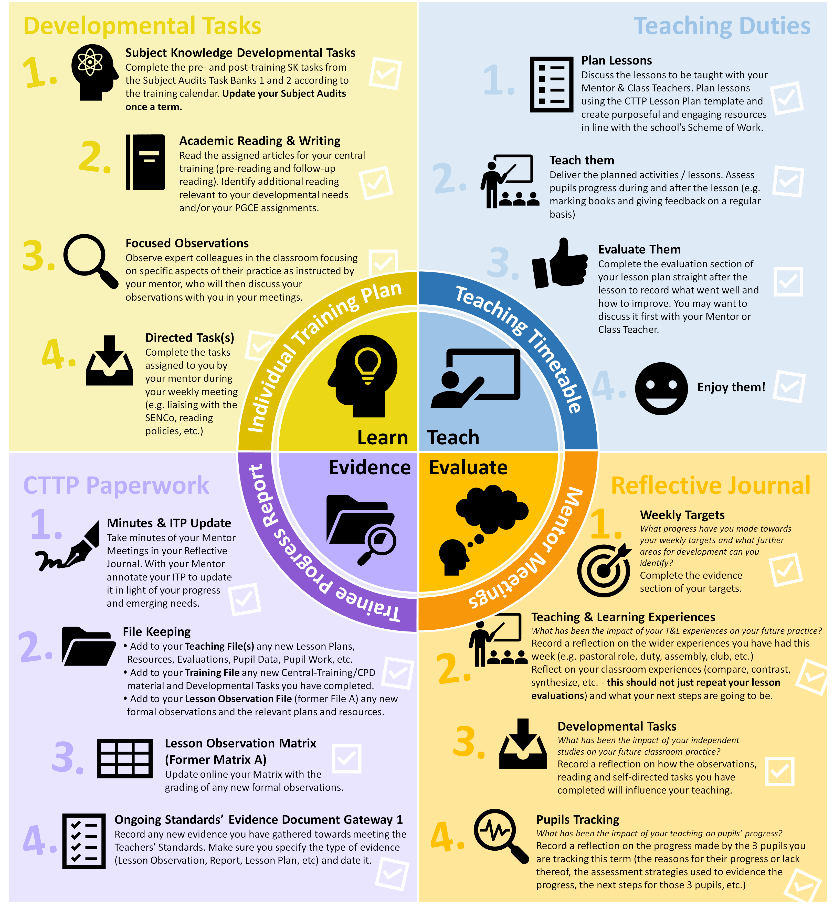

Appendix 3.1
Observation Guidelines: Behaviour Management (Week 1)
Date: |  |  | Class: |  | Topic:
A. Beginning
Describe how the teacher starts off, either at the beginning of a lesson or of a new activity.
C. Rules, Routines and Expectations
Describe how routines are established at the beginning of the school year.
Describe how high expectations are reinforced through praise
Note what appear to be the main behavioural expectations (i.e. classroom rules) about…
Talking:
Movement:
Teacher-Pupil relationships:
Setting out of written work:
F. Learning Environment & Relationships
Describe how the teacher develops a positive, predictable and safe environment as well as a culture of respect and trust in the classroom.
G. Ending
Describe how a teacher ends the lesson / phase.

Appendix 3.2
Observation Guidelines: Principles of Instruction (Week 2)
Date: |  | Class: |  |  | Topic:
A. Small Steps
Describe how the teacher introduces new complex material in small steps so as not to overload the pupils’ working memory.
B. Modelling
Describe how the teacher models activities to exemplify the instructions before the task begins.
Describe how the teacher models new processes and ideas to help pupils understand and make those ideas more concrete and accessible.
C. Checking Understanding
Describe how the teacher uses questioning to check pupils’ understanding and recollection of prior knowledge.
Describe how the teacher checks pupils’ understanding of instructions before a task begins.
Describe how the teacher prompts pupils to elaborate when responding to questioning to check that a correct answer stems from secure understanding.
Describe how the teacher monitor pupil work during the lesson to check for possible misconceptions.
D. Questioning
Describe how the teacher uses questioning to...
… assess understanding
… pinpoint knowledge gaps
… break down problems
… offer greater scaffolding (support)
… model their own thinking
… extend and challenge
… develop literacy
E. Practice
Describe how the teacher builds in the lesson several opportunities for independent and purposeful practice after exposition of new knowledge / skills.
Describe how those opportunities for independent practice increase in challenge throughout the lesson as knowledge becomes more secure.
Describe how the teacher builds in additional practice to meet the individual needs of certain pupils.
Appendix 3.3
Observation Guidelines: Engaging the Learner (Week 3)
Date: |  | Class: |  | Topic:
A. Activities and Resources
Describe the activities and resources used to engage the learner, develop their intellectual curiosity and stimulate their critical thinking.
B. Pace and Timing
Describe how the teacher times their activity so as to maintain appropriate pace during the lesson.
C. Grouping
Describe how pupils are grouped and the impact on their progress, behaviour and motivation.
D. Motivation
Describe how the teacher appeals to the pupils’ intrinsic motivation (e.g. praising effort, resilience, etc.) and extrinsic motivation (e.g. rewards)

Appendix 3.4
Observation Guidelines: Adaptive Teaching (Week 6)
Date: |  | Class: |  | Topic:
A. Class Context
Prior to the lesson, discuss with teacher the pupils’ differences, including their different levels of prior knowledge and potential barriers to learning.
B. Types of support from teacher
Describe how the teacher supports different pupils in the class to allow them to succeed in the tasks.
C. Maintaining high expectations
Describe how the teacher adapts the lesson, whilst maintaining high expectations for all, so that all pupils have the opportunity to meet expectations.
D. Grouping
Describe how the pupils are grouped within the class and how this allows for more tailored support. Does the grouping impact on motivation and engagement of the pupils?

E. Teaching
Describe instances when the teacher…
Connects new content to existing knowledge:
Further breaks down new content for identified pupils:
Builds in additional practice:
Reframes questions to provide greater scaffolding:
F. Working with Colleagues
If Teaching Assistants are present in the class, describe how they are deployed to provide additional or adapted support under the supervision of the class teacher.

Appendix 3.5
Observation Guidelines: Behaviour Management (Week 7)
Date: |  |  | Class: |  | Topic:
A. Beginning
Describe how the teacher starts off, either at the beginning of a lesson or of a new activity.
B. Transitions
Note what happens when the activity changes from one kind to another (e.g., from whole class teaching to group or individual work).
D. Behaviour Management
Note how the teacher manages / avoids misbehaviour consider teacher movement, voice commands, instructions and body language.
Illustrative Event: Consider one event from the lesson, this need not be dramatic, and describe the teachers method of management.
What led up to the event?
What happened?
Describe the outcome.
Describe the teacher’s view of the event after.
E. Motivation
Describe how the teacher motivate pupils by supporting them to master challenging content, which builds towards long-term goals.
G. Ending
Describe how a teacher ends the lesson / phase.

Appendix 4.1
Bitesize Summary: The Science of Learning
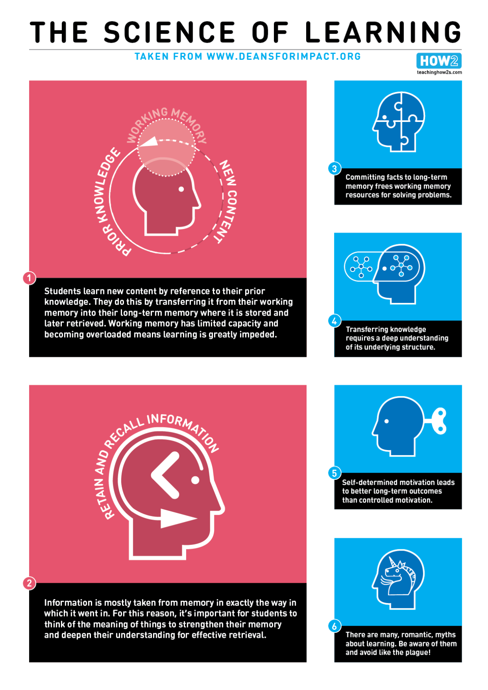
Appendix 4.2
Bitesize Summary: Principles of Instruction
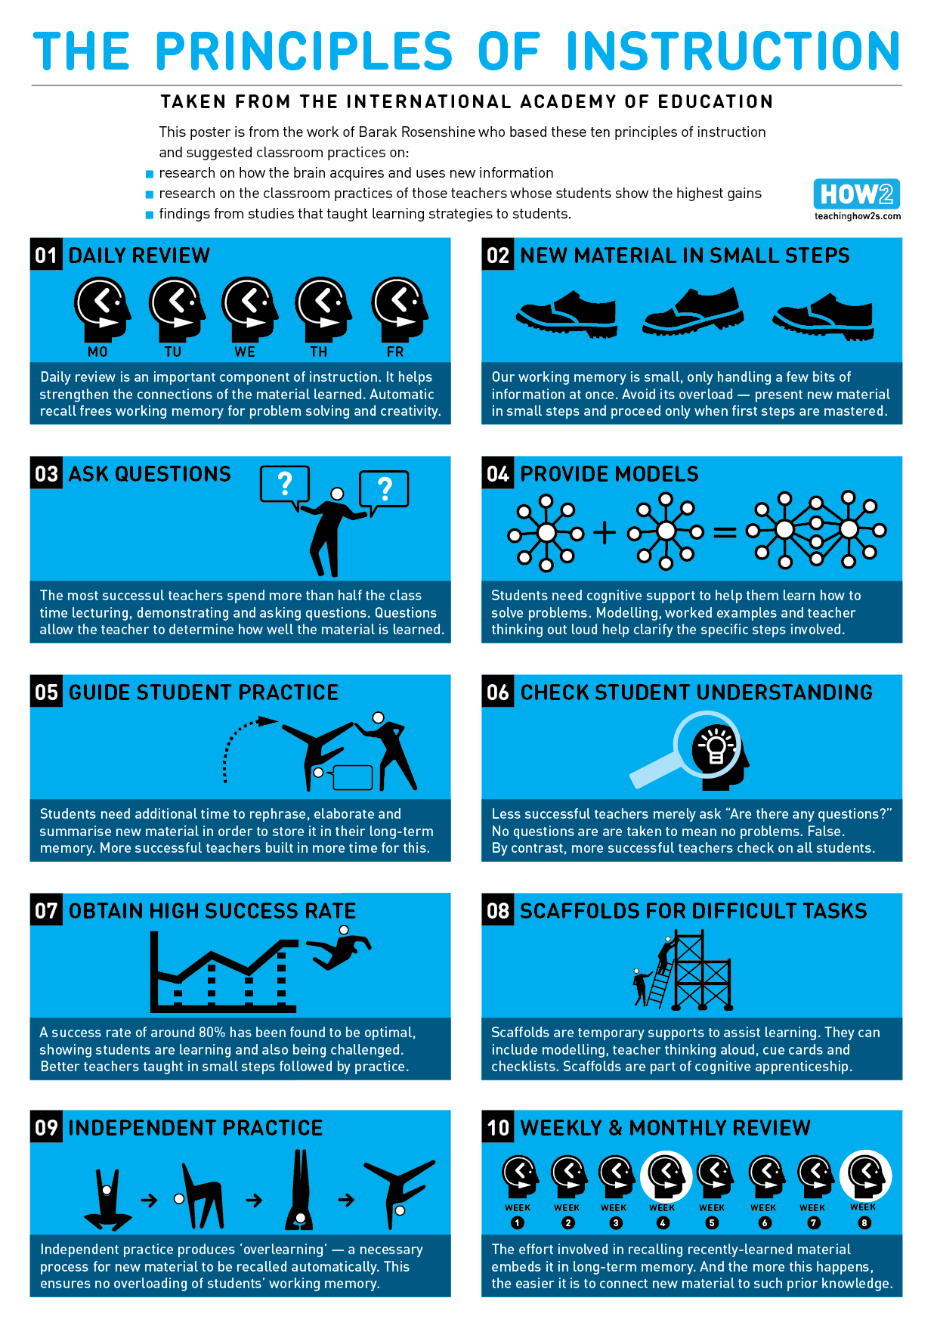
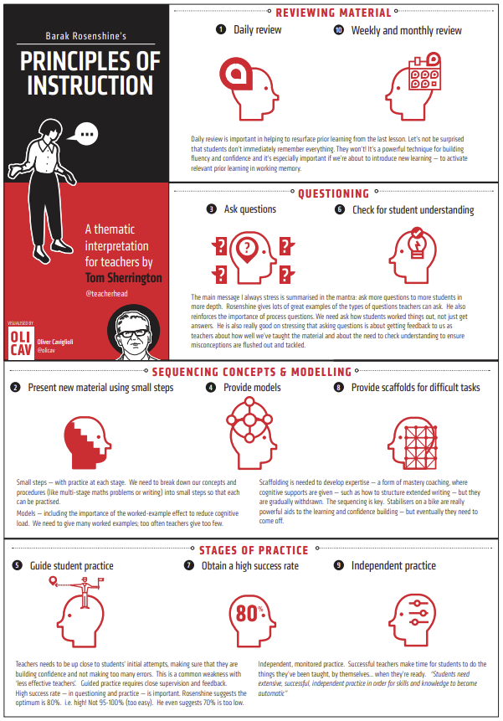
Appendix 4.3
Bitesize Summary: What Makes Great Teaching
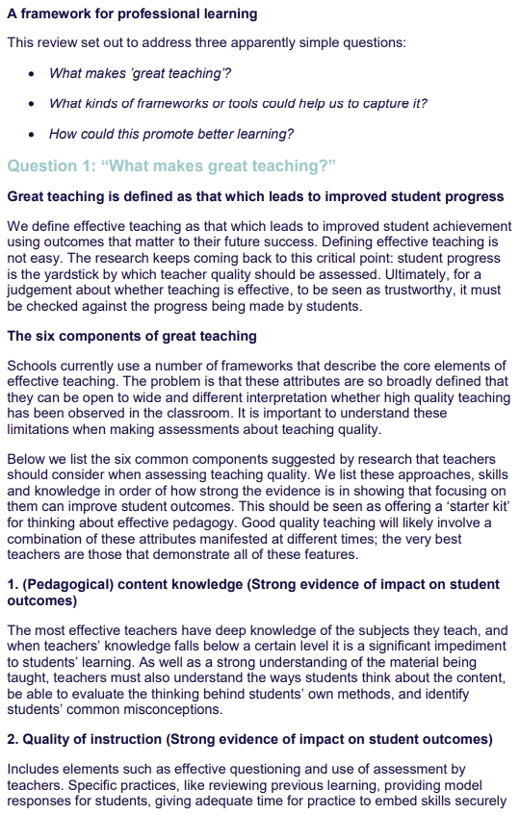
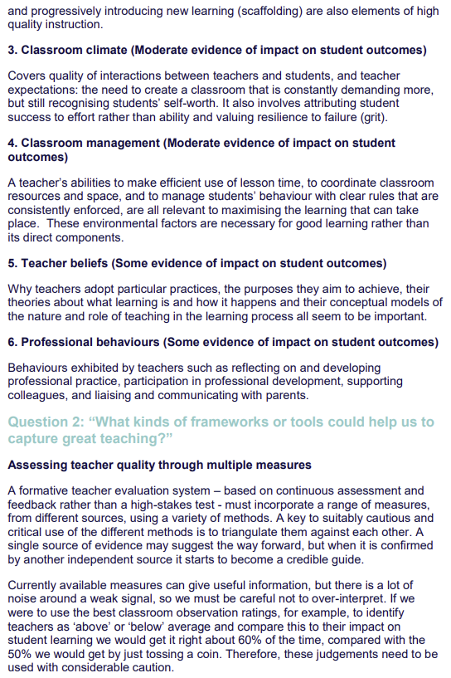
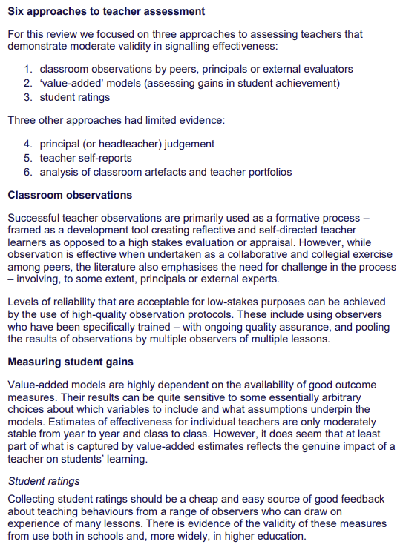
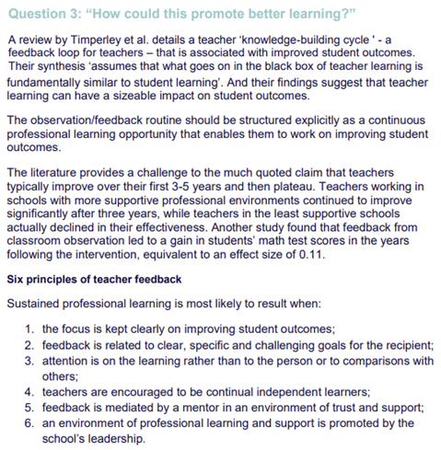
Appendix 5
Practical advice and Targets for Trainees to try in lessons
Consider filming yourself teaching a lesson to review and reflect upon your teaching and learning, delivery and presence.
How do I develop my presence in the classroom?
1: Effective use of your voice:
- Vary the intonation (pitch) and volume of your voice, along with the speed of delivery.
- Avoid shouting and project your voice by breathing from your diaphragm to get a deeper sound.

2: Be confident:
- Aim to be confident rather than confrontational
- Be decisive and consistent eg. when giving instructions, choosing pupils to do things, collecting in books/resources.
- Focus on routines, rules and reasons for them and avoid direct confrontation. Don’t get into argument.
- Don’t punish the whole class and seek a positive outcome, that is, give pupils a chance to make amends/ put things right.

3: Use humour –when used appropriately, this is a great strategy to defuse and resolve situations. Just ensure your body language fits with what you are saying: that is, don’t laugh/smile while reprimanding a pupil! However, don’t be afraid to laugh with your class (when appropriate).

4: Be passionate about your subject so your pupils see and know that you are, and be encouraging.
How do I ensure pupils know the learning objectives and outcomes for each lesson?

1: Emphasise the importance of the learning:
- Keep your focus on the learning objectives and outcomes and keep coming back to these.
- Monitor body language and facial expression to gauge understanding.
- Don’t get side-tracked by irrelevant questions- keep pupils on task.

2: Give clear instructions:
- Keep these short and concise and use key vocabulary.
- Repeat them several times in different ways.
- Write / display key things pupils need on the board- visual prompt.
- Use questioning to check understanding.
- Be aware of any misconceptions and address these.
- Ask pupils to repeat your instructions back to you.
- USE MODELLING to ensure pupils know how to structure their work to achieve the learning objective.

3: NB. Remember there is a difference between facilitating and teaching in a lesson; teaching
requires effective modelling.

How do I develop positive relationships and consistently reinforce high expectations?
1: Give pupils praise- when appropriate and ensure it is sincere.
2: Implement consistently the School Behaviour Policies.
3: Cut out low-level disruption/ peripheral chat:
- Do not talk over pupils.
- Use pupils’ names to correct individuals.
- Wait for silence (and tell them what you are waiting for!).
- Move pupils who continue to talk.
- Set up a seating a plan if necessary.

How do I ensure there is pace and challenge in the lesson?
1: Increase pace:
- Timed activities.
- Focus on LEARNING rather than teaching.
- Clear, snappy content.
- Get pupils on task as quickly as possible and give frequent time checks.
- Ensure pupils are clear of your expectations- what they have to complete by the end of the lesson.
- Monitor pupils to ensure they are on task.
- Organise resources so they are readily available to pupils.
- Plan for smooth transitions between tasks.
- Plan a variety of activities and break down tasks into manageable units.
- Know pupils’ names and direct questions to them.

2: Set time limits:
- Always give a time limit for a task- time targets. These should be verbal and may be displayed.
- Try using stop-clock, timer, music etc.
- Start and end each lesson promptly- good modelling of effective use of time.
- Give the pupils less time than they think they need (helps with pace and provides challenge too).
- Count down the time (with urgency/ as a sense of challenge / positively).
- Give pupils a prompt towards the end of the task or lesson to focus them on finishing.
- Avoid dead time - when off task pupils may start to misbehave. Consider additional challenge in your planning.
- Practise how long things take to do.
- Try not to repeatedly ask: “Have you finished?”

3: Ensure transitions are smooth (so the pace of learning is not slowed down):
- Have a clear plan to your lesson - start, middle and end.
- Organise resources so they are readily available to pupils and arrange furniture to suit the activity.
- Know pupils’ names and groupings and give clear, concise directions to them.
- Ensure all pupils are listening before giving the next instruction.
- Be confident and clear in your delivery.

Appendix 6 - Weekly Reflection – Impact Questions
Impact questions
The following questions and exemplification support analytical and constructively critical analysis of everything that a teacher does or doesn’t do. Have you . . . .

AOF 1 – High Expectations and Managing Behaviour
- Communicated a belief in the academic potential of all pupils ? ( CCF1)
- Demonstrated consistently high behavioural expectations ? ( CCF1)
- Developed a positive, predictable and safe environment for pupils? ( CCF7)
- Established effective routines and expectations? ( CCF7)
- Built trusting relationships ? ( CCF7)
- Motivated pupils ? ( CCF7)
AOF 2 - Pedagogy
- Avoided overloading working memory ? ( CCF2)
- Built on pupil’s prior knowledge ? ( CCF2)
- Increased the likelihood of material being retained ? ( CCF2)
- Planned effective lessons ? ( CCF4)
- Made good use of expositions ? ( CCF4)
- Modelled effectively ? ( CCF4)
- Stimulated pupil thinking and checked for understanding ? ( CCF4)
- Developed an understanding of different pupil needs ? ( CCF5)
- Provided opportunity for all pupils to experience success? ( CCF5)
- Met individual needs without creating unnecessary workload? ( CCF5)
- Grouped pupils effectively? ( CCF5)
AOF 3 - Curriculum
- Delivered a carefully sequenced and coherent curriculum ? ( CCF3)
- Supported pupils to build increasingly complex mental models ? ( CCF3)
- Developed fluency ? ( CCF3)
- Helped pupils apply knowledge and skills to other contexts ? ( CCF3)
- Developed pupils’ literacy ? ( CCF3)
AOF 4 – Professional Behaviours
- Developed as a professional ? ( CCF8)
- Built effective working relationships? ( CCF8)
- Managed workload and wellbeing ? ( CCF8)
AOF 5 - Assessment
- Avoided common assessment pitfalls? ( CCF6)
- Checked prior knowledge and understanding during lessons? ( CCF6)
- Provided high-quality feedback? ( CCF6)
- Made marking manageable and effective? ( CCF6)

Appendix 6b - Impact Questions Exemplification
Impact questions
The following questions and exemplification support analytical and constructively critical analysis of everything that a teacher does or doesn’t do. Have you . . . . .
AOF 1 – High Expectations and Managing Behaviour
High Expectations ( CCF1)
Communicated a belief in the academic potential of all pupils ? | Tasks that stretch but are achievable within a challenging curriculum - Intentional but consistent language – A positive environment - making mistakes and learning from them – effort and perseverance - Opportunities to engage parents and carers
Managing Behaviour ( CCF7)
Developed a positive, predictable and safe environment for pupils? | Respond quickly to any behaviour that threatens emotional safety – Establish a supportive and inclusive environment with a predictable system of reward and sanction – Work alongside colleagues as part of a wider system of behaviour management – Give manageable, specific and sequential instructions. – Check pupils’ understanding of instructions before a task begins. - Use consistent language and non-verbal signals for common classroom directions. – Use early and least-intrusive interventions as an initial response to low level disruption.
Established effective routines and expectations? | Establish routines at the beginning of the school year, then reinforce both in classrooms and around the school. - Create and explicitly teach routines that maximise time for learning.
Built trusting relationships ? | Liaise with parents, carers and colleagues to better understand pupils’ individual circumstances & how they can be supported. – Respond consistently to pupil behaviour. – Engage parents, carers and colleagues with support.
Motivated pupils ? | Support pupils to master challenging content, which builds towards long-term goals. - Provide opportunities for pupils to articulate their longterm goals and help them to see how these are related to their success in school. - Support pupils to journey from needing extrinsic motivation to being motivated to work intrinsically.
Demonstrated consistently high behavioural expectations ? | Create a culture of respect and trust – Clear behavioural expectations – Applying rules, sanctions and rewards – Acknowledge and praise pupil effort
AOF2 - Pedagogy
How pupils learn ( CCF2)
Avoided overloading working memory ? | Pupils prior knowledge – How much new information to introduce – How to reduce distractions – Complex material into smaller steps
Built on pupil’s prior knowledge ? | Sequence lessons – Build on foundational elements – Identify and plan to prevent possible misconceptions – Share understanding and points of confusion – Link known to what is taught
Increased the likelihood of material being retained ? | Plan regular review and practice of ideas and concepts – Design practice, generation and retrieval tasks - Balance exposition, repetition and retrieval of knowledge and skills
Classroom practice ( CCF4 )
Planned effective lessons ? | Break down tasks into constituent components - Use modelling, explanations and scaffolding – Teach foundation then problem solving and critical thinking – Remove scaffolding only after success - Consolidate and practice applying new skills/knowledge
Made good use of expositions ? | Concrete representation of abstract ideas – Start expositions at the point of pupil understanding – Combine verbal and graphical
Modelled effectively ? | Make process steps memorable and ensure recall – Narrate thought processes when modelling - Expose pitfalls and explain how to avoid them
Stimulated pupil thinking and checked for understanding ? | Consider factors that support effective collaborative/paired work – Provide scaffold for pupil talk to increase focus and rigour – Plan activities around focussed ‘hard thinking’ – Include a range of question types to extend and challenge – Provide wait time between question/response )
Adaptive Teaching ( CCF5)
Developed an understanding of different pupil needs ? | ( Support pupils with a range of additional needs, including SEND Code of Practice – Identify pupils who need new content further broken down – Use formative assessment – Work closely with SENCO and DSL under supervision)
Provided opportunity for all pupils to experience success? | (Adapt lessons whilst maintaining high expectations and opportunity to meet expectations for all – Balance input of new concepts – Effective use of TA and other adults)
Met individual needs without creating unnecessary workload? | ( Decide whether intervening within lessons would be more efficient /effective than planning different lessons - Make use of well-designed resources – Plan to connect new content with pupils' existing knowledge or providing additional pre-teaching - Build in additional practice or removing unnecessary expositions )
Grouped pupils effectively? | ( Identify how the school changes groups regularly, avoiding the perception that groups are fixed – identify how school ensures that any groups based on attainment are subject specific – Apply high expectations to all groups, ensure all pupils access rich curriculum )

AOF 3 - Curriculum
Subject and Curriculum ( CCF3)
Delivered a carefully sequenced and coherent curriculum ? | Identify essential concepts, knowledge skills and principles – Focus on key ideas – How curriculum informs lesson preparation – Learn and master essential concepts, knowledge , skills and principles – Accumulate and refine a range of effective resources - Awareness of misconceptions and how to help pupils how to master concepts
Supported pupils to build increasingly complex mental models ? | Revisit big ideas over time – Teach key concepts through a range of examples – Balance exposition, repetition, practice and critical skills and knowledge - Draw links between content and core concepts and principles
Developed fluency ? | Use retrieval and spaced practice to build recall – Provide tasks that support learning of key ideas
Helped pupils apply knowledge and skills to other contexts ? | Interleave concrete and abstract – Ensure relevant domain specific knowledge
Developed pupils’ literacy ? | Clear understanding of systematic, synthetic phonics – Support fluent readers and legible, fluent writers - Model reading comprehension – Promote reading for pleasure – Teach different forms of writing – Teach vocabulary explicitly and plan for repeated exposure to high utility and high frequency vocabulary - Modell and require high quality oral language
AOF 4 – Professional Behviours
Professional Behaviours ( CCF8)
Developed as a professional ? | Engage in professional development with clear intentions for impact on pupil outcomes, over time with opportunities for practice. - Identify and carry out duties relating to Part 2 of the Teachers’ Standards. Strengthen pedagogical and subject knowledge by participating in wider networks. - Learn to extend subject and pedagogic knowledge as part of the lesson preparation process. – Seek challenge, feedback and critique from mentors and other colleagues in an open and trusting working environment. - Reflect on progress made, recognise strengths and weaknesses and identify next steps for further improvement. - Engage critically with research and use evidence to critique practice.
Built effective working relationships? | Seek ways to support individual colleagues and work as part of a team. - Communicate with parents and carers proactively and make effective use of parents’ evenings to engage. - Work closely with the SENCO and other professionals to support pupils with additional needs - Make explicit links between interventions delivered outside of lessons with classroom teaching. - Share the intended lesson outcomes with teaching assistants ahead of lessons. - Ensure that support provided by teaching assistants in lessons is additional to, rather than a replacement for, support from the teacher – Contribute positively to the wider school culture and develop a feeling of shared responsibility for improving the lives of all pupils – Know who to contact with any safeguarding concerns and have a clear understanding of what to report. – Prepare teaching assistants for lessons under supervision.
Managed workload and wellbeing ? | Use and personalise systems and routines to support efficient time and task management – Understand the importance of the right to support – Protect time for rest and recovery and be aware of the sources of support available to support good mental wellbeing- Collaborate with colleagues to share the load of planning and preparation and make use of shared resources
AOF 5 - Assessment
Assessment ( CCF6)
Avoided common assessment pitfalls? | Plan formative assessment tasks linked to lesson objectives – identify ahead what indicates understanding - Choose externally validated materials to make summative assessments in controlled conditions – Draw conclusions about what pupils have learned by looking at patterns of performance over a number of assessments.
Checked prior knowledge and understanding during lessons? | Structure tasks and questions to enable the identification of knowledge gaps and misconceptions – Use assessments to check for prior knowledge and pre-existing misconceptions – Prompt pupils to elaborate when responding to questioning to check secure understanding. – Monitor pupil work during lessons - Check for misconceptions
Provided high-quality feedback? | Pupils’ responses to feedback can depend on a range of social factors - Scaffold self-assessment by sharing model work with pupils, highlighting key details. - Ensure feedback is specific and helpful in peer- or self-assessment. - Focus on specific actions for pupils and providing time for pupils to respond to feedback.
Made marking manageable and effective? | How to record data to improve pupil outcomes. - Understanding written marking is only one form of feedback. - Identify efficient approaches to marking and alternatives to providing feedback - Use verbal feedback in place of written feedback - Reduce the opportunity cost of marking e.g. use abbreviations and codes. - Highlight errors related to misunderstandings, rather than careless mistakes when marking.
Professional Behaviours ( CCF8)
Developed as a professional ? | Engage in professional development with clear intentions for impact on pupil outcomes, over time with opportunities for practice. - Identify and carry out duties relating to Part 2 of the Teachers’ Standards. Strengthen pedagogical and subject knowledge by participating in wider networks. - Learn to extend subject and pedagogic knowledge as part of the lesson preparation process. – Seek challenge, feedback and critique from mentors and other colleagues in an open and trusting working environment. - Reflect on progress made, recognise strengths and weaknesses and identify next steps for further improvement. - Engage critically with research and use evidence to critique practice.
Built effective working relationships? | Seek ways to support individual colleagues and work as part of a team. - Communicate with parents and carers proactively and make effective use of parents’ evenings to engage. - Work closely with the SENCO and other professionals to support pupils with additional needs - Make explicit links between interventions delivered outside of lessons with classroom teaching. - Share the intended lesson outcomes with teaching assistants ahead of lessons. - Ensure that support provided by teaching assistants in lessons is additional to, rather than a replacement for, support from the teacher – Contribute positively to the wider school culture and develop a feeling of shared responsibility for improving the lives of all pupils – Know who to contact with any safeguarding concerns and have a clear understanding of what to report. – Prepare teaching assistants for lessons under supervision.
Managed workload and wellbeing ? | Use and personalise systems and routines to support efficient time and task management – Understand the importance of the right to support – Protect time for rest and recovery and be aware of the sources of support available to support good mental wellbeing- Collaborate with colleagues to share the load of planning and preparation and make use of shared resources

Appendix 7 – ITT Core Content Framework Summary
High Expectations (Standard 1 – ‘Set high expectations’) Observe and/or discuss with expert colleagues:  - Tasks stretch and challenge all children.  - Use intentional and consistent language that promotes challenge and aspiration.  - Create a positive environment where perseverance is part of the daily routine.  - Include parents and carers in the education of their children - proactively highlight successes.  - Create a culture of respect and trust in the classroom that supports all pupils to succeed  - Teach and rigorously maintain clear behavioural expectations (e.g. for contributions, volume level and concentration).  - Apply rules, sanctions and rewards in line with school policy.  - Acknowledge and praise pupil effort and emphasising progress being made.  How Pupils Learn (Standard 2 – ‘Promote good progress’) Observe and/or discuss with expert colleagues:  - Considers children’s PKU when planning how much new information to introduce.  - Reduce distractions keeping the complexity of a task to a minimum; attention is focused on the content.  - Break complex material into smaller steps  - Sequence lessons so that pupils secure foundational knowledge before encountering more complex content.  - Misconceptions and plan how to prevent these forming.  - Encourage pupils to share emerging understanding and points of confusion so that misconceptions can be addressed.  - Link what pupils already know to what is being taught. Plan regular review and practice of key ideas and concepts over time (e.g. through carefully planned use of structured talk activities) and deconstructing this approach.  - Design practice, generation and retrieval tasks that provide just enough support so that pupils experience a high success rate when attempting challenging work  - Balance exposition, repetition, practice and retrieval of critical knowledge and skills.  - Increase challenge with practice and retrieval as knowledge becomes more secure - removing scaffolding.  Subject & Curriculum (Standard 3–‘Demonstrate good subject & curriculum knowledge’) Observe and/or discuss with expert colleagues:  •Identify essential concepts, knowledge, skills and principles of the subject.  •Use retrieval/spaced practice to build automatic recall key knowledge and how to deconstruct this approach.  •The rationale and process for curriculum choices. How the school’s curriculum materials inform lesson preparation.  •Provide opportunities for all pupils to learn and master essential concepts, knowledge, skills and principles of the subject.  •Accumulate and refine a collection of powerful analogies, illustrations, examples, explanations and demonstrations.  •Use resources and materials aligned with the school curriculum (e.g. textbooks)  •Misconceptions and how to help pupils master important concepts.  •Revisit the big ideas of the subject over time and teach key concepts through a range of examples.  •Draw explicit links between new content and the core concepts and principles in the subject.  • Key ideas securely (e.g. quizzing pupils so they develop fluency with times tables).  •Interleave concrete and abstract examples, slowly withdrawing concrete examples and drawing attention to the underlying structure of problems and deconstructing this approach.  •Ensure pupils have relevant domain-specific knowledge, especially when being asked to think critically within a subject.  •Demonstrate a clear understanding of SSP for early reading and spelling.  •Support younger pupils to become fluent readers and to write fluently and legibly.  •Model reading comprehension by asking questions, making predictions, and summarising when reading.  •Promote reading for pleasure (uses a range of whole class reading /reading high-quality texts to children).  •Teach different forms of writing by modelling planning, drafting and editing.  •Teach unfamiliar vocabulary explicitly and planning for pupils to be repeatedly exposed to high-utility and high-frequency vocabulary in what is taught.  •Model high-quality oral language, recognising that spoken language underpins the development of reading and writing (e.g. requiring pupils to respond to questions in full sentences, making use of relevant technical vocabulary)  Classroom Practice (Standard 4 – ‘Plan and teach well structured lessons’) Observe and/or discuss with expert colleagues:  •Break tasks down into constituent components when first setting up independent practice (e.g. using tasks that scaffold pupils through meta-cognitive and procedural processes) and deconstructing this approach.  •Model explanations, scaffolds approaches, removes scaffolding where appropriate.  •Promotes critical thinking and problem solving.  •Enables children to consolidate and practise applying new knowledge and skills.  •Use concrete representation of abstract ideas (e.g. making use of analogies, metaphors, examples and non-examples).  •Start expositions at the point of current pupil understanding.  •Combine a verbal explanation / relevant graphical representation of a concept or process  •Make the steps in a process memorable / recalling (e.g. naming them / linking to memorable stories).  •Narrate thought processes/modelling thinking (e.g. ask questions to aloud/refer to PKU).  •Expose potential pitfalls and explaining how to avoid them.  •Support collaborative / paired work – are children familiar with paired/group routines.  •Provide scaffolds for pupil talk to increase the focus and rigour of dialogue.  •Activities are planned to encourage children to think hard.  •Include a range of types of questions in class discussions to extend and challenge pupils (e.g. by modelling new vocabulary or asking pupils to justify answers).  •Provide appropriate wait time between question and response where more developed responses are required. | Adaptive Teaching (Standard 5 – ‘Adapt teaching’) Observe and/or discuss with expert colleagues:  •Support pupils with a range of additional needs, work with the SENCO and DSL including how to use the SEND Code of Practice.  •Identify pupils who need new content further broken down. Make use of formative assessment.  •Adaption of lessons, whilst maintaining high expectations for all, so that all pupils have the opportunity to meet expectations and deconstructing this approach.  •Balance input of new content so that pupils master important concepts.  •Use TAs/AA  •Decide whether intervening within lessons with individuals and small groups would be more efficient and effective than planning different lessons for different groups of pupils.  •Make use of well-designed resources (e.g. textbooks).  •Plan to connect new content with pupils' existing knowledge or providing additional pre-teaching if pupils lack critical knowledge  •Build in additional practice or removing unnecessary expositions.  •Reframe questions to provide greater scaffolding or greater stretch.  •Discuss with expert colleagues how groups change regularly, avoiding the perception that groups are fixed.  •Discuss with expert colleagues how the school ensures that groups based on attainment are subject specific.  •Apply high expectations to all groups, and ensuring all pupils have access to a rich curriculum.  Assessment (Standard 6 – ‘Make accurate and productive use of assessment’) Observe and/or discuss with expert colleagues:  •Plan formative assessment tasks linked to lesson objectives and think ahead about what would indicate understanding (e.g. by using hinge questions to pinpoint knowledge gaps).  •Choose, where possible, externally validated materials, used in controlled conditions when required to make summative assessments.  •Draw conclusions about what pupils have learned by looking at patterns of performance over a number of assessments with support and scaffolding from expert colleagues (e.g. appreciating that assessments draw inferences about learning from performance).  •Structure tasks and questions to enable the identification of knowledge gaps and misconceptions (e.g. by using common misconceptions within multiple-choice questions).  •Use assessments to check for prior knowledge and pre-existing misconceptions.  •Prompt pupils to elaborate when responding to questioning to check that a correct answer stems from secure understanding.  •Monitor pupil work during lessons, including checking for misconceptions.  •How pupils’ responses to feedback can vary depending on a range of social factors (e.g. the message the feedback contains or the age of the child).  •Scaffold self-assessment by sharing model work with pupils, highlighting key details.  •Ensure feedback is specific and helpful when using peer- or self-assessment.  •Focus on specific actions for pupils and providing time for pupils to respond to feedback.  •Record data only when it is useful for improving pupil outcomes.  •Develop an understanding that written marking is only one form of feedback.  •Identify efficient approaches to marking and alternative approaches to providing feedback (e.g. using whole class feedback or well supported peer- and self-assessment) and deconstructing this approach.  •Use verbal feedback during lessons in place of written feedback after lessons where possible.  •Reduce the opportunity cost of marking (e.g. by using abbreviations and codes in written feedback).  •Prioritise the highlighting of errors related to misunderstandings, rather than careless mistakes when marking.  Managing Behaviour (Standard 7 – ‘Manage behaviour effectively’) Observe and/or discuss with expert colleagues  - Establishes routines and quickly responds to behaviour/bullying that threatens emotional safety.  - Establish a supportive and inclusive environment offers reliable system of reward and sanction in line with school policy.  - Creates and explicitly teaches routines in lines with school ethos – maintains high expectations.  - Work alongside colleagues as part of a wider system of behaviour management.  - Give manageable, specific and sequential instructions.  - Check pupils’ understanding of instructions before a task begins.  - Use consistent language and non-verbal signals for common classroom directions.  •Use least-intrusive interventions for LLD.  •Use effective strategies for liaising with parents, carers and colleagues to understand pupils’ individual circumstance that ensure high academic and behavioural expectations.  - Respond consistently to pupil behaviour.  - Master challenging content, which builds towards long-term goals and deconstructing this approach.  • how to provide opportunities for pupils to articulate their long-term goals and helping them to see how these are related to their success in school.  - Support pupils to journey from needing extrinsic motivation to being motivated to work intrinsically.  Professional Behaviours (Standard 8 – ‘Fulfil wider professional responsibilities’) Observe and/or discuss with expert colleagues  • Receive clear, consistent and effective mentoring on the duties relating to Part 2 of the Teachers’ Standards.  • Strengthen and extend pedagogical and subject knowledge by participating in wider networks and lesson preparation.  • Seek challenge, feedback and critique from mentors and other colleagues – work as a team  • Reflect on progress made, recognise strengths and weaknesses and identifying next steps for further improvement.  • Engage critically with research and using evidence to critique practice.  • Communicate with parents and carers proactively and make effective use of parents’ evenings to engage parents and carers in their children’s schooling and deconstructing this approach.  • Work closely with the SENCO and other professionals supporting pupils with additional needs, including how to make explicit links between interventions delivered outside of lessons with classroom teaching.  • Share the intended lesson outcomes with teaching assistants ahead of lessons.  • Receive clear, consistent and effective mentoring in how to ensure that support provided by teaching assistants in lessons is additional to, rather than a replacement for, support from the teacher.  • Contribute positively to the wider school culture and developing a feeling of shared responsibility for improving the lives of all pupils within the school (e.g. by supporting expert colleagues with their pastoral responsibilities, such as careers advice). Collaborate with colleagues to share load of preparation and planning.  • Know who to contact with any safeguarding concerns and having a clear understanding of what sorts of behaviour, disclosures and incidents to report.  • Personalise systems and routines to support efficient time and task management.  • Discuss and analyse with expert colleagues the importance of the right to support (e.g. to deal with misbehaviour).  • Protect time for rest and recovery; be aware of sources of support available to support good mental wellbeing.

