“One looks back with appreciation to the brilliant teachers, but with gratitude to those who touched our human feelings. The curriculum is so much necessary raw material, but warmth is the vital element for the growing plant and for the soul of the child.”
Carl Jung

Keep in PT / Mentor File

Training Handbook

Autumn 1- 2022-3
Secondary

Trainee: Mentor: Main School:

QA Checks: Autumn 1 PT ☐ PLT ☐ Date:

Contents
￼
Core Training Requirements 4
Grading Trainees Student Progress and Trainee Assessment 6
Training Programme Spring Overview 7
Training Programme Autumn 1 Overview 8
Training Programme Teaching and Training Schedule 10
PT/Mentor Meetings
Weekly Training Guidance Key and Acronyms 13
Weekly Training Guidance Ongoing Weekly Tasks (for Mentor Training) 14
Training Week 1 Week commencing 06/09/21 15
Training Week 2 Week commencing 13/09/21 19
Training Week 3 Week commencing 20/09/21 20
Training Week 4 Week commencing 27/09/21 25
Training Week 5 Week commencing 04/10/21 29
Training Week 6 Week commencing 11/10/21 33
Training Week 7 Week commencing 18/10/21 37
Appendices
￼
Appendix 2 What do Trainees Need to Do on a Weekly Basis? 44
Appendix 3.1 Observation Guidelines: Behaviour Management (Week 1) 45
Appendix 3.2 Observation Guidelines: Engaging the Learner (Week 1) 47
Appendix 3.3 Observation Guidelines: Assessment (Week 3) 48
Appendix 3.4 Observation Guidelines: Principles of Instruction (Week 4) 50
Appendix 3.5 Observation Guidelines: Curriculum in Practice (Week 5) 52
Appendix 3.6 Observation Guidelines: Adaptive Teaching (Week 6) 53
Appendix 3.7 Observation Guidelines: Behaviour Management (Week 7) 55
Appendix 4 Practical advice and Targets for Trainees to try in lessons 57
Appendix 5 Weekly Reflection 59
Appendix 6.1 Bitesize Summary: The Science of Learning 60
Appendix 6.2 Bitesize Summary: Principles of Instruction 61
Appendix 6.3 Bitesize Summary: Embedding Formative Assessment 63
Appendix 6.4 Bitesize Summary: Six Effective Strategies for Learning 64
Appendix 6.5 Bitesize Summary: The Beginning Teacher’s Behaviour Toolkit 67
Appendix 6.6 Bitesize Summary: Six Recommendations for Improving Behaviour in Schools 68
Appendix 7 Standards’ Evidence Grading 69

Secondary Handbook Guidance
for Professional Tutors and Mentors

Trainee Name:
School:
Professional Tutor:
Mentor:
 Key Information
Mike Shorten : CEO Bishop Hogarth Catholic Education Trust
Monita Atkinson: Director of Carmel Professional Training Centre
Vice Principal Standards Carmel College
 01325 523 474
 atkinsonm@carmel.bhcet.org.uk
Monica Shepherd: Director of ITT (Initial Teacher Training) and Secondary Lead
 01325 523 460
 mshepherd@carmel.bhcet.org.uk
Iain Knox: Primary Lead
 01325 523 460
 iknox@carmel.bhcet.org.uk
Lily Bonas: Administration CTTP
 01325 523 474
 lbonas@carmel.bhcet.org.uk
Core Training Requirements
- Professional Tutor (PT) to monitor and quality assure trainee experiences and development throughout the training year.
- PT to facilitate opportunities for the Mentors to meet, support and observe their trainees on a weekly basis, as outlined in the School Agreement and the Training Handbooks.
- Mentor to meet with their trainee for a minimum of one hour’s training per week to review progress and set weekly targets as outlined in the Training Handbooks.
- Training Handbooks to be used by all schools.
- ITT Core Content Framework to be embedded in all aspects of training (school-based and central) https://www.gov.uk/government/publications/initial-teacher-training-itt-core-content-framework
- Clear links to be drawn between central and school-based training.
- Class teacher (CT) or Mentor to be present in the classroom with the trainee for the first term and in second school placement for the first week as a minimum, unless salaried. CT or Mentor to offer support and feedback both formally and informally.
- Assessment strategies to be included in all curriculum-based training.
- Ongoing reflections and evaluations of training and classroom practice (recorded in Reflective Journals, in lesson evaluations and post training evaluations).
- Academic study time to be protected.
- PT to check that all documents are completed and signed off before the final PLT (Partnership Link Tutor) visit in the summer term and final assessment.

Suggested teaching commitment for this half term- approximately 20% timetable allocation that is, 2-4 planned and taught lessons inclusive of small groups and whole classes per week, based on 4 days not 5.

Assessment
Student Progress and Trainee Assessment
CTTP consider that the quality of trainees’ teaching is judged by the impact they
have on student progress and learning over time.
When grading trainees assess them with specific reference to student progress over
time.
Teachers’ Standards - final assessment (summer term).
1. Set high expectations which inspire, motivate and challenge students | 5. Adapt teaching to respond to the strengths and needs of all students
2. Promote good progress and outcomes by students | 6. Make accurate and productive use of assessment
3. Demonstrate good subject and curriculum knowledge | 7. Manage behaviour effectively to ensure a good and safe learning environment | PART 2. Personal and Professional Conduct
4. Plan and teach well-structured lessons | 8. Fulfil wider professional responsibilities

Training Programme
Overview
CTTP Spiral Curriculum
School-Based Training
Follow-Up Mentor Meeting
School-Based Training
Focused Observation
Academic Study
Pre-Reading
Academic Study
Follow-Up Reading
Central Training
Training Session
Central Training
Consolidation
Training Session
PT
Mentor

The Role of the Mentor/PT
School-Based Training | - Organise focused observations (joint when possible).  - Review focused observations and deconstruct observed approaches.  - Using Training Handbook, review central training sessions and discuss academic reading. Review impact of central training on trainee’s Teaching and Learning.  - Rehearse, practise, and give feedback on related skills.
Academic Study | - Protect directed study time (2 hours / week)  - Be aware of and familiar with trainee’s reading list (see bibliography on CTTP Teams VLE).
Central Training | - Be aware of weekly training focus.  - Check training files half-termly.

Training Programme
Autumn 1 Training Focuses (Central Training)
Core Area 1  Behaviour Management  & High Expectations  (TS1, 7) | Core Area 2  Pedagogy  (TS2, 4, 5) | Core Area 3  Curriculum  (TS3) | Core Area 4  Assessment  (TS6) | Core Area 5  Professional Behaviours (TS8)
- Behaviour Management (1)  - Voice coaching and developing an effective classroom presence. | - Research in Action  - Lesson Planning and Engagement  - Teaching Pupils with SEND (Special Educational Needs and Disabilities)  - Educational Theory and Cognitive Load Theory  - PGCE: Supporting Individual Needs | - PGCE (Post Graduate Certificate in Education) Induction  - PGCE Supporting Individual Needs  - Subject Knowledge (1)  - Academic Writing | - Data and Pupil Progress  - Assessment Strategies | - Welcome & Professionalism  - Safeguarding & Prevent Agenda  - Professional Skills (Literacy, Numeracy, Oracy, ICT, Leadership, Professional Development)

Suggested teaching commitment for this half-term:
(to be progressively built into the timetable over the half-term)
● 20% timetable allocation (approx. 2-4 60-min. planned and taught lessons / week or equivalent).

Timetable requirements:
● 2 hours protected Academic Study Time
● 1 hour protected Mentor Training
PLT Visit Window:
 3rd October – Friday 14th October 2022 (exc. Thursdays)

Observation: focussed observation of expert staff modelling professional behaviour/skills to engage the learner and observation of department/school routines - appendices 3:2.
Organise: Induction to school policies, procedures, routines, timetable arrangements etc.
Week 1  c/ 05/09/22 | Lesson 1 | Lesson 2 | Lesson 3 | Lesson 4 | Lesson 5
Monday
Tuesday
Wednesday
Thursday
Friday | Central Training: Welcome | Central Training:  Professionalism | Central Training:  Professionalism | Central Training:  Safeguarding | Central Training:  Prevent Agenda

Week 2  c/ 12/09/22 | Lesson 1 | Lesson 2 | Lesson 3 | Lesson 4 | Lesson 5
Monday
Tuesday
Wednesday
Thursday | Central Training: Effective lesson Planning and Engaging the Learner.
Friday

Observation: Focussed observation of expert staff delivering the curriculum in practice, engaging the Learner and using effective assessment strategies - appendices 3:2, 3.3, 3:5 and 6:3
Organise: QA Lesson Observation of Trainee: Mentor-CT or Mentor-PT
Week 3  c/ 19/09/22 | Lesson 1 | Lesson 2 | Lesson 3 | Lesson 4 | Lesson 5
Monday
Tuesday
Wednesday
Thursday | Central Training: PGCE Induction.
Friday

Observation: Focussed observation of expert staff using effective behaviour management strategies - appendices 3:1, 3;7, 6:5, 6:6.
Organise: Start/end/key transition point lesson observation.
Week 4  c/ 26/09/22 | Lesson 1 | Lesson 2 | Lesson 3 | Lesson 4 | Lesson 5
Monday
Tuesday
Wednesday
Thursday | Central Training: Behaviour management, voice coaching and developing a classroom presence.
Friday

Observation: Focussed observation of adaptive teaching. Appendix 6:4 and the SEND Code of Practice.
Organise: trainee tracking of 3 students over time (incl. a SEND student)

PLT Visit 1 Window | Week 5  c/ 03/10/22 | Lesson 1 | Lesson 2 | Lesson 3 | Lesson 4 | Lesson 5
 | Monday
 | Tuesday
 | Wednesday
 | Thursday | Central Training: Adaptive Teaching. Data and progress.
 | Friday

Observation: focussed observation of adaptive teaching: Supporting Individual Needs – appendix 3:6 and 6:4.
Organise: trainee tracking of a SEND student and research regarding the specific SEND need.

PLT Visit 1 Window | Week 6  c/ 10/10/22 | Lesson 1 | Lesson 2 | Lesson 3 | Lesson 4 | Lesson 5
 | Monday
 | Tuesday
 | Wednesday
 | Thursday | Central Training: PGCE (1): Adaptive teaching: Supporting Individual Needs. Data
 | Friday

Observation: Focussed observation of the implementation of cognitive load theory. Appendices 6:1, 6:2, 6:4.
Organise: Plan and deliver a teaching activities which consider the science of learning and cognitive load theory.
Week 7  c/ 17/10/22 | Lesson 1 | Lesson 2 | Lesson 3 | Lesson 4 | Lesson 5
Monday
Tuesday
Wednesday
Thursday | Central Training: Educational theory and cognitive load theory.
Friday

Key Dates
Secondary Mentor Training
Carmel Cluster: Thursday 22/09/2022 2.30 pm - 4.00 pm.
Other Lead Schools to arrange training with their Cluster school's week c/ 19/09/2022

Weekly Training Guidance
Key and Acronyms
Key
 Weekly Tasks
◻ Training Focus
 Discussion
☹ Review of Focused Observation
 Suggested Reading
 To do this week
↓ Task for the Trainee

Acronyms
CCF  CTTP  DFE  ECF  GPS  INA  (SC)ITT  KCSIE  FTE  LO  LP  NQT | Core Content Framework  Carmel Teacher Training Partnership  Department for Education  Early Career Framework  General Professional Studies  (School-Centred) Initial Teacher Training  Keeping Children Safe in Education  Full Time Equivalent  Lesson Observation  Lesson Plan  Newly Qualified Teacher | MA  PGCE  PLT  PT  QA  QTS  RJ  SA  SK  SMU  SSP  TPR  TS | Master’s  Post-Graduate Certificate in Education  Partnership Link Tutor  Professional Tutor  Quality Assurance  Qualified Teacher Status  Reflective Journal  Subject Audit  Subject Knowledge  St Mary’s University  Second School Placement  Trainee Progress Report  Teachers’ Standards

Weekly Training Guidance
Ongoing Weekly Tasks (for Mentor Training)
 | Weekly Tasks: summary | 
1. Teaching and Learning (Target Review and Setting)
 Discuss and review trainee’s teaching experiences this week and review last session’s targets.
Check Reflective Journal and sign off last session’s targets. Ensure congruence with Training Handbook.
Add review comment and evidence in Training Handbook.
Discuss and agree new targets for the week ahead based on:
□ their teaching and learning for that week (lesson observations),
□ a discussion regarding student progress as directed in the Training Handbook,
Discuss strategies to achieve targets and define clear actions and success criteria as well as the support that will be made available to the trainee.
Record the targets in the Training Handbook. The trainee needs to record the same targets in their Reflective Journal AND record notes of their mentor meeting with you.
2. Gateway 1
There is an expectation that all trainees will have meet the expectations within Gateway 1, at least at a minimum level by Christmas (PLT 2 visit). Trainees are encouraged to review and annotate this document on a weekly/regular basis with their mentor and/or PT.
 Review and discuss this week’s recorded evidence. Ensure it is accurate, relevant, specific, and dated.
If your trainee is struggling to meet the Gateway 1 expectations, please notify the Central CTTP team and highlight your cause for concern.
3. Impact and Outcomes of Central Training
 Discuss with trainee the impact and outcomes of their central training.
Agree with the trainee how to consolidate and continue this training in school.
4. Student Progress Tracking
Support trainee to track, evaluate and evidence the impact of their teaching upon student progress and learning over time.
The trainee is required to select a minimum of 3 students who display a range of ability, educational needs and language differences and track, over the half term, their academic progression through assessment. They will need to evaluate and evidence the impact of their teaching on student progress and learning over time. Over the period of tracking the trainee is to identify the barriers to learning and critically evaluate in their Reflective Journal strategies to overcome these.
 Advise ‘how’ to track the students and encourage the trainee to speak to the class teacher, plus additional adults such as learning support assistants/ teaching assistants who may also be supporting the student.
5. Wellbeing and Workload
 Discuss wellbeing, time, and workload management with trainee.
Consider the trainees workload overall – lesson planning and teaching, academic study, and strategies to manage work /life balance.
Training Weeks 1-2 – PT
Week commencing 05-16/09/22
Professional Tutor

To Do This Week | 
1. School information and organisation for trainee as they start their Main Placement
☐  Discuss with trainee:
The school
- The catchment area / schools' context;
- Ofsted Report and School Prospectus;
- Classes within the school and year structures;
- Health and Safety information- procedures: fire, accident, injury, and security;
- Safeguarding and Child Protection policies and procedures /child welfare;
- Professional expectations and the Teachers’ Standards.
The classes
- General information: daily organisation and routines, school resources, website, access to computers etc.
- The teaching timetable and why it is organised as it is;
- Administrative routines and tasks for example, marking the attendance register, letters from parents, notes for other staff.
The wider life of the school and professional values
- Extra-curricular activities, such as, clubs, teams, and any links with the local community;
- The school’s expectations of staff to be fully involved in the life of the school.
☐ Direct trainee to:
- Spend some time familiarising themselves with the school and meeting the staff;
- Consider the focus of observations in classes and complete the weekly observations tasks.
2. Admin.
☐ Return a signed copy of the Partner School Agreement to CTTP.
☐ Provide CTTP with an up-to-date list of mentors, email address, information etc.
☐ Familiarise yourself with the Training Handbook Autumn Term 1, calendar etc.

Training Weeks 1- 2 - Mentor
Week commencing 05-16/09/22
Mentor

This Week’s Training Focus
Either…

Personalised Training Focus  Based on trainee initial/emerging needs. | ◻
Training Focus:
Notes:

Or…

Suggested Training Focus | ◻
Focus: Professional Behaviours.
Discuss with trainee:
□ Staffing: staff structure and staff responsibilities within the school and their responsibilities which will help answer the question: ‘Who do I go to for /if …?’
□ The curriculum and timetable including classes to be taught.
□ Resources available and access arrangements.
□ Key school routines.
□ Professional expectations - as a class teacher, a team member, colleague, dress code etc.
□ Keeping Children Safe in Education Part One (KCSIE Part 1)
□ Key initial CTTP documents and how to complete them throughout the year:
□ Reflective Journal: for your trainee to record ‘analytical reflections’ of their experiences each week (it is not a diary of the week).
□ Lesson Observation Matrix (Matrix A): in which your trainee will record their weekly formal observations.
Direct trainee to:
□ School Information: Familiarise themselves with the school information, organisation, code of conduct and policies (incl. safeguarding and behaviour).
□ Safeguarding Checklist: Complete the Safeguarding Checklist (pink sheet) following your discussion of KCSIE Part 1. Remind them to bring it to their first Central Training session.
□ Subject Audits: The trainee should be completing their subject audits next week. Together in discussion, review their experience in each subject area and moderate their baseline judgments.
Assigned Reading
□ Reading: Relevant school policies and procedures.
□ Reading: Keeping Children Safe in Education, school Safeguarding and Prevent policies.

Notes:

To Do This Week | 
Notes
1.Notes.
☐
☐
2. Admin.
☐ Teaching and Learning - target setting.
- Discuss trainee progress, well-being, workload and the impact of training.
Ensure you and your trainee can access web page and complete the Mentor/PT Profile information for CTTP
☐ Familiarise yourself with the Training Handbook Autumn 1 2022-2023 and Calendar.
3. Teaching Schedule (which year groups the trainee will be teaching in during their training year).
☐ Start to create this using the subject audits. Use the pre-populated document available on CTTP Teams VLE and delete what you do not need and add what you do, personalising it to your trainee’s needs. (Guidance will be given in Mentor training). Once developed this plan can be annotated with any changes or additions during Mentor meetings - it is a very ‘live’ document. The completed ITP and Teaching Schedule will be reviewed with your PLT during their first visit and each subsequent visit.
3. Focused Observation: Professional behaviour, skills and principles of instruction.
☐ Organise for the trainee to observe professional behaviours and the principles of instruction in operation in lessons.
4. Engagement Task
☐ Organise for the trainee to plan and deliver a short engagement task (min. 20 minutes) in Week 3 (Appendix 3:2).

Notes:

Training Weeks 1-2 - Trainee
Week commencing 05-16/09/22
Trainee Targets Setting and Review
CTTP consider that the quality of trainee’s teaching should be judged by the impact on student progress and learning.
Target 1 (Focus on maximising impact of teaching on student progress)
Actions and Support to access Target | Success Criteria | Related TS
Review comment | Evidence

Target 2 (Focus on teaching and learning)
Actions and Support to access Target | Success Criteria | Related TS
Review comment | Evidence

Target 3
Actions and Support to access Target | Success Criteria | Related TS

Training Week 3 – PT
Week commencing 19/09/22
Professional Tutor

To Do This Week | 
 Weekly Tasks:
☐
If you have an early concern regarding your trainee, please notify the Central CTTP team and highlight your cause for concern.
☐ Discuss wider reading/writing carried out in first two weeks.
How does their study relate to and impact on their practice? Remind trainee that they have access to all online library resources through Leeds Trinity University, Carmel Learning Resource Centre, and Chartered College.
Settling-in catch-up
☐ Discuss trainee experience to date in school, how they are settling into the school and managing the course (well-being).

Training Week 3 - Mentor
Week commencing 19/09/21
Mentor

This Week’s Training Focus
Either…

Personalised Training Focus  Based on trainee’s Initial Needs Analysis, Subject Audits, and emerging needs. | ◻
Training Focus: Refer to Individual Training Plan
Notes:

Or…

Suggested Training Focus | ◻
Focus: Principles of Instruction.
Review Focused Observation.
Discuss Central Training Week 2 Effective Lesson Planning and Engaging the Learner and identify future training needs in this area.
Discuss their Follow-up Reading “Principles of Instruction.” What will be the impact on their practice?
Discuss with trainee:
□ lesson planning and how to complete CTTP Lesson Plan template.
□ how to plan lessons that:
- break down new complex material into smaller steps to avoid overloading students’ working memory.
- build opportunities for independent and purposeful practice.
□ how to deliver lessons which make effective use of:
- modelling (to make activities, new ideas and processes more concrete and accessible)
- questioning (to check understanding, pinpoint knowledge gaps, break down complex problems, scaffold learning, stretch and challenge and model the teacher’s own thinking)
□ a range of activities to engage the learner (Magenta Principles, Kagan Collaborative Learning, etc.)
□ a range of teaching resources and material, incl. digital resources, textbooks, games, etc.
□ how to make effective use of ICT to engage the learner (EEF (Education Endowment Foundation) Bitesize Summary: https://educationendowmentfoundation.org.uk/public/files/Publications/digitalTech/EEF_Digital_Technology_Summary_of_Recommendations.pdf)
□ how to manage timings during lesson to maintain an appropriate pace throughout the lesson.
□ how to appeal to students’ intrinsic and extrinsic motivation by using a range of strategies from praise to rewards.
□ how to increase student engagement by engaging parents and carers in the learning (EEF Bitesize Summary: https://educationendowmentfoundation.org.uk/public/files/Publications/ParentalEngagement/EEF_Parental_Engagement_Summary_of_recommendations.pdf)
□ how to group students to maximise attainment and motivation.

Direct trainee to:
□ plan a lesson, together with their mentor, which will be co-delivered by them and their Mentor / a Class Teacher or taught independently (based on the trainee’s confidence and readiness).

Assigned Reading
□ Pre-Reading: The Science of Learning, Deans for Impact, 2015
https://deansforimpact.org/wp-content/uploads/2016/12/The_Science_of_Learning.pdf
Bitesize Summary in Appendix 6.1.
□ Follow-up Reading: Principles of Instruction, B. Rosenshine, 2012
https://files.eric.ed.gov/fulltext/EJ971753.pdf
Bitesize Summary in Appendix 6.2.

Notes:

To Do This Week | 
Notes:
☐
☐
☐
☐
☐

1. Weekly
Teaching and learning – target setting
Review trainee progress, well-being, workload and the impact of training,

2. Organisation Check
☐ Check the trainee’s file are set up.
☐ Check they know about Gateway 1 (Christmas).

3. Quality assurance – Joint Observation Mentor/Class Teacher or Mentor/PT
☐Organise a Joint Observation with a Class Teacher or Professional Tutor to be carried out in Week 4.

3. Engagement Task Observation and Feedback
☐ Observe the trainee’s Engagement Task (Appendix 3:2).

4. Focused Observation: Principles of Instructions (Appendix 3.4)
☐ Organise for the trainee to observe in Week 4 (jointly with mentor if possible) a lesson or part of a lesson in which an expert colleague will demonstrate some of the key principles of instruction discussed in today’s mentor training:
- How to introduce new content in small steps and then build in opportunities for independent practice
- How to make effective use of modelling and questioning
- How to check understanding

Training Week 3 - Trainee-
Trainee Targets and Review
CTTP consider that the quality of trainee’s teaching should be judged by the impact on student progress and learning over time; it is the trainee’s strengths across the Teachers’ Standards in their entirety that are integral to this. Targets should therefore focus on those aspects. Use appendix 5 to help you inform your choice of targets.
Target 1 (Focus on maximising impact of teaching on students’ progress)
Actions and Support to access Target | Success Criteria | Related TS
Review comment | Evidence

Target 2 (Focus on teaching and learning)
Actions and Support to access Target | Success Criteria | Related TS
Review comment | Evidence

Target 3
Actions and Support to access Target | Success Criteria | Related TS
Review comment | Evidence

Training Week 4 - PT
Week commencing 26/09/21
Professional Tutor

To Do This Week | 
 Weekly Tasks:
☐ Review trainee progress.
☐ Discuss wider reading/writing carried out this week.
How does their study relate to and impact on their practice? Remind trainee that they have access to all online library resources through Leeds Trinity University, Carmel Learning Resource Centre and CTTP Teams VLE.

1. Preparations for PLT 1 Visit
☐ Ensure trainees are prepared for their PLT visit and that all files and paperwork are up to date (both electronic and hard copies) and organised. Ensure all documents have been completed checked, verified, and signed off:
- Partner School Agreement
- Teaching Schedule (an overview of which year groups the trainee will be teaching in during their training year)
- Lesson Observation Matrix
- Gateway 1 - introduction
Take some time to familiarise yourself with this document prior to the PLT visit. During this first half term, start to review your trainee’s progress against the standards in this document. Trainees are encouraged to discuss and annotate this document weekly/regularly with their PT / mentor.
☐ Look out for an email from your Partnership Link Tutor who will contact you to arrange a school visit. The completed documents will be reviewed with your Professional Link Tutor during their first visit and a copy returned to Carmel TTP.
☐ Check what class trainees are going to teach for the PLT joint observation (30 min.) and what resources they will need. Advise the trainee as appropriate in preparing their lesson.
☐ Agree who will do the joint observation (30 min.) with the PLT - you or the Mentor?

2. Wellbeing and Workload
☐ Consider the trainees workload overall - lesson planning and teaching, academic study, and a pending PLT visit! (Work-life balance)

Training Week 4 - Mentor
Week commencing 26/09/21
Mentor

This Week’s Training Focus
Either…

Personalised Training Focus  Based on trainee’s Initial Needs Analysis, Subject Audits, and emerging needs. | ◻
Training Focus: Refer to Individual Training Plan
Notes:

Or…

Suggested Training Focus | ◻
Focus: Behaviour Management
Review Focused Observation from Week 3 and deconstruct with trainee the various approaches they observed.
Discuss Impact of Central Training and identify future training
Discuss with trainee:
The school and department Behaviour Management Policy.
A range of effective behaviour management techniques.
How to plan for effective behaviour for learning
Direct trainee to:
Plan, with support, a lesson which includes explicit behaviour management opportunities.
Observe the management of the start of a lesson or the end of a lesson or alternatively a key transition point.
Assigned Reading
Pre-Reading: School/department behaviour management policy and appendices: 3:1, 3;7, 6:5 and 6:6.
Reading: The beginning teacher’s behaviour Toolkit, 2019 and Improving behaviour in schools, 2019.

Notes:

☐
☐☐☐
☐
☐☐☐☐.☐
☐
☐
☐
☐

To Do This Week | 
Notes:
☐
☐
☐
☐
☐

1. Weekly
Teaching and learning – target setting
Review trainee progress, well-being, workload and the impact of training,

2. Organisation Check
☐ Check the trainee’s file are set up.
☐ Check they know about Gateway 1 (Christmas).

3. Quality assurance – Joint Observation Mentor/Class Teacher or Mentor/PT
☐Organise a Joint Observation with a Class Teacher or Professional Tutor to be carried out in Week 4.

3. Engagement Task Observation and Feedback
☐ Observe the trainee’s Engagement Task.

4. Focused Observation: Behaviour for learning and behaviour management
☐ Organise for the trainee to observe in Week 4 (jointly with mentor if possible) a lesson or part of a lesson in which an expert colleague will demonstrate some of the key principles of behaviour management discussed in today’s mentor training (Appendix 3:1)
- How to establish routines
- Effective behaviour for learning
- How to manage challenging behaviour

Training Week 4 - Trainee
Trainee Targets and Review
CTTP consider that the quality of trainee’s teaching should be judged by the impact on student progress and learning over time. Targets should therefore focus on those aspects.
Target 1 (Focus on maximising impact of teaching on student progress)
Actions and Support to access Target | Success Criteria | Related TS
Review comment | Evidence

Target 2 (Focus on teaching and learning)
Actions and Support to access Target | Success Criteria | Related TS
Review comment | Evidence

Target 3
Actions and Support to access Target | Success Criteria | Related TS
Review comment | Evidence

Training Week 5 - PT
Week commencing 03/10/22
PLT 1 Visit Window
Professional Tutor

To Do This Week | 
 Weekly Tasks:
☐ Review trainee progress.
If you have an early concern about your trainee, please notify the Central CTTP team and highlight your cause for concern with your PLT.
☐ Discuss wider reading/writing carried out this week.
How does their study relate to and impact on their practice? Remind trainee that they have access to all online library resources through Leeds Trinity University, Carmel Learning Resource Centre, and Chartered College resources.

Training Week 5 - Mentor
Week commencing 03/10/21
PLT 1 Visit Window
Mentor

This Week’s Training Focus
Either…

Personalised Training Focus  Based on trainee’s Initial Needs Analysis, Subject Audits, and emerging needs. | ◻
Training Focus: Refer to Individual Training Plan
Notes:

Or…

Suggested Training Focus | ◻
Focus: Adaptive Teaching (supporting individual needs). Data and pupil progress.
Review Focused Observation.
Discuss Impact of Central Training from Week 4 on Behaviour Management and identify future training needs in this area.
Discuss their Follow-up Reading.
Discuss with trainee:
□ effective strategies for teaching students with SEND, SEND policy systems and personnel in school
□ Direct trainee to:
□ plan, with support from mentor, an activity for a group of students with SEND/ a SEND class and deliver the activity.

Assigned Reading
□ Pre-Reading: School/department SEND policy, the SEND Code of Practice, appendix 6:4.
Follow-up Reading: Six Strategies for Effective Learning, Y. Weinstein, M. Smith
https://static1.squarespace.com/static/56acc1138a65e2a286012c54/t/57d03e669de4bbd3567d57a6/1473265254536/All-Color-Posters.pdf
Bitesize Summary in Appendix 6.4.

Notes:

To Do This Week | 
 Weekly Tasks: (full guidance on page 12)
☐ Teaching and Learning (target review and setting).
☐ Review trainee progress
☐ Discuss the impact and outcomes of Central Training.
☐ Discuss student progress tracking.
☐ Discuss well-being and workload.

1. Focused Observation: Adaptive Teaching (Supporting Individual Needs) (Appendix 3.6)
☐Organise for the trainee to observe in Week 6 (jointly with mentor if possible) a lesson or part of a lesson in which an expert colleague will demonstrate the use of a range of adaptive teaching strategies and scaffolds to personalise learning and allow all students, including students with SEND, to access the learning, be stretched, challenged, and make good progress.
Trainee to observe a colleague using individual pupil data.

Notes:

Training Week 5 -Trainee
PLT 1 Visit Window
Trainee Targets and Review
CTTP consider that the quality of trainee’s teaching should be judged by the impact on student progress and learning over time; it is the trainee’s strengths across the Teachers’ Standards in their entirety that are integral to this. Targets should therefore focus on those aspects. Use appendix 5 to help you inform your choice of targets.
Target 1 (Focus on maximising impact of teaching on students’ progress)
Actions and Support to access Target | Success Criteria | Related TS
Review comment | Evidence

Target 2 (Focus on teaching and learning)
Actions and Support to access Target | Success Criteria | Related TS
Review comment | Evidence

Target 3
Actions and Support to access Target | Success Criteria | Related TS
Review comment | Evidence
Training Week 6 - PT
Week commencing 10/10/22
PLT 1 Visit Window
Professional Tutor

To Do This Week | 
 Weekly Tasks:
☐ Review the On-going Trainee Standards’ Evidence Record Autumn Term Gateway 1.
☐ Discuss wider reading/writing carried out this week.
How does their study relate to and impact on their practice? Remind trainee that they have access to all online library resources through Leeds Trinity University, Carmel Learning Resource Centre and CTTP Teams VLE.

Training Week 6 - Mentor
Week commencing 10/10/22
PLT 1 Visit Window
Mentor

This Week’s Training Focus
Either…

Personalised Training Focus  Based on trainee’s Initial Needs Analysis, Subject Audits, and emerging needs. | ◻
Training Focus: Refer to Individual Training Plan
Notes:

Or…

Suggested Training Focus | ◻
Focus: Adaptive Teaching and subject knowledge.
Review Focused Observation and deconstruct with trainee the various approaches they observed (Appendix 3.5)
Discuss Impact of Central Training from Week 5 on Subject Knowledge Development and identify future training needs in this area and record in ITP.
Discuss their Follow-up Reading “Including Students with SEN (Special Educational Needs) and/or Disabilities in Secondary [Subject].” What will be the impact on their practice?
Discuss with trainee:
□ the National Programmes of Study for KS3 and KS4. the school’s Curriculum and departmental Scheme of Work, Long-Term and Medium-Term Plans.
□ the subjects' key threshold concepts.
□ how to plan for progression across a sequence of lessons.
□ how the departmental Scheme of Works are designed to ensure progression from KS3 to KS4.
□ the departmental curriculum intent and rationale (vision for the knowledge, skills, and values that the pupils will learn within their subject)
□ how knowledge is carefully sequenced, revisited and consolidated over time in the curriculum to allow students to develop more complex mental models (schemata) of the subject key concepts.
□ some of the most common misconceptions within the subject curriculum.
Direct trainee to:
□ prepare, with support from mentor, a medium-term plan for the classes they will be taking after October half-term.

Assigned Reading
□ Pre-Reading: Subject-Specific National Programmes of Study for KS3 and KS4
https://www.gov.uk/government/collections/national-curriculum

□ Follow-up Reading: Including students with SEN and/or disabilities in Subject-Specific Secondary Classrooms, TDA, 2009
https://dera.ioe.ac.uk/cgi/search/archive/advanced?screen=Search&dataset=archive&_action_search=Search&q_merge=ALL&q=&r_merge=ALL&r=including+students+with+SEN&creators_name_merge=ALL&creators_name=&corp_creators_merge=ALL&corp_creators=&date=&series_merge=ALL&series=&organisations=tda&organisations_merge=ANY&eprintid=&satisfyall=ALL&order=-date%2Fcreators_name%2Ftitle

Notes:

To Do This Week | 
 Weekly Tasks: (full guidance on page 12)
☐ Teaching and Learning (target review and setting).
☐ Review trainee progress
☐ Discuss the impact and outcomes of Central Training.
☐ Discuss Student Progress Tracking.
☐ Discuss well-being and workload.
1. Complete Trainee Progress Report
☐ Complete Trainee Progress Report, including specific evidence to support your comments, a grading for each standard and a Target Grade for the end of the course. Send it to your Professional Tutor.
Use the Standard Descriptors to support your comments and grading. Ensure that grading reflects the content of the Lesson Observation Matrix (former Matrix A).
Discuss the content of the report with your trainee, incl. areas of concern. There should not be surprises.
Do not share grading before it has been moderated by your Professional Tutor.

2. Focused Observation: Behaviour Management (Appendix 3.7)
☐ Organise for trainee to observe in Week 7 (jointly with mentor if possible) a lesson or part of a lesson in which an expert colleague will demonstrate how to establish a positive environment conducive to learning and how to effectively deploy a range of behaviour management strategies to maintain high expectations throughout a lesson.

Notes:

Training Week 6 - Trainee
Trainee Targets and Review
PLT 1 Visit Window
CTTP consider that the quality of trainee’s teaching should be judged by the impact on student progress and learning over time; it is the trainee’s strengths across the Teachers’ Standards in their entirety that are integral to this. Targets should therefore focus on those aspects. Use appendix 5 to help you inform your choice of targets.
Target 1 (Focus on maximising impact of teaching on students’ progress)
Actions and Support to access Target | Success Criteria | Related TS
Review comment | Evidence

Target 2 (Focus on teaching and learning)
Actions and Support to access Target | Success Criteria | Related TS
Review comment | Evidence

Target 3
Actions and Support to access Target | Success Criteria | Related TS
Review comment | Evidence

Training Week 7- PT
Week commencing 17/10/22
Professional Tutor

To Do This Week | 
 Weekly Tasks:
☐ Review the On-going Trainee Standards’ Evidence Record Autumn Term Gateway 1.
☐ Discuss wider reading/writing carried out this week.
How does their study relate to and impact on their practice? Remind trainee that they have access to all online library resources through Leeds Trinity University, Carmel Learning Resource Centre and CTTP Teams VLE.

1. Verify and send Trainee Progress Report (TPR)
☐ Check the Trainee Progress Report sent by the trainee’s mentor and moderate their grading. Send a copy of the moderated report to CTTP (thonnartm@carmel.bhcet.org.uk), the trainee’s Partnership Link Tutor, their Mentor, and the trainee.

2. Share PLT Report
☐ Ensure that Mentor and Trainee are emailed a copy of the completed PLT Report 1.

Training Week 7 - Mentor
Week commencing 17/10/22
Mentor

This Week’s Training Focus
Either…

Personalised Training Focus  Based on trainee’s Initial Needs Analysis, Subject Audits, and emerging needs. | ◻
Training Focus: Refer to Individual Training Plan
Notes:

Or…

Suggested Training Focus | ◻
Focus: Behaviour Management
Review Focused Observation from Week 1 on Behaviour Management (Establishing Expectations) and Week 7 on Behaviour Management and deconstruct with trainee the various approaches they observed (Appendices 3.1 & 3.7)
Discuss Impact of Central Training from Week 2 on Behaviour Management and identify future training needs in this area and record in ITP.
Discuss their Follow-Up Reading “Improving Behaviour in Schools: Six recommendations”. What will be the impact on their practice?
Improving Behaviour in Schools: Six recommendations for improving behaviour in schools, Education Endowment Foundation, 2019
https://educationendowmentfoundation.org.uk/tools/guidance-reports/improving-behaviour-in-schools/
Bitesize Summary in Appendix 6.6.
You may also refer to their Pre-Reading:
The Beginning Teachers’ Behaviour Toolkit, Tom Bennett, 2016
https://tombennetttraining.co.uk/wp-content/uploads/2020/05/Tom_Bennett_summary.pdf
Bitesize Summary in Appendix 6.5.
Discuss with trainee:
□ the school Behaviour Policy and how trainees should be using this.
□ the impact of a whole school behaviour policy and the trainee’s understanding of this.
□ the strategies the trainee observed in school. What works? Why? For example, what sanctions and rewards systems have they observed?
- who to ask for support when required (right to support)
- the importance of demonstrating, teaching and rigorously maintaining clear high behavioural expectations.
- how establishing and reinforcing routines, especially at the beginning of the school year (both in classrooms and around the school), including through positive reinforcement, can help create an effective learning environment.
- how to establish a supportive and inclusive environment with a predictable system of reward and sanction in the classroom.
□ Future training needs in this area (record in the ITP).
Direct trainee to:
□ complete the Professional Skills Numeracy Initial Self-Assessment Questionnaire and share their results with you. (Average time to complete 20 min.)
https://forms.office.com/Pages/ResponsePage.aspx?id=-OvlemCWl0mB-Fxg9M2FOFiXDiCqdwhCgZZkSd3fFmhUMEZTQUc1REhWU04yV1pYSEVYVVNVQjI1WSQlQCNjPTEu
Discuss any areas for development needed and record in ITP. You may refer to the “Areas of Numeracy” document available in CTTP Teams VLE Library >> Professional Skills.

□ complete the Professional Skills Literacy Initial Self-Assessment Questionnaire and share their results with you (average time to complete 15 min.)
https://forms.office.com/Pages/ResponsePage.aspx?id=-OvlemCWl0mB-Fxg9M2FOFiXDiCqdwhCgZZkSd3fFmhUOVhIMVA1S0dSUUExRTdaNTJRSDE1QTk5TCQlQCNjPTEu
Discuss any areas for development needed and record in ITP. You may refer to the literacy documents available in CTTP Teams VLE Library >> Professional Skills.

Assigned Reading:
□ Reading: Areas of Numeracy, DfE (Department for Education), 2014
https://teams.microsoft.com/l/file/15B58D18-99DF-4235-8A8D-0913CFD81227?tenantId=7ae5ebf8-9660-4997-81f8-5c60f4cd8538&fileType=pdf&objectUrl=https%3A%2F%2Fcarmelorg.sharepoint.com%2Fsites%2FCTTPTestTeam2%2FShared%20Documents%2FGeneral%2FLibrary%2FProfessional%20Skills%2FAreas%20of%20numeracy.pdf&baseUrl=https%3A%2F%2Fcarmelorg.sharepoint.com%2Fsites%2FCTTPTestTeam2&serviceName=teams&threadId=19:1S8FDSZB65lNJFb-K2uvPuZXGosSjqMNsfWsfhMhaS81@thread.tacv2&groupId=96438f64-9187-4d83-8676-e5f80e4c817c
□ Reading: Literacy Glossary, DfE, 2014
https://teams.microsoft.com/l/file/D6F50C7B-BF68-4AC6-80A0-AB79F9886A7E?tenantId=7ae5ebf8-9660-4997-81f8-5c60f4cd8538&fileType=pdf&objectUrl=https%3A%2F%2Fcarmelorg.sharepoint.com%2Fsites%2FCTTPTestTeam2%2FShared%20Documents%2FGeneral%2FLibrary%2FProfessional%20Skills%2FLiteracy%20glossary.pdf&baseUrl=https%3A%2F%2Fcarmelorg.sharepoint.com%2Fsites%2FCTTPTestTeam2&serviceName=teams&threadId=19:1S8FDSZB65lNJFb-K2uvPuZXGosSjqMNsfWsfhMhaS81@thread.tacv2&groupId=96438f64-9187-4d83-8676-e5f80e4c817c
Notes:

To Do This Week | 
 Weekly Tasks: (full guidance on page 12)
☐ Teaching and Learning (target review and setting).
☐ Review the On-going Trainee Standards’ Evidence Record Autumn Term Gateway 1.
☐ Discuss the impact and outcomes of Central Training.
☐ Discuss Student Progress Tracking.
☐ Discuss well-being and workload.

Training Week 7 - Trainee
Trainee Targets and Review
CTTP consider that the quality of trainee’s teaching should be judged by the impact on student progress and learning over time; it is the trainee’s strengths across the Teachers’ Standards in their entirety that are integral to this. Targets should therefore focus on those aspects. Use appendix 5 to help you inform your choice of targets.
Target 1 (Focus on maximising impact of teaching on students’ progress)
Actions and Support to access Target | Success Criteria | Related TS
Review comment | Evidence

Target 2 (Focus on teaching and learning)
Actions and Support to access Target | Success Criteria | Related TS
Review comment | Evidence

Target 3
Actions and Support to access Target | Success Criteria | Related TS
Review comment | Evidence

Appendix 1

Secondary Training Calendar 2022-2023

Training type:

Lead School (for Subject Knowledge) training:

• SK (Subject Knowledge) (4 subject knowledge days) – please attend your Lead School for Subject Knowledge.

Cluster-based training:

CB GPS (cluster-based general professional studies) – please attend your regional cluster:

• CC - Carmel College (south)

• SA - St. Anthony’s (east)

• SJ - St. John’s (west)

Central:

• CTTP (Carmel Teacher Training Partnership) GPS (central general professional studies) – please attend central training at CTTP.

• RA (Research in Action)- please attend central training at CTTP.

• PGCE – Postgraduate certificate of education – please attend central training at CTTP.

Remote:

• SD PGCE - PGCE study day - academic writing- work from home.

Cluster information:
- CC: Carmel College Cluster (south)
- SA: St Anthony’s Cluster (east)
- SJ: St John’s Cluster (west)

 | Date | Session | Training  type | School/  Cluster/  Central
1. | Friday 09/09/22 | Welcome.  Professionalism.  Educational theory (1) and on-line courses (Safeguarding, Prevent etc.)  Research in action (1) | GPS  GPS | CTTP  CTTP
2. | Thursday 15/09/22 | Effective Lesson planning (RP)  Engaging the Learner (RP) | GPS | CTTP
3. | Thursday 22/09/22 | PGCE Induction | PGCE | CTTP
4. | Thursday 29/09/22 | Behaviour Management (Session 1)  Voice Coaching and developing a classroom presence | GPS | CB
5. | Thursday 06/10/22 | Teaching Pupils with Special Educational Needs (Session 1)  Data and Pupil Progress | GPS | CB
6. | Thursday 13/10/22 | PGCE Assignment 1 (Session 1) | PGCE | CTTP
7. | Thursday 20/10/22 | Educational Theory (2) and Cognitive Load Theory | GPS | CB
8. | Thursday 03/11/22 | Subject Knowledge (1) | SK | SK School
9. | Thursday 10/11/22 | Assessment (1)  Mental health and well-being  File guidance | GPS | CB
10. | Thursday 17/11/22 | Professional skills: ICT in the Classroom  Research in action (2) | GPS  GPS | CTTP  CTTP
11. | Thursday 24/11/22 | PGCE Assignment 1 (Session 2) | PGCE | CTTP
12. | Thursday 01/12/22 | EAL (English as an Additional Language), inclusion and diversity | GPS | CB
13. | Wednesday 07/12/22 | Start of PGCE on-line tutorials | PGCE | On-line
14. | Thursday 08/12/22 | Stretch and challenge  Professional Skills: oracy | GPS | CB

15. | Mon 12/12/22 | Study Day – academic writing | PGCE | WFH
16. | Tuesday13/12/22 | Subject Knowledge (2) | SK | SK  School
17. | Wednesday 14/12/22 | How children learn to read and supporting children’s reading.  Professional skills: literacy.  Mathematics across the curriculum.  Professional skills: numeracy. | GPS  GPS | CTTP  CTTP
18. | Thursday 15/12/22 | Visit to second school placement department. | SK | SSP  School
19. | Friday 16/12/22 | Applications and interviews.  Career progression in education. | GPS | CB
20. | Tuesday 20/12/22 | PGCE Assignment 1 submission | PGCE | N/A
 |  | CHRISTMAS HOLIDAY
21. | Thursday 05/01/22 | Behaviour Management (2)  Research in Action (3) – submission. | GPS  GPS | CB  WFH
22. | Thursday 12/01/22 | PGCE Assignment 2 (Session 1) | PGCE | CTTP
23. | Thursday 19/01/22 | Subject Knowledge (3) | SK | SK  School
24. | Thursday 02/01/22 | Teaching in other establishments (1) | GPS | CTTP
25. | Thursday 09/01/22 | Social mobility for all: closing the disadvantaged gap | GPS | CB
26. | Thursday 16/02/22 | The wider curriculum (1) - ethos, RSE, Citizenship and SMSC  Teaching children with SEND (2) | GPS | CB
27. | Thursday 02/03/22 | PGCE Assignment 2 (Session 2) | PGCE | CTTP
28. | Thursday 09/03/22 | The wider curriculum (2) -citizenship, extra-curricular, CEIAG and the role of the form tutor | GPS | CB
29. | Thursday 16/03/22 | Subject Knowledge (4) | SK | SK  school
30. | Thursday 23/03/22 | Study Day – Academic writing | PGCE | WFH
31. | Thursday 30/03/22 | Study Day – academic writing | PGCE | WFH
 |  | EASTER HOLIDAY

Appendix 2 – removed for update (not required this half-term).
Appendix 3.1
Observation Guidelines: Behaviour Management.
Date: |  |  | Class: |  | Topic:
A. Beginning
Describe how the teacher starts off, either at the beginning of a lesson or of a new activity.
C. Rules, Routines and Expectations
Describe how routines are established at the beginning of the school year.
Describe how high expectations are reinforced through praise
Note the main behavioural expectations (i.e., classroom rules) about…
Talking:
Movement:
Teacher-Student relationships:
Setting out of written work:
F. Learning Environment & Relationships
Describe how the teacher develops a positive, predictable, and safe environment as well as a culture of respect and trust in the classroom.
G. Ending
Describe how a teacher ends the lesson / phase.

Appendix 3.2
Observation Guidelines: Engaging the Learner.
Date: |  | Class: |  | Topic:
A. Activities and Resources
Describe the activities and resources used to engage the learner, develop their intellectual curiosity, and stimulate their critical thinking.
B. Pace and Timing
Describe how the teacher times their activity to maintain appropriate pace during the lesson.
C. Grouping
Describe how students are grouped and the impact on their progress, behaviour, and motivation.
D. Motivation
Describe how the teacher appeals to the students’ intrinsic motivation (e.g., praising effort, resilience, etc.) and extrinsic motivation (e.g., rewards)

Appendix 3.3
Observation Guidelines: Assessment
Date: |  | Class: |  | Topic:
A. Beginning
Describe how the teacher starts off a lesson or of a new activity. How do they assess prior knowledge?
B. Questioning
Listen to the breadth of questions that the teacher uses- can you identify the purpose of their questioning e.g., assessment - check prior knowledge and understanding, to stretch the learners, to scaffold the learners, to seek ideas, others?
- List the different types of questioning you hear.
- What is the purpose of using this style of questioning?
- What is the impact?
C. Assessment Strategies
Take snap shots of the lesson and describe the teacher’s methods of assessment at different stages.

D. Ending
Describe how a teacher ends the lesson – how do they assess what the children have learnt in the lesson?
E. Progress
How does the teacher know what progress the children have made within the lesson and at the end of the lesson?
F. Feedback from the Teacher
How do the children know how successful they are during the lesson and at the end of the lesson?

Appendix 3.4
Observation Guidelines: Principles of Instruction.
Date: |  | Class: |  |  | Topic:
A. Small Steps
Describe how the teacher introduces new complex material in small steps so as not to overload the students’ working memory.
B. Modelling
Describe how the teacher models' activities to exemplify the instructions before the task begins.
Describe how the teacher models' new processes and ideas to help students understand and make those ideas more concrete and accessible.
C. Checking Understanding
Describe how the teacher uses questioning to check students’ understanding and recollection of prior knowledge.
Describe how the teacher checks students’ understanding of instructions before a task begins.
Describe how the teacher prompts students to elaborate when responding to questioning to check that a correct answer stems from secure understanding.
Describe how the teacher monitor student work during the lesson to check for misconceptions.
D. Questioning
Describe how the teacher uses questioning to...
… assess understanding
… pinpoint knowledge gaps
… break down problems
… offer greater scaffolding (support)
… model their own thinking
… extend and challenge
… develop literacy
E. Practice
Describe how the teacher builds in the lesson several opportunities for independent and purposeful practice after exposition of new knowledge / skills.
Describe how those opportunities for independent practice increase in challenge throughout the lesson as knowledge becomes more secure.
Describe how the teacher builds in additional practice to meet the individual needs of certain students.
Appendix 3.5
Observation Guidelines: Curriculum in Practice.
Date: |  | Class: |  | Topic:
A. Knowledge of the Curriculum
Prior to the lesson, look at and print the departmental scheme of work for the class that you are going to observe, so you can refer to it while observing your colleague.
B. Curriculum Intent
What aspects of the National Curriculum / your Subject’s Programme of Study are the focus of this lesson?
How are the learning intentions stated in the scheme of work communicated with the students?
Is the big picture shared with the students? How does the teacher refer to prior and future learning?
C. Curriculum Design
How does the teacher ensure that the key components identified in the scheme of work are introduced coherently and sequentially during the lesson and that students’ thinking is focused on those?
How do the scheme of work and lesson observed allow students to develop their literacy skills, especially by explicitly teaching discipline-specific writing and skills and high-utility and high-frequency vocabulary?
How does the teacher make use of resources and materials aligned with the scheme of work to support its delivery (e.g., textbooks or shared resources designed by expert colleagues that carefully sequence content)?
Appendix 3.6
Observation Guidelines: Adaptive Teaching.
Date: |  | Class: |  | Topic:
A. Class Context
Prior to the lesson, discuss with teacher the students’ differences, including their different levels of prior knowledge and potential barriers to learning.
B. Types of support from teacher
Describe how the teacher supports different students in the class to allow them to succeed in the tasks.
C. Maintaining high expectations
Describe how the teacher adapts the lesson, whilst maintaining high expectations for all, so that all students can meet expectations.
D. Grouping
Describe how the students are grouped within the class and how this allows for more tailored support. Does the grouping impact on motivation and engagement of the students?

E. Teaching
Describe instances when the teacher…
Connects new content to existing knowledge:
Further breaks down new content for identified students:
Builds in additional practice:
Reframes questions to provide greater scaffolding:
F. Working with Colleagues
If Teaching Assistants are present in the class, describe how they are deployed to provide additional or adapted support under the supervision of the class teacher.

Appendix 3.7
Observation Guidelines: Behaviour Management.
Date: |  |  | Class: |  | Topic:
A. Beginning
Describe how the teacher starts off, either at the beginning of a lesson or of a new activity.
B. Transitions
Note what happens when the activity changes from one kind to another (e.g., from whole class teaching to group or individual work).
D. Behaviour Management
Note how the teacher manages / avoids misbehaviour consider teacher movement, voice commands, instructions, and body language.
Illustrative Event: Consider one event from the lesson, this need not be dramatic, and describe the teacher's method of management.
What led up to the event?
What happened?
Describe the outcome.
Describe the teacher’s view of the event after.
E. Motivation
Describe how the teacher motivate students by supporting them to master challenging content, which builds towards long-term goals.
G. Ending
Describe how a teacher ends the lesson / phase.

Appendix 4
Practical advice and Targets for Trainees to try in lessons
Consider filming yourself teaching a lesson to review and reflect upon your teaching and learning, delivery, and presence.
How do I develop my presence in the classroom?
1: Effective use of your voice:
- Vary the intonation (pitch) and volume of your voice, along with the speed of delivery.
- Avoid shouting and project your voice by breathing from your diaphragm to get a deeper sound.

2: Be confident:
- Aim to be confident rather than confrontational
- Be decisive and consistent e.g., when giving instructions, choosing students to do things, collecting in books/resources.
- Focus on routines, rules (and reasons for them) and avoid direct confrontation. Do not get into argument.
- Do not punish the whole class and seek a positive outcome, that is, give students a chance to make amends/ put things right.

3: Use humour –when used appropriately, this is a great strategy to defuse and resolve situations. Just ensure your body language fits with what you are saying: that is, do not laugh/smile while reprimanding a student! However, do not be afraid to laugh with your class (when appropriate).

4: Be passionate about your subject so your students enjoy your subject and be encouraging.
How do I ensure students know the learning objectives and outcomes for each lesson?

1: Emphasise the importance of the learning:
- Keep your focus on the learning objectives and outcomes and keep coming back to these.
- Monitor body language and facial expression to gauge understanding.
- Do not get side-tracked by irrelevant questions- keep students on task.

2: Give clear instructions:
- Keep these short and concise and use key vocabulary.
- Repeat them several times in different ways.
- Write / display key things students need on the board- visual prompt.
- Use questioning to check understanding.
- Be aware of any misconceptions and address these.
- Ask students to repeat your instructions back to you.
- USE MODELLING to ensure students know how to structure their work to achieve the learning objective.

3: NB. Remember there is a difference between facilitating and teaching in a lesson; teaching
requires effective modelling.

How do I develop positive relationships and consistently reinforce high expectations?
1: Give students praise- when appropriate and ensure it is sincere.
2: Implement consistently the School Behaviour Policies.
3: Cut out low-level disruption/ peripheral chat:
- Do not talk over students.
- Use students’ names to correct individuals.
- Wait for silence (and tell them what you are waiting for!).
- Move students who continue to talk.
- Set up a seating a plan if necessary.

How do I ensure there is pace and challenge in the lesson?
1: Increase pace:
- Timed activities.
- Focus on LEARNING rather than teaching.
- Clear, snappy content.
- Get students on task as quickly as possible and give frequent time checks.
- Ensure students are clear of your expectations- what they must complete by the end of the lesson.
- Monitor students to ensure they are on task.
- Organise resources so they are readily available to students.
- Plan for smooth transitions between tasks.
- Plan a variety of activities and break down tasks into manageable units.
- Know students’ names and direct questions to them.

2: Set time limits:
- Always give a time limit for a task- time targets. These should be verbal and may be displayed.
- Try using stop-clock, timer, music etc.
- Start and end each lesson promptly- good modelling of effective use of time.
- Give the students less time than they think they need (helps with pace and provides challenge too).
- Count down the time (with urgency/ as a sense of challenge / positively).
- Give students a prompt towards the end of the task or lesson to focus them on finishing.
- Avoid dead time - when off task students may start to misbehave. Consider additional challenge in your planning.
- Practise how long things take to do.
- Try not to repeatedly ask: “Have you finished?”

3: Ensure transitions are smooth (so the pace of learning is not slowed down):
- Have a clear plan to your lesson - start, middle and end.
- Organise resources so they are readily available to students and arrange furniture to suit the activity.
- Know students’ names and groupings and give clear, concise directions to them.
- Ensure all students are listening before giving the next instruction.
- Be confident and clear in your delivery.

Appendix 5
Weekly Reflection.
Consider from your teaching this week and over a sequence of lessons:
Impact questions
The following questions and exemplification support analytical and constructively critical analysis of everything that a teacher does or doesn’t do. Have you . . . .

AOF 1 – High Expectations and Managing Behaviour
- Communicated a belief in the academic potential of all pupils ? ( 1)
- Demonstrated consistently high behavioural expectations ? ( 1)
- Developed a positive, predictable and safe environment for pupils? ( 7)
- Established effective routines and expectations? ( 7)
- Built trusting relationships ? ( 7)
- Motivated pupils ? ( 7)
AOF 2 - Pedagogy
- Avoided overloading working memory ? ( 2)
- Built on pupil’s prior knowledge ? ( 2)
- Increased the likelihood of material being retained ? ( 2)
- Planned effective lessons ? ( 4)
- Made good use of expositions ? ( 4)
- Modelled effectively ? ( 4)
- Stimulated pupil thinking and checked for understanding ? ( 4)
- Developed an understanding of different pupil needs ? ( 5)
- Provided opportunity for all pupils to experience success? ( 5)
- Met individual needs without creating unnecessary workload? ( 5)
- Grouped pupils effectively? ( 5)
AOF 3 - Curriculum
- Delivered a carefully sequenced and coherent curriculum ? (3)
- Supported pupils to build increasingly complex mental models ? ( 3)
- Developed fluency ? ( 3)
- Helped pupils apply knowledge and skills to other contexts ? ( 3)
- Developed pupils’ literacy ? ( 3)
AOF 4 – Professional Behaviours
- Developed as a professional ? ( 8)
- Built effective working relationships? ( 8)
- Managed workload and wellbeing ? ( 8)
AOF 5 - Assessment
- Avoided common assessment pitfalls? (6)
- Checked prior knowledge and understanding during lessons? ( 6)
- Provided high-quality feedback? ( 6)
- Made marking manageable and effective? ( CCF6)
Appendix 6.1
Bitesize Summary: The Science of Learning
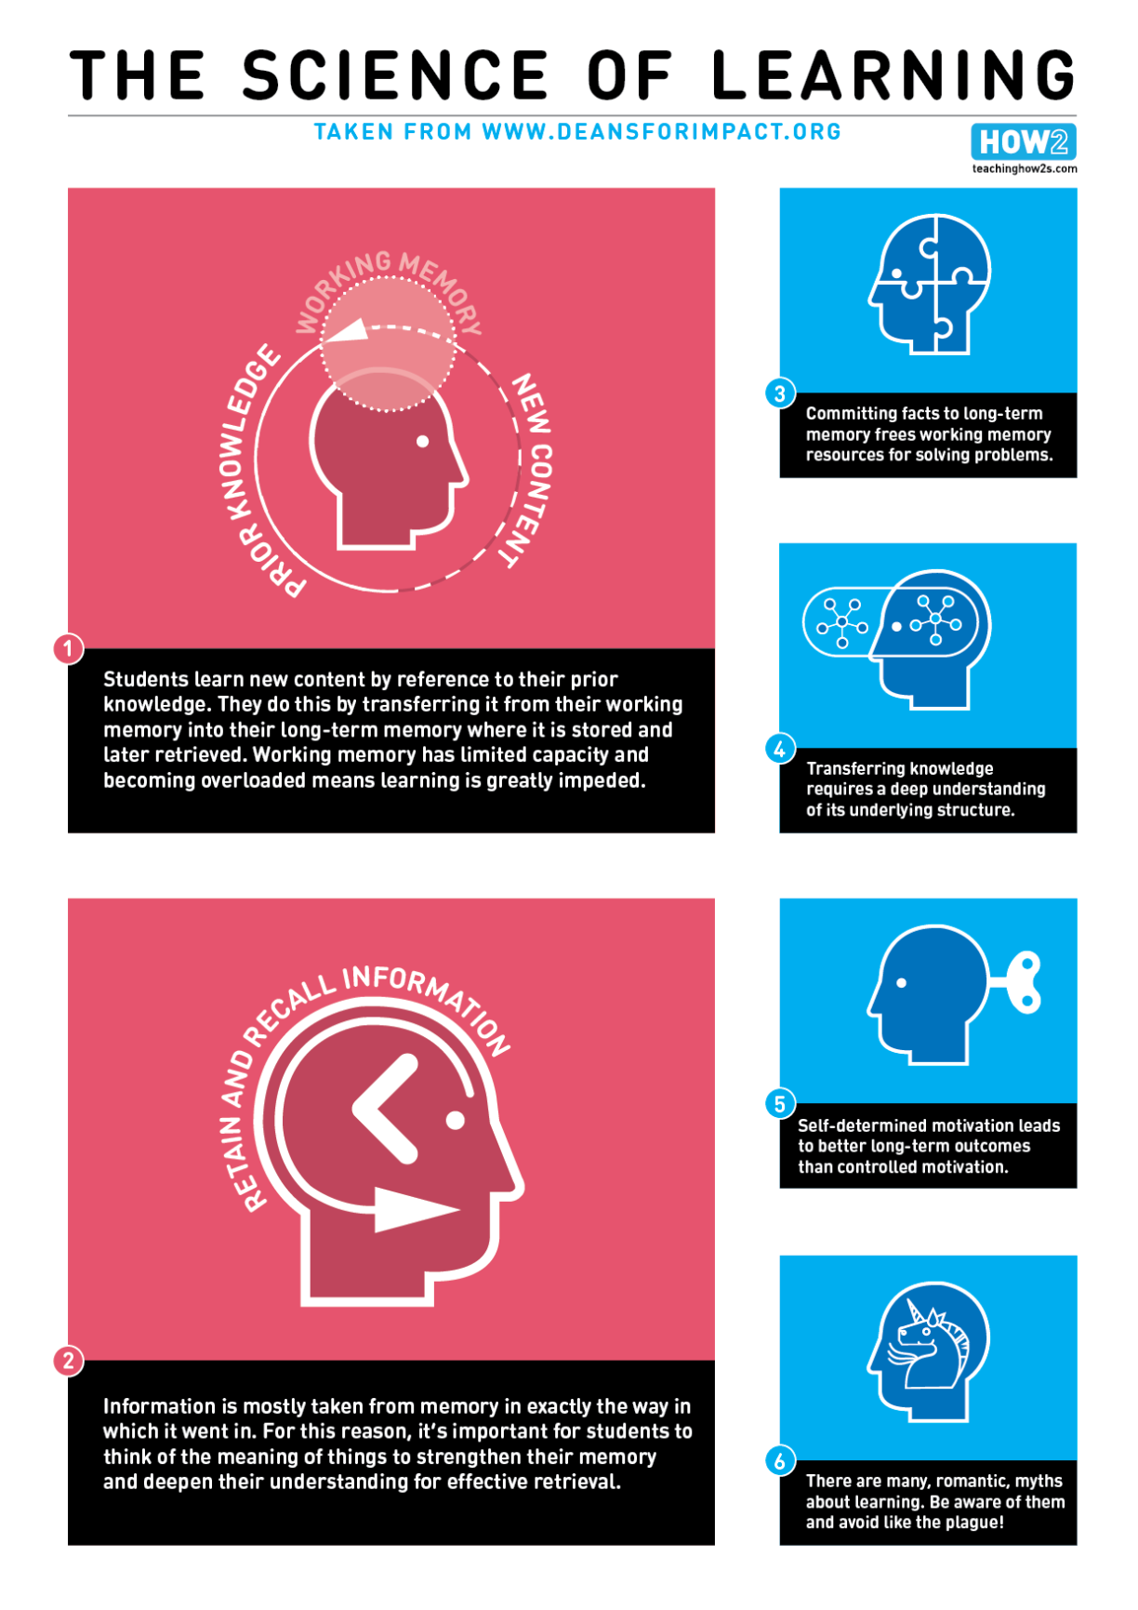
Appendix 6.2
Bitesize Summary: Principles of Instruction
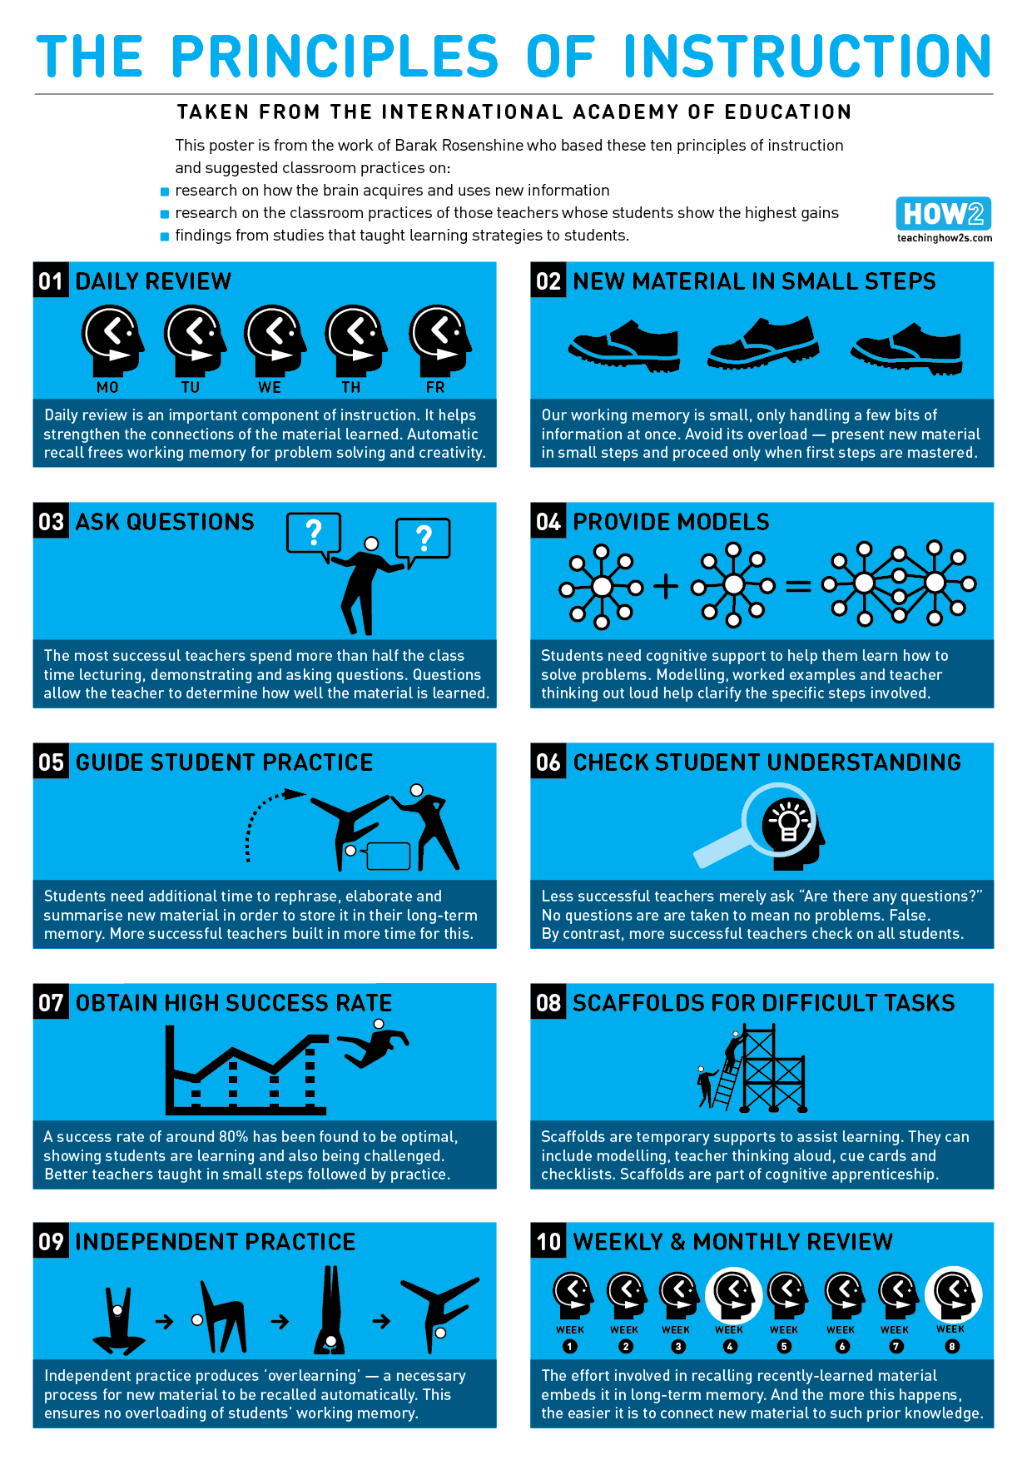
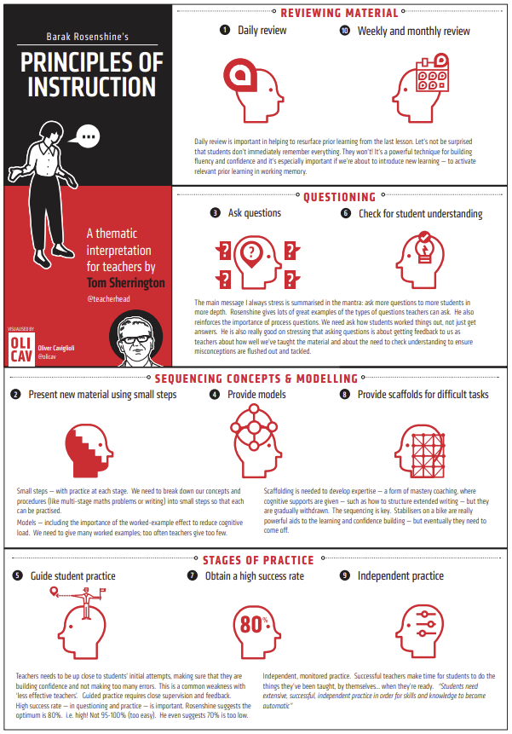
Appendix 6.3
Bitesize Summary: Embedding Formative Assessment
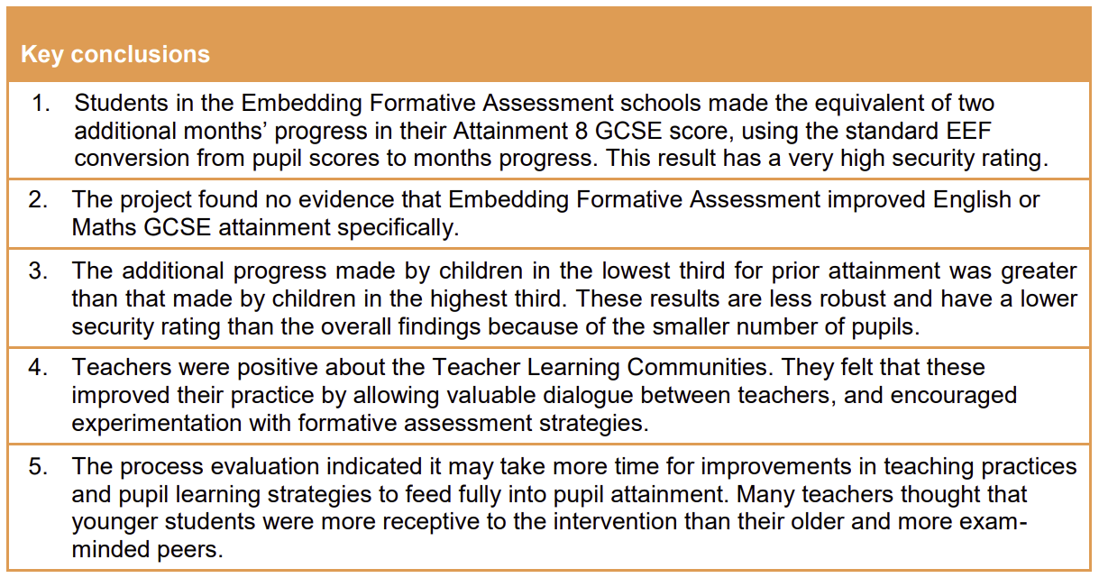

Appendix 6.4
Bitesize Summary: Six Effective Strategies for Learning
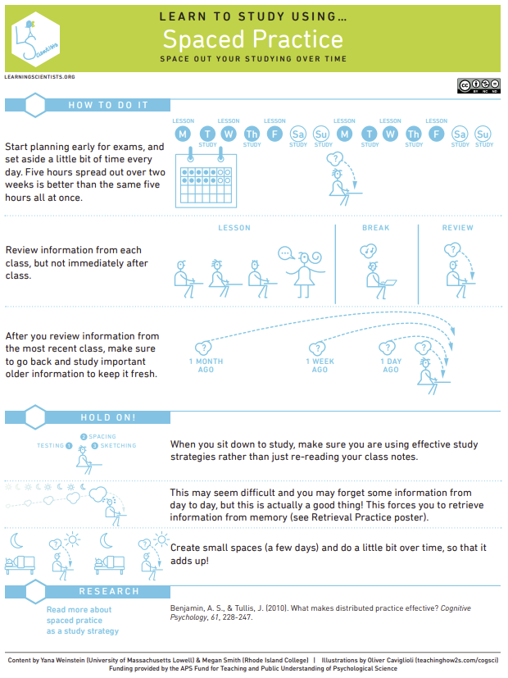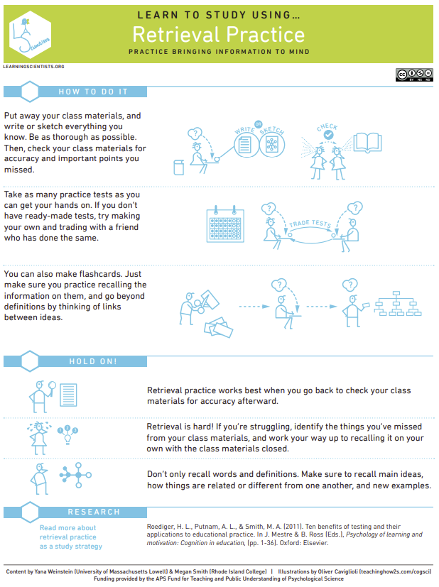
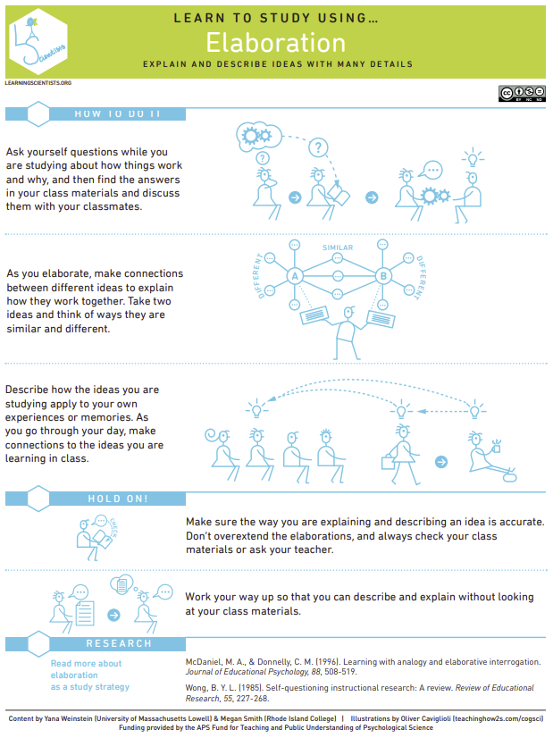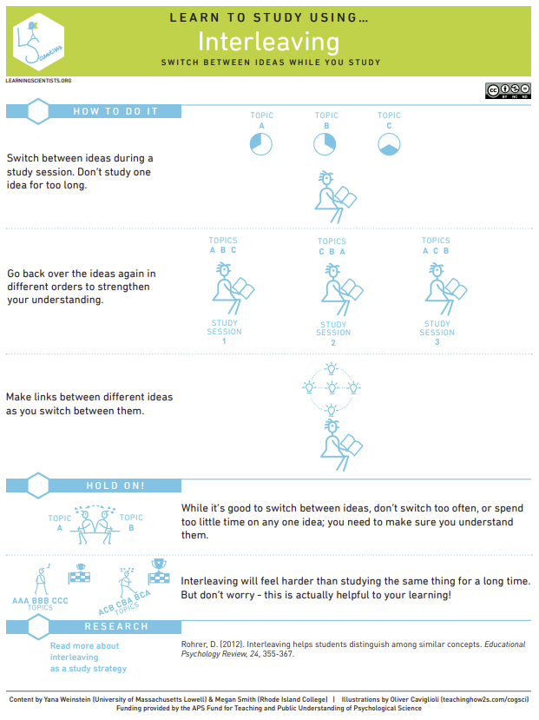
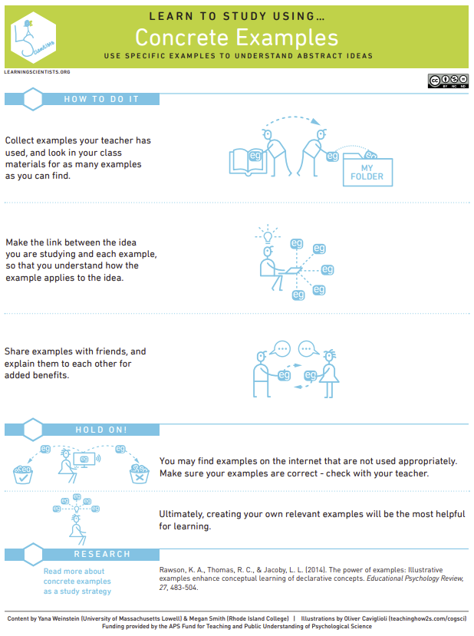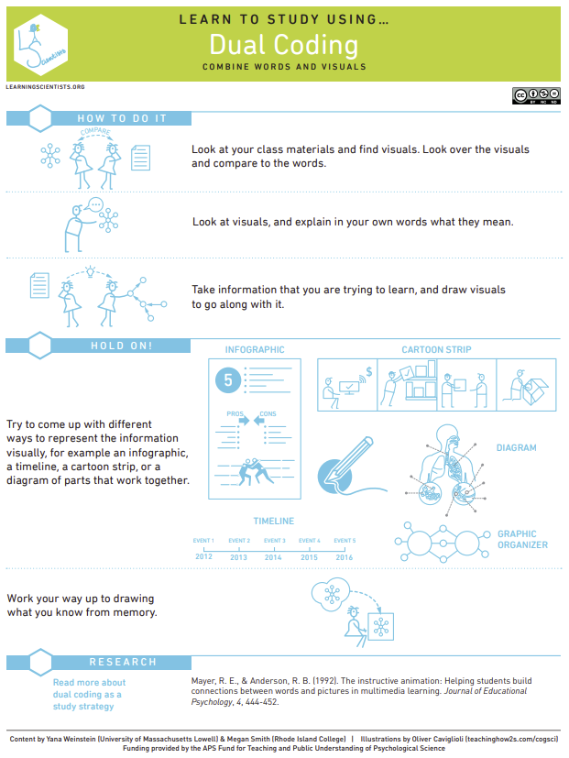
Appendix 6.5
Bitesize Summary: The Beginning Teacher’s Behaviour Toolkit
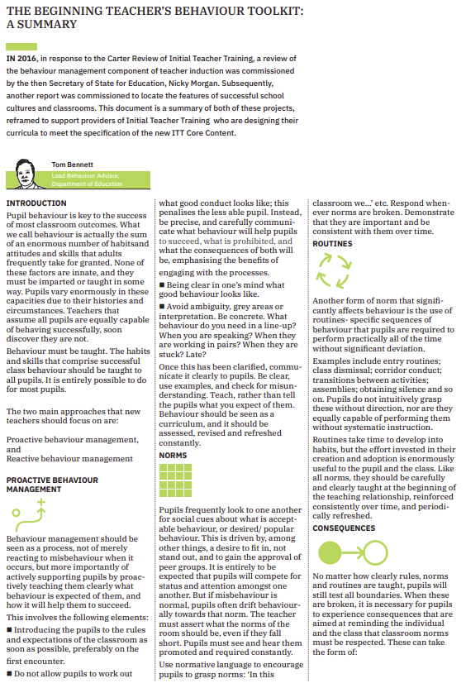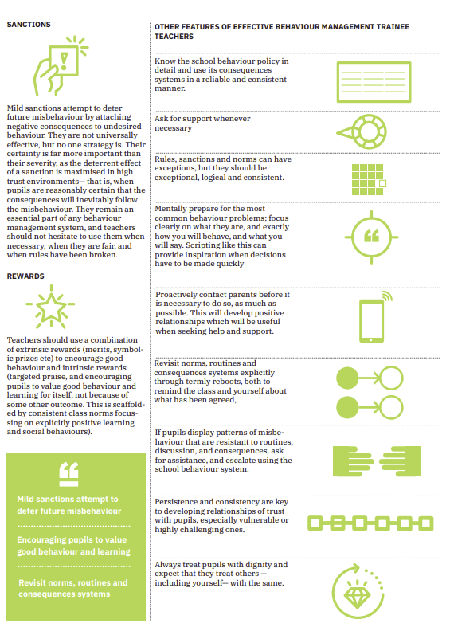
Appendix 6.6
Bitesize Summary: Six Recommendations for Improving Behaviour in Schools
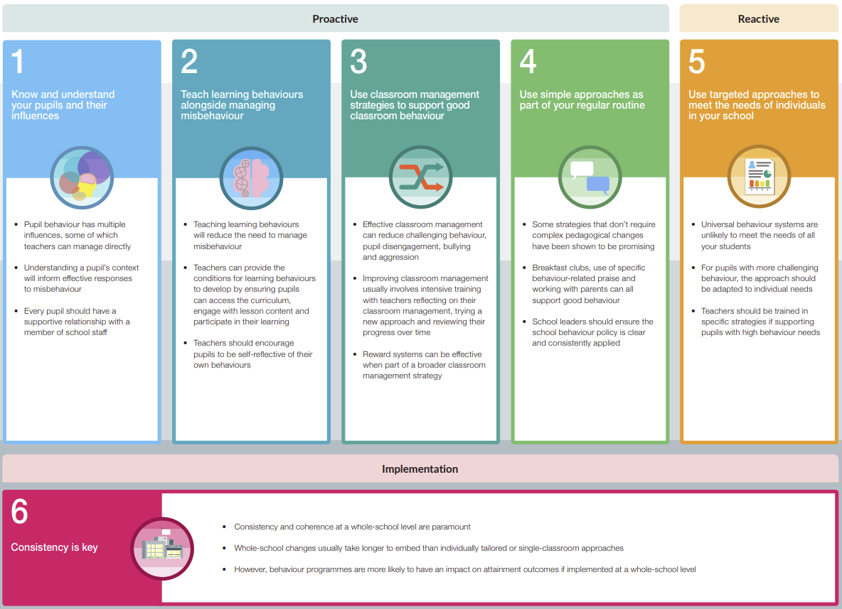
Appendix 7
Trainees are graded against the Teacher’s Standards at final assessment.

