Trainee Progress Report

Trainee | School | Professional Tutor |  |  |  | Mentor
Following consideration of the observations to date and professional discussion with the trainee, identifying their perception of progress, please report and colour code the Trainee’s current PROGRESS with specific reference to the Areas of Focus including your evidence against them.
You may find it useful term on term to use a different colour font to differentiate progress.

Exceeding | Meeting | Within | Towards | Risk of Failure

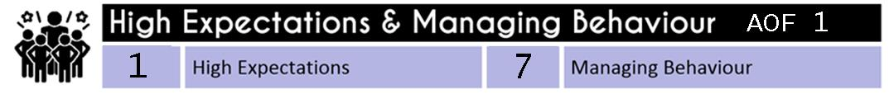 |  |  | Baseline |  |  |  | Autumn  (PLT2) |  | Spring 1  SSP  (PLT3) |  | Spring 2  (PLT4 Interim) | Summer  (PLT5 Final) | PT Signature
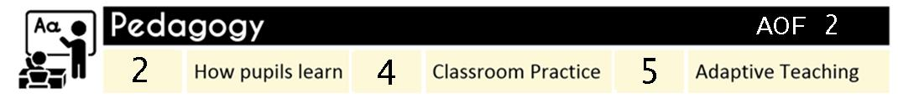 |  |  |  | Baseline |  |  | Autumn  (PLT2) |  | Spring 1  SSP  (PLT3) |  | Spring 2  (PLT4 Interim) | Summer  (PLT5 Final) | PT Signature
 |  |  |  | Baseline |  |  | Autumn  (PLT2) |  | Spring 1  SSP  (PLT3) |  | Spring 2  (PLT4 Interim) | Summer  (PLT5 Final) | PT Signature
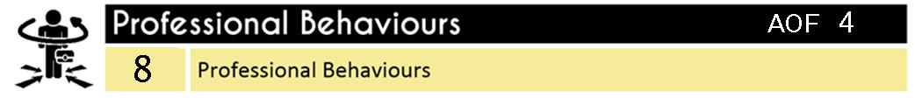 |  |  |  | Baseline |  |  | Autumn  (PLT2) |  | Spring 1  SSP  (PLT3) |  | Spring 2  (PLT4 Interim) | Summer  (PLT5 Final) | PT Signature
 |  |  |  |  | Baseline |  |  | Autumn  (PLT2) |  | Spring 1  SSP  (PLT3) | Spring 2  (PLT4 Interim) | Summer  (PLT5 Final) | PT Signature

Professional Behaviours - Part 2 |  | Baseline | Autumn  (PLT2) | Spring 1  SSP  (PLT3) | Spring 2  (PLT4 Interim) | Summer  (PLT5 Final) | PT Signature
Teachers uphold public trust in the profession and maintain high standards of ethics and behaviour, within and outside school, by:  - treating pupils with dignity, building relationships rooted in mutual respect, and at all times observing proper boundaries appropriate to a teacher’s professional position  - having regard for the need to safeguard pupils’ well-being, in accordance with statutory provisions  - showing tolerance of and respect for the rights of others  - not undermining fundamental British values, including democracy, the rule of law, individual liberty and mutual respect, and tolerance of those with different faiths and beliefs  - ensuring that personal beliefs are not expressed in ways which exploit pupils’ vulnerability or might lead them to break the law.  Teachers must have proper and professional regard for the ethos, policies and practices of the school in which they teach, and maintain high standards in their own attendance and punctuality.  Teachers must have an understanding of, and always act within, the statutory frameworks which set out their professional duties and responsibilities. |  | Met or Not met  (No grading) | Met or Not met  (No grading) | Met or Not met  (No grading) | Met or Not met  (No grading) | Met or Not met  (No grading)

What are your Trainee’s specific strengths?
Are there any concerns? | No | Yes (Please provide details)
Completed by Professional Tutor:
Date:

