Theory into Practice:
- Developing Hard Thinking
- Oracy – Developing Structured Talk
- Effective Questioning

Workbook Dec. ’22 Name ______________________
Ben Newmark
LOVE this. I tell classes early and often this is my signal that they're ready and listening. "Your pen down and your eyes on me is my signal you're ready." I'm performative and *bothered* about EVERYONE doing this. "Just a sec.. Chantelle you still working? Ready? Cheers."

Brightening Lines - Sharpen Routines!

- Clear instructions – all students paying attention to you
- Clear time limit for task
- Students repeat task
- Ask if anyone is still unsure
- Very briefly repeat task and time limit
- Clear “Go” signal
- Scan the room – make it obvious “withitness”
- Praise those who begin straight away
- Anonymously challenge the non-starters

Ben Newmark
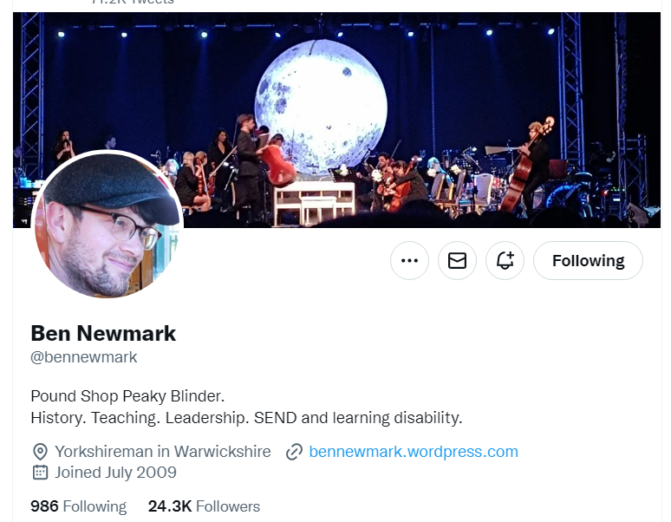
Twitter logo
Nov 25 • 20 tweets • 3 min read
Things that have worked for me…
Part 2.
1. Be iterative and granular about what *exactly* you expect children to do in a lesson. E g what does them listening to you look like? Check for understanding on this the same way you would on something you’d taught.

2. Be obsessive about *all* children doing what you have told them to do in exactly the way you have told them. Don’t let this slip. You can give options on how something is done but then these need to be *your* options. E g “spider diagram or bullet point list.”

3. Check work children have done regularly. Or at very least be seen to check. Look pleased if it’s pleasing. Look disappointed if it is disappointing. Know children well so you can make this judgement accurately.

4. Call and response is great for new words. For all years. Get over the awkwardness and make it part of your teaching. When they say it they feel more confident with it and it’s more likely to appear in their work.

5. Never allow shouting out. Not ever. It can be cute but it’s a wrecking ball and you’ll only understand how damaging after you stop allowing it altogether.

6. Give timings and display them. It doesn’t matter if your timing is a bit out. You can always finish early or add time but showing the time creates a sense of purpose and urgency.

7. Before each lesson know your floor and ceiling. What will all children leave knowing? What will those who learn fastest leave knowing? Both are important but the floor is most important.

8. Before any negative interaction with a child about their work consider what the outcome you want is and whether your words might be more about you than about what’s best for them. Then do it.

9. Give specific praise. Do not give generic praise. Children know this is insincere.

10. When you find yourself exasperated by children not getting something frame it as in interesting problem and lean into it.
11. Develop little micro-scripts like “no talking once you’re in my classroom” and say them so often they sound like ancient laws. Give the same instructions in the same way. Children respond well to this sort of consistency.

12. One Voice in the classroom unless you’ve asked them to talk. No exceptions.

13. For every task you get pupils to do find ways to make them think hard about the right stuff. Eliminate time filler tasks. E g for notetaking insist that students do this without using their resources and then check them. No copying.

14. Make sure you teach what you want children to remember most again and again and again. Test them on it again and again and again.

15. Always have something you’re working on to improve your teaching. One thing is enough. And if you’re in charge of it it’s fun.

16. Have students you are “working on”. This works best if it comes from you – who do you have a hunch could do much better? You can’t do this for all but you can do it for some. And you should.

17. Have an area of your subject you are learning more about. Don’t try to tie this to what you’re teaching next week. This is a perk and it’s for you. Follow your interest. In the end it’ll be a jigsaw piece in a picture you can’t see yet.

18. Give clear feedback kindly when student is just plain wrong. Don’t confuse them with “that’s sort of right.” Say “That isn’t right because..” Then check they’ve got it with a question.

19. Remember that Y7s are really, really small and scared a lot of the time. Make them feel safe.

20. Remember that Y11s are really, really small and scared a lot of the time. Make them feel safe. Remember a that the people you work with are really, really small and scared a lot of the time. Make them feel safe.
TASK
- Highlight 5/6 you find interesting … things you might want to do/ consider or develop even further this year.

- Now distil your list to 4
Number I might develop this by ….
Number I might develop this by ….
Number I might develop this by ….
Number I might develop this by ….

RECALL

Teachers are far more likely to have a positive impact if they..

Revisit…

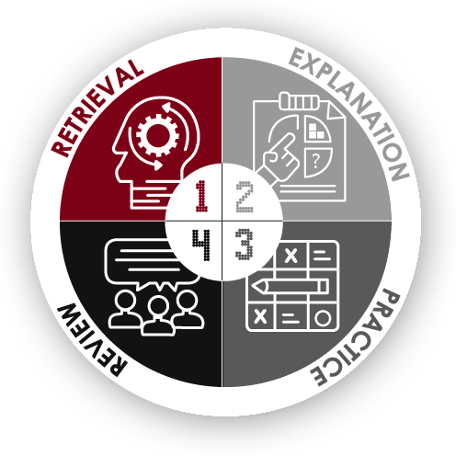

Developing hard thinking

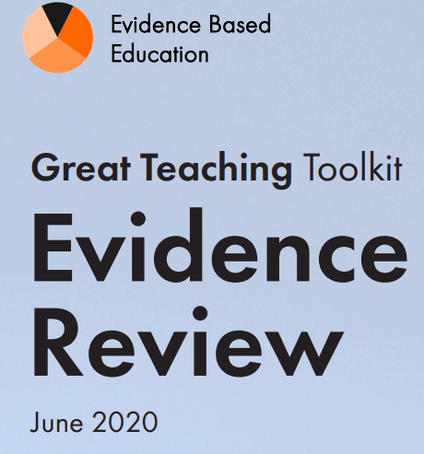
Structuring refers to the choice, matching and sequencing of learning tasks and signalling how they contribute to learning goals. Great teachers share learning aims with their students in ways that help students to understand what success looks like. This does not mean simply writing out lesson objectives or (worse still) getting students to copy them down. Abstract statements of learning aims may be useful but are certainly not enough. To specify learning aims properly, teachers also need to have examples of the kinds of problems, tasks and questions learners will be able to do, as well as examples of work that demonstrates them, with a clear story about how and why each piece of work meets each aim. Great teachers also help students to understand why a particular activity is taking place and how current learning fits into a wider structure. They draw attention to key ideas and signal transitions between activities that focus on different parts of the journey.

A component of structuring is the selection of learning tasks. Tasks must present an appropriate level of difficulty for each student: hard enough to move them forward, but not so hard that they cannot cope, given the existing knowledge and resources they can draw on. Tasks must also promote deep rather than just surface-level thinking (Hattie, 2012), focusing on abstraction, generalisation and the connectedness and flexibility of ideas rather than just reproduction of facts or procedures. In planning a curriculum, tasks must be sequenced so that prerequisite knowledge and skills are accessible and fluent when they are needed. Great teachers build in opportunities for review to check this is the case – and adapt their plans if not.

Great teachers also recognise that complex tasks often require scaffolding: beginning with a simplified or limited version of the task to make it manageable. This often requires some differentiation, as different learners may begin with different levels of readiness and different capacity for learning new material. A knowledge of individual students’ needs, including SEND, comes into play here. However, one of the defining characteristics of great teachers is that they require all students to achieve success (Hattie, 2012). Scaffolding provides a gentler entry, but the destination remains the same. Lower-attainers may take longer and need more help, but the job of teachers is to ‘disrupt the bell curve’, not just to preserve it (Wiliam, 2018). The crucial thing about scaffolding is that you take it away as ideas and procedures become secure and fluent: by the end, those complex tasks are accessible to all.

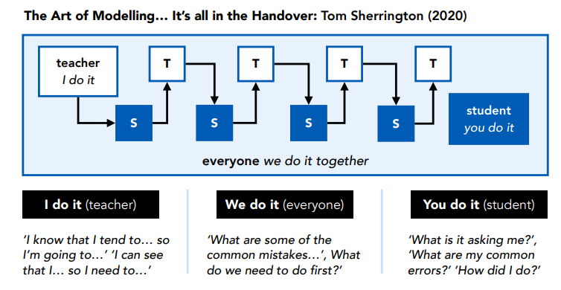

Effective scaffolding increases the chances of pupils experiencing success and improves pupil motivation (Coe et al., 2014).
- Success should be a central guiding principle when deciding whether and when to remove scaffolding as pupil expertise increases.

What does all this mean for me – my context … my subject domain?

Cognitive Load Theory & Developing thinking….

Cognitive load theory is a theory of how human brains learn and store knowledge

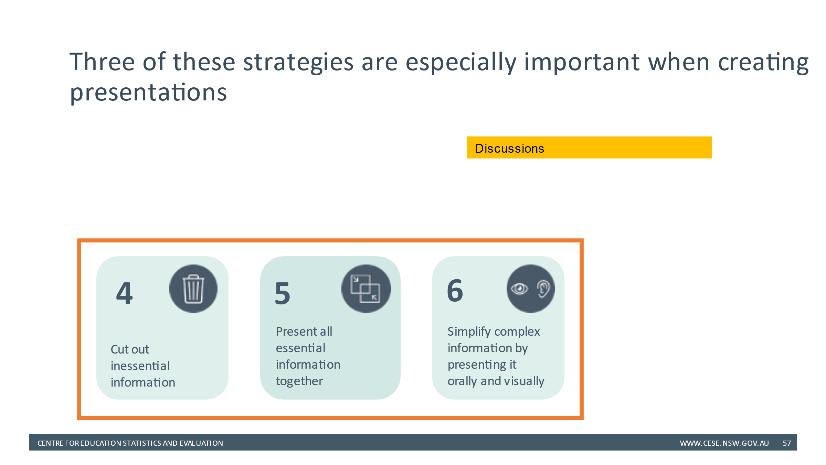

Developing Structured Talk >>>>>

Discussion point:
Our challenge …
If oral language approaches are so important and beneficial –
should we be giving this more attention?

Evidence-Informed Approaches to Classroom Talk:

- Accountable talk

- Dialogic teaching

Practical strategies for developing talk in the classroom

Practical Strategies – discussion point

Developing Effective Questioning >>>

Reframe a question

What does good questioning look like?

Video notes

Discussion point:

- Think Pair Share

- Check for understanding

- Cold Call

Discussion point:
- Mini-white-boards

- MCQs

- Whole class response – ‘choral’

Some principles of effective questioning:
  - Asking lots of questions is good (Rosenshine) … but type and how they are used matters most (Coe)
  - High ratio of participation and inclusive
  - Try to promote/activate student thinking
  - Check thinking, knowledge and understanding in real time – choices ??
  - Insight into student thinking/understanding
  - It should develop oracy / dialogue
  - Questioning skills can be learnt!
  - Questioning has high impact…
The most important things:
- Agree what good questioning looks like
- Shared language / ‘model of good’ - CC, TPS, No Opt Out, Choral Response
- Agree Questioning has high impact – improving teaching
- Discuss a core repertoire of techniques e.g. CC, TPS, No Opt Out, Choral Response
- Everyone is included, everyone is connected, everyone is thinking
- Dynamic, responsive – great teaching!
- Can some techniques become more familiar routines? Change habits e.g. TPS. MWBs… frequent, punchy, productive.
Action steps … e.g. TPS and CC everyday… then discuss, share, collaborate

4 Action steps:

How will you plan for more productive talk?

How will you plan for more effective questioning?

