Secondary Handbook Guidance
for Professional Tutors, Mentors and Trainees

Trainee Name:
Second school placement school:
Second school placement Professional Tutor:
Second school placement Mentor:
Key Information
Mike Shorten: CEO Bishop Hogarth Catholic Education Trust
Monita Atkinson: Director of Carmel Professional Training Centre/Vice Principal (Standards) Carmel College
Monica Shepherd: Director of Teacher Training CTTP
01325 523 460
mshepherd@carmel.bhcet.org.uk
Iain Knox: Primary Lead CTTP
01325 523 460
iknox@carmel.bhcet.org.uk
Lily Bonas: Administration CTTP
01325 523 474
lbonas@carmel.bhcet.org.uk

Core Training Requirements
- Professional Tutor (PT) to monitor and quality assure the trainee experiences and development throughout the training year.
- PT to facilitate opportunities for the Mentors to meet, support and observe their trainees on a weekly basis, as outlined in the School Agreement and Training Handbooks.
- Mentor to meet with their trainee for a minimum of one hour’s training per week to review progress and set weekly targets as outlined in the Training Handbooks.
- Training Handbooks to be used by all schools.
- ITT Core Content Framework to be embedded in all aspects of training (school-based and central) https://www.gov.uk/government/publications/initial-teacher-training-itt-core-content-framework
- Clear links to be drawn between central and school-based training.
- Class teacher (CT) or Mentor to be present in the classroom with the trainee for the first term and in second school placement for the first week as a minimum, unless salaried. CT or Mentor to offer support and feedback both formally and informally.
- Assessment strategies to be included in all curriculum-based training.
- Ongoing reflections and evaluations of training and classroom practice (recorded in Reflective Journals, in lesson evaluations and post-training evaluations).
- Academic study time to be protected.
- PT to check that all documents are completed and signed off before the final PLT visit in May and final file submission.

Training Programme
Spring 1 Overview
CTTP Spiral Curriculum
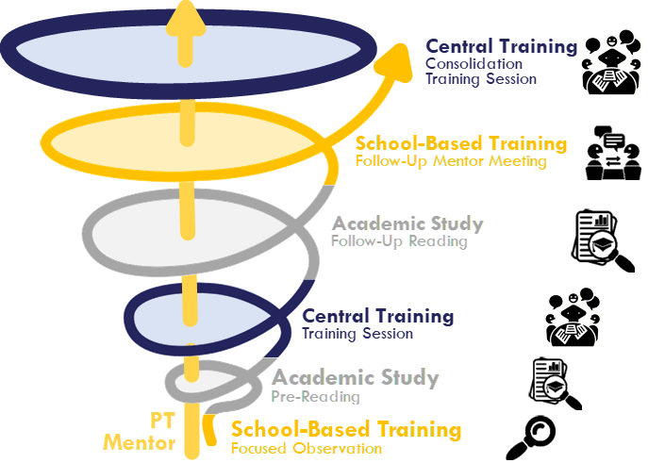
The Role of the Mentor/PT
School-Based Training | - Organise focused observations (joint when possible)  - Review focused observations and deconstruct observed approaches.  - Using PT/Mentor handbook, review central training sessions and discuss academic reading. Review impact of central training on trainee’s Teaching and Learning.  - Rehearse, practise, and give feedback on related skills.
Academic Study | - Protect directed study time (2 hours / week)  - Be aware of and familiar with trainee’s reading list (see bibliography on CTTP Teams VLE).
Central Training | - Be aware of weekly training focus.  - Check training files half-termly.

Training Programme
Spring 1 Overview
Spring 1 Training Schedule

 | Focused Observation  to be conducted by the trainee | Central Training Sessions | Assigned  Reading  Pre-Reading  Follow-up Reading | Focus suggestions for mentor training | Monitoring
Week 15  02/01 | N/A | Behaviour management (2  N.B. This will be e-mailed as a PowerPoint presentation due to varying school holidays. | - Second school placement website, school information, policies etc. | N/A | N/A
Week 16  w/b  09/01 | Adaptive Teaching. | PGCE: Assignment 2 Session 1. | - PGCE Reading | Professional Behaviours (SSP) | Weekly observation PGCE Assignment (2)
Week 17  w/b  16/01 | Behaviour Management | Subject Knowledge Day (3) | - Subject-Specific knowledge and understanding.  - Behaviour Management. | Behaviour Management (SSP)  Subject Knowledge | Joint QA observation
Week 18  w/b  23/01 | Planning for Progress | Subject Knowledge (4) | - Subject-Specific knowledge and understanding.  - Assessment for Learning  - Summative Assessment | Planning for Progress.  Subject Knowledge. | Main Placement Mentor Progress Visit
Week 19  w/b  30/01 | Summative Assessment | Teaching in various “other establishments”: Residential SEND, Pupil Referral Unit, Young Offenders Provision, and a post-16 College | - Making Best use of Teaching Assistants and other staff  - Effective strategies employed in other organisations  - Post-16 education. | Summative Assessment.  Effective working with TA’s and other adults. | PLT3 Window
Week 20  w/b  06/02 | Marking and Feedback. | Philosophy for Children.  Effective Educational Research: Metacognition. | SAPERE materials re. Philosophy for Children.  EEF research on Metacognition. | Stretch and challenge: disadvantaged pupils and social mobility for all.  Marking and Feedback. | PLT3 Window
Week 21  w/b  15/02 | Engaging with the wider curriculum.  Working with parents. | The wider curriculum: ethos, RSE, Citizenship and SMSC (spiritual, moral, social, and cultural education).  Teaching pupils with SEND (2) | The Attainment Gap.  SEND Code of Practice and EEF SEND guidance. | .  Working with parents/  carers (SSP). | Weekly observation  SSP Target Review  PLT3 & Trainee Progress Report

Spring 1 Training Foci (Central Training)
TS1 | TS7 | TS2 | TS4 | TS5 | TS3 | TS6 | TS8
Behaviour Management (2) |  | Teaching Pupils with SEND (2)  Planning for Progress.  Adaptive Teaching.  Metacognition  Stretch and Challenge (3)  Marking and Feedback |  |  | Subject Knowledge (3 and 4) | Assessment for Learning and Summative Assessment. | Effective Research in Education  Working with parents Working with other professionals.

Training Programme
Teaching and Training Schedule
Suggested teaching commitment for this half-term:
(to be progressively built up in the timetable over the half-term)
40% timetable allocation (approx. 6-8 x 60-min. planned and taught lessons / week or equivalent).
Timetable requirements:
2 hours protected Academic Study Time
1 hour protected Mentor Training
KS3 and KS4 experience (and post-16 where applicable)
PLT Visit Window:
Monday 30th January – Friday 10th February 2023 (exc. Thursdays)

Include a focused observation: Adaptive Teaching (Appendices 5.2, 5:5 and 6:5)
Week 16  w/b 09/01/23 | Lesson 1 | Lesson 2 | Lesson 3 | Lesson 4 | Lesson 5
Monday
Tuesday
Wednesday
Thursday | Central Training: PGCE Assignment 2 (Session 2).
Friday

Include a focused observation: Behaviour Management (Appendix 5:1)
Organise a Joint QA Observation (Mentor – PT/CT)
Week 17  w/b 16/01/23 | Lesson 1 | Lesson 2 | Lesson 3 | Lesson 4 | Lesson 5
Monday
Tuesday
Wednesday
Thursday | Subject Knowledge Day (3).
Friday

Include a focused observation: Planning for Progress (Appendices 5:6, 6:1 and 6:2)
Organise Progress Visit & QA Observation by Main Placement Mentor
Week 18  w/b 23/01/23 | Lesson 1 | Lesson 2 | Lesson 3 | Lesson 4 | Lesson 5
Monday
Tuesday
Wednesday
Thursday | Central Training: Subject Knowledge (4)
Friday

Include a focused observation: Summative Assessment (Appendix 5:3)
PLT Visit 3 Window | Week 19  w/b 30/01/23 | Lesson 1 | Lesson 2 | Lesson 3 | Lesson 4 | Lesson 5
 | Monday
 | Tuesday
 | Wednesday
 | Thursday | Central Training: Teaching in other establishments.
 | Friday

Include a focused observation: Marking and Feedback (Appendix 6:3)
PLT Visit 3 Window | Week 20  w/b 06/02/23 | Lesson 1 | Lesson 2 | Lesson 3 | Lesson 4 | Lesson 5
 | Monday
 | Tuesday
 | Wednesday
 | Thursday | Central Training:  Philosophy for Children (am).  Metacognition (pm).
 | Friday

Include a focus: Working with parents (Appendices 5:4 and 6:4).
Week 21  w/b 13/02/23 | Lesson 1 | Lesson 2 | Lesson 3 | Lesson 4 | Lesson 5
Monday
Tuesday
Wednesday
Thursday | Central Training:  The wider curriculum (am).  Teaching pupils with SEND (pm).
Friday

Key Dates

Strategic Board Meeting.
N.B. Board members only.
Monday 09.01.2023
1-2.30pm at CTTP.

PLT (Partnership Link Tutor) Meeting/Training.
Tuesday 17.01.2023
1-3pm at CTTP.

PT (Professional Tutor) Secondary Meeting/Training.
Carmel Cluster:
Wednesday 25.01.2023
2.30 - 4pm CTTP.
Other Lead Schools to arrange meeting/training with their cluster schools
w/b 23.09.2023

Mentor Secondary Meeting/Training.
Carmel Cluster:
Tuesday 07.02.2023
2.30-4pm CTTP
Other Lead Schools to arrange meeting/training with their cluster schools
w/b 06.02.2023

Weekly Training Guidance
Ongoing Weekly Tasks (for Mentor Training)
 | Weekly Tasks: | R
1. Teaching and learning (target review and setting).
Discuss and review trainee’s teaching experience this week and review last targets.
Check Reflective Journal and sign off last session’s targets. Ensure congruence with Training Handbook.
Add review comment and evidence in Training Handbook.
Discuss and agree new targets for the week ahead based on:
- their teaching and learning for that week (lesson observations),
- a discussion regarding key focus for that week as noted in Training Handbook,
Discuss strategies to achieve these and define clear actions and success criteria as well as the support that will be made available to the trainee.
Record the targets in the Training Handbook. The trainee needs to record the same targets in their Reflective Journal AND record notes of their mentor meeting with you.
2. Trainee progress towards Spring Term Gateway 2.
There is an expectation that all trainees will have met the standards within Gateway 2, at least at a minimum level by Easter (PLT 4 visit). Trainees are encouraged to review and annotate this document on a weekly/regular basis with their mentor and/or PT.
Review and discuss this week’s recorded evidence. Ensure it is accurate, relevant, specific, and dated.
If your trainee is struggling to meet the standards at a minimum level, please notify the Central CTTP team and highlight your cause for concern.
3. Impact and outcomes of central training.
Discuss with trainee the impact and outcomes of their central training.
Agree with the trainee how to consolidate and continue training in school.
4. Student progress tracking.
Support trainee to track, evaluate and evidence the impact of their teaching on student progress and learning over time.
The trainee is required to select a minimum of 3 students who display a range of ability, educational needs and language differences and track, over the half term, their academic progression through assessment. They will need to evaluate and evidence the impact of their teaching on student progress and learning over time. Over the period of tracking the trainee is to identify the barriers to learning and critically evaluate in their Reflective Journal strategies to overcome these.
Advise ‘how’ to track the students and encourage the trainee to speak to the class teacher, plus additional adults such as learning support assistants/ teaching assistants who may also be supporting the student.
5. Wellbeing and workload.
Discuss wellbeing, time, and workload management with trainee.
Consider the trainees workload overall – lesson planning and teaching, academic study, and strategies to manage a work /life balance.

Trainee Week 15
SSP preparation
From Thursday 05/01/23

¨
Focus: Professional Behaviours - Second School Placement Familiarisation.
Trainee to familiarise themselves at the end of term/ start of term, Christmas break etc. with:
λ Staffing: staff structure and staff responsibilities.
λ The curriculum and timetable including classes to be taught.
λ Special Educational Needs - school context re: number of pupils on SEND register and school provision.
λ Resources available and access arrangements.
λ School routines.
λ Professional expectations - as a class teacher, a team member /colleague, dress code.
λ Familiarise themselves with school / classes info.
λ Find out about the structure of staffing within the school and their responsibilities which will help answer the question: ‘Who do I go to for /if …?’

Assigned Reading
λ Website, school/departmental information, organisational information, policies etc.

Notes:

Targets Week 16
Week commencing 09/01/23
Discuss targets agreed by Trainee and Main Placement Mentor at the end of Autumn 2.
CTTP consider that the quality of trainee’s teaching should be judged by the impact on student progress and learning over time.
Target 1 Focus on maximising impact of teaching on student progress.
Actions and support to access target | Success criteria | CCF
Review comment | Evidence

Target 2 Focus on teaching and learning.
Actions and support to access target | Success criteria | CCF
Review comment | Evidence

Target 3
Actions and support to access target | Success criteria | CCF
Review comment | Evidence

Training Week 16
Week commencing 09/01/23
Professional Tutor/Mentor

To Do This Week | $
Weekly tasks:
​​☐​ Review the On-going Evidence Record Spring Term Gateway 2.
If your trainee is struggling to meet the standards at a minimum level, please notify the Central CTTP team and highlight your cause for concern.
​​☐​ Discuss wider reading/writing carried out this week.
How does their study relate to and impact on their practice? Remind trainee that they have access to all online library resources through Leeds Trinity University, Chartered College (via LTU) and Carmel Learning Resource Centre.
1. School information and organisation for trainee as they start their SSP.
​​☐​ Discuss with trainee:
The school
- The catchment area / school context;
- Ofsted Report and School Prospectus;
- Classes within the school and year structures;
- Health and Safety information- procedures: fire, accident, injury, and security;
- Safeguarding and Child Protection policies and procedures /child welfare;
- Professional expectations – teachers standards.
The classes
- General information: daily organisation and routines, school resources, website, access to computers etc.
- The teaching timetable and why it is organised as it is;
- Administrative routines and tasks for example, marking the attendance register, letters from parents, notes for other staff.
The wider life of the school and professional values
- Extra-curricular activities, such as, clubs, teams, and any links with the local community;
- The school’s expectations of staff to be fully involved in the life of the school.
​​☐​ Direct trainee to:
- Read the most recent OFSTED report;
- Spend some time familiarising themselves with the school and meeting the staff;
- Consider the focus of observations in classes and complete the relevant focused observations (see appendices).
2. Second School Placement Targets
​​☐​ Share and discuss the trainee’s SSP targets and the success criteria to meet these.

Targets Week 17
Week commencing 16/01/23
CTTP consider that the quality of trainee’s teaching should be judged by the impact on student progress and learning over time.

Target 1 Focus on maximising impact of teaching on student progress.
Actions and support to access target | Success criteria | CCF
Review comment | Evidence

Target 2 (Focus on teaching and learning)
Actions and support to access target | Success criteria | CCF
Review comment | Evidence

Target 3
Actions and support to access target | Success criteria | CCF
Review comment | Evidence

Training Week 17
Week commencing 16/01/23
Professional Tutor

To Do This Week | $
R Weekly Tasks:
​​☐​ Review the On-going Trainee Evidence Record Spring Term Gateway 2.
If your trainee is struggling to meet the standards at a minimum level, please notify the Central CTTP team and highlight your cause for concern.
​​☐​ Discuss wider reading/writing carried out this week.
How does their study relate to and impact on their practice? Remind trainee that they have access to all online library resources through Leeds Trinity University, Chartered College (via LTU) and Carmel Learning Resource Centre.

Training Week 17
Week commencing 16/01/23
Mentor

This Week’s Training Focus
Either…

Personalised Training Focus  Based on trainee’s Initial Needs Analysis, Subject Audits, and emerging needs. | ¨
Training Focus: Refer to Individual Training Plan
Notes:

Or…

Suggested Training Focus | ¨
Focus: Adaptive teaching and effective deployment of TA’s.
Deconstruct with trainee the various approaches they have observed last term, and this linked to adaptive teaching (Appendices 5:2, 5:5 and 6:5).
Discuss Impact of Central Training from previous term on Teaching Pupils with SEND and PGCE Training on Supporting Individual Needs and identify future training needs in this area and record.
Discuss with trainee:
λ The effective deployment of, and planning for, Learning Support Assistants and Teaching Assistants.
λ That teaching assistants (TAs) can support pupils more effectively when they are prepared for lessons by teachers, and when TAs supplement rather than replace support from teachers.
λ How to develop an understanding of students’ needs by:
λ Working closely with the Special Educational Needs Co-ordinator (SENDCo) and special education professionals and the Designated Safeguarding Lead (DSL) under supervision of expert colleagues.
λ How to provide opportunity for all students to experience success by:
λ Making effective use of teaching assistants and other adults in the classroom under supervision of expert colleagues.
λ Build effective working relationships, by:
λ Sharing the intended lesson outcomes with teaching assistants ahead of lessons.
λ Ensuring that support provided by teaching assistants in lessons is additional to, rather than a replacement for, support from the teacher.
λ Preparing teaching assistants for lessons under supervision of expert colleagues.
Direct trainee to:
λ Read their classes’ SEND information.
λ Arrange a meeting with the SSP SENDCo.
λ Following the focused observation in Week 17 (Appendix 5.3), plan a lesson which deploys the Class Teacher as a TA, including the relevant information in the lesson plan.

Assigned Reading
λ Pre-Reading: Making Best Use of Teaching Assistants: Summary of Recommendations, EEF, 2018
https://educationendowmentfoundation.org.uk/public/files/Publications/Teaching_Assistants/TA_RecommendationsSummary.pdf
Bitesize Summary in Appendix 6.5.
λ Follow-Up Reading: Teaching Strategies and Approaches for Students with Special Educational Needs (selected passages), Davis et al., 2004
http://dera.ioe.ac.uk/6059/1/RR516.pdf

Notes:

To Do This Week
R Weekly Tasks: (full guidance on page 12)
​​☐​ Teaching and learning (target review and setting).
​​☐​ Review evidence record - Spring Term Gateway 2.
​​☐​ Discuss the impact and outcomes of central training.
​​☐​ Discuss student progress tracking.
​​☐​ Discuss well-being and workload.
1. Quality assurance – Joint Observation Mentor/Class Teacher or Mentor/PT
​​☐​ Organise a Joint Observation with a Class Teacher or Professional Tutor to be carried out in Week 17.

2. Focused Observation: Adaptive Teaching (Appendix 5.2)
​​☐​ Organise for the trainee to observe in Week 21 (jointly with mentor if possible) a lesson or part of a lesson in which an expert colleague will demonstrate the use of a range of adaptive teaching strategies and scaffolds to personalise learning and allow all students, including students with SEND to access the learning, be stretched, and challenged and make good progress.

Notes:

Targets Week 17
Week commencing 16/01/23
CTTP consider that the quality of trainee’s teaching should be judged by the impact on student progress and learning over time.
Target 1 (Focus on maximising impact of teaching on students’ progress)
Actions and support to access target | Success criteria | Related TS
Review comment | Evidence

Target 2 (Focus on teaching and learning)
Actions and support to access target | Success criteria | Related TS
Review comment | Evidence

Target 3
Actions and support to access target | Success criteria | Related TS
Review comment | Evidence

Training Week 17
Week commencing 16/01/23
Professional Tutor

To Do This Week | $
R Weekly Tasks:
​​☐​ Review the On-going Trainee Standards’ Evidence Record Spring Term Gateway 2.
If your trainee is struggling to meet the standards at a minimum level, please notify the Central CTTP team and highlight your cause for concern.
​​☐​ Discuss wider reading/writing carried out this week.
How does their study relate to and impact on their practice? Remind trainee that they have access to all online library resources through Leeds Trinity University, Chartered College via LTU and Carmel Learning Resource Centre.
1. SSP Preparation for PLT 3 Visit (continued)
​​☐​ Look out for an email from your Partnership Link Tutor who will contact you to arrange a visit. Internal quality assurance: carry out a joint observation of the trainee with the mentor beforehand.
​​☐​ Liaise with the mentor and check the list of documentation required for the PLT visit are completed prior to the meeting.
​​☐​ Meet with the mentor to review progress in meeting second school placement targets and to agree next steps. Complete the Final Review document of SSP Targets. This information will feed into the trainee’s SSP Progress Report.
​​☐​ Mentor to complete the trainee SSP Progress Report before the PLT meeting and share this with your trainee prior to the PLT 3 meeting. PT and Mentor need to agree Gateway 2 assessment.
​​☐​ Trainee to update online files and bring physical files along to the meeting to review prior to PLT meeting - are they organised? Check all trainee files are up to date, with matrix.
​​☐​ Check with the trainee, their on-going evidence record Spring Term Gateway 2 document is up to date.
​​☐​ Review trainee’s audits.
​​☐​ Agree who will do the joint observation with the PLT- you or the Mentor?

2. Wellbeing and Workload
​​☐​ Consider the trainees workload overall - lesson planning and teaching, academic study, and a pending PLT visit! (Work-life balance)

Training Week 17
Week commencing 16/01/23
Mentor

This Week’s Training Focus
Either…

Personalised Training Focus  Based on trainee’s Initial Needs Analysis, Subject Audits, and emerging needs. | ¨
Training Focus: Refer to Individual Training Plan
Notes:

Or…

Suggested Training Focus | ¨
Focus: Planning for Progress.
Review Focused Observation on Planning for Progress (Appendix 5.6, 6:1 and 6:2) and deconstruct with trainee the various approaches they have observed.
Discuss Impact of PGCE Training from Week 17 on Planning for Progression and identify future training needs in this area and record in ITP.
Discuss with trainee:
λ How to effectively plan for progress in your subject area.
λ How regular purposeful practice of what has previously been taught can help consolidate material and help pupils remember what they have learned.
λ Requiring pupils to retrieve information from memory, and spacing practice so that pupils revisit ideas after a gap are also likely to strengthen recall.
λ How worked examples that take pupils through each step of a new process are also likely to support pupils to learn.
λ How ensuring pupils master foundational concepts and knowledge before moving on is likely to build pupils’ confidence and help them succeed.
λ How pupils learn new ideas by linking those ideas to existing knowledge, organising this knowledge into increasingly complex mental models (or “schemata”); carefully sequencing teaching to facilitate this process is important.
λ How to Support pupils to build increasingly complex mental models, by:
λ Revisiting the big ideas of the subject over time and teach key concepts through a range of examples.
λ Balancing exposition, repetition, practice of critical skills and knowledge.
λ Drawing explicit links between new content and the core concepts and principles in the subject.
λ Develop fluency, by:
λ Using retrieval and spaced practice to build automatic recall of key knowledge and deconstructing this approach.
λ Providing tasks that support pupils to learn key ideas securely (e.g., quizzing pupils so they develop fluency with times tables).
Direct trainee to:
λ Read the school’s Teaching & Learning policy and consider similarities and differences with their main placement in their reflective journal.
Suggested Reading
λ Putting Students on the Path to Learning: The Case for Fully Guided Instruction, R.E. Clark, P. Kirschner, J. Sweller, 2012
https://www.aft.org/sites/default/files/periodicals/Clark.pdf
Bitesize Summary in Appendix 6.1.
λ What Works Best: 2020 Update Chapter 2: Explicit Teaching (pp. 11-15), Centre for Education Statistics and Evaluation, 2020
https://www.cese.nsw.gov.au/images/stories/PDF/What-works-best-2020-update.pdf

Notes:

To Do This Week | $
R Weekly Tasks: (full guidance on page 12)
​​☐​ Teaching and Learning (target review and setting).
​​☐​ Review the on-going evidence record Spring Term Gateway 2.
​​☐​ Discuss the impact and outcomes of Central Training.
​​☐​ Discuss Student Progress Tracking.
​​☐​ Discuss well-being and workload.
1. Complete Trainee Progress Report
​​☐​ Complete Trainee Progress Report, including specific evidence to support your comments, and the assessment for each section. Send it to your Professional Tutor.
Use the descriptors to support your comments and grading. Ensure that grading reflects the content of the Lesson Observation Matrix.
Discuss the content of the report with your trainee, incl. areas of concern. There should not be any surprises.
Do not share grading before it has been moderated by your Professional Tutor.

2. SSP Preparation for PLT 3 Visit (Continued)
​​☐​ Ensure all online/physical files and documents are completed and ready for PLT 3 meeting.
​​☐​ Check evidence files in preparation for PLT 3 meeting - are they organised and has Matrix been completed ready for the PLT to sign off?
​​☐​ Check trainee’s progress against Gateway 2 within on-going evidence Record Spring Term Gateway 2 document.
​​☐​ Review Trainees audits.
​​☐​ Review trainee’s progress in achieving their SSP targets and following discussion with the PT, complete the Final Review document of SSP Targets. This information will feed into the trainee’s SSP TPR.
​​☐​ Complete and share the Trainee Progress Report with trainees prior to the PLT 3 meeting.
​​☐​ Check which class trainees are going to teach for the PLT visit and what resources they will need. Look at lesson planning together and what the trainee intends to teach for the PLT visit. Trainee should have brought some ideas with them.

3. Quality assurance – Main Placement Mentor Progress Visit
​​☐​ Carry out joint QA observation with Main Placement Mentor.

4. Focused Observation: Effective Deployment of TAs (Appendix 5.5)
​​☐​ Organise for the trainee to observe in Week 19 (jointly with mentor if possible) a lesson or part of a lesson in which a Teaching Assistant is effectively deployed and direct trainee to use their Focused Observation handbook for aspects to consider.

Notes:

Targets Week 18
Week commencing 23/01/23

CTTP consider that the quality of trainee’s teaching should be judged by the impact on student progress and learning over time.

Target 1 (Focus on maximising impact of teaching on students’ progress)
Actions and Support to access Target | Success Criteria | Related TS
Review comment | Evidence

Target 2 (Focus on teaching and learning)
Actions and Support to access Target | Success Criteria | Related TS
Review comment | Evidence

Target 3
Actions and Support to access Target | Success Criteria | Related TS
Review comment | Evidence

Training Week 18
Week commencing 23/01/23
Professional Tutor

To Do This Week | $
R Weekly Tasks:
​​☐​ Review the On-going Trainee Standards’ Evidence Record Spring Term Gateway 2.
If your trainee is struggling to meet the standards at a minimum level, please notify the Central CTTP team and highlight your cause for concern.
​​☐​ Discuss wider reading/writing carried out this week.
How does their study relate to and impact on their practice? Remind trainee that they have access to all online library resources through Leeds Trinity University, Chartered College via LTU and Carmel Learning Resource Centre.
1. Verify and send Trainee Progress Report (TPR)
​​☐​ Check the Trainee Progress Report sent by the trainee’s mentor and moderate their grading. Send a copy of the moderated report to CTTP (thonnartm@carmel.bhcet.org.uk), the trainee’s Partnership Link Tutor, their Mentor, and the trainee.
If areas of concern are identified, contact CTTP to discuss additional support required.

Training Week 18
Week commencing 23/01/23
Mentor

This Week’s Training Focus
Either…

Personalised Training Focus  Based on trainee’s Initial Needs Analysis, Subject Audits, and emerging needs. | ¨
Training Focus: Refer to Individual Training Plan
Notes:

Or…

Suggested Training Focus | ¨
Focus: Summative Assessment.
Review (Appendix 5.4i) and deconstruct with trainee the various approaches they have observed linked to Assessment for Learning.
Discuss Impact of Central Training Assessment and relevant Subject-Knowledge Training and identify future training needs in this area and record.
Discuss with trainee:
λ The role of summative assessment so they are clear about the decision it will be used to support.
λ How good and effective assessment helps teachers avoid being over-influenced by potentially misleading factors, such as how busy pupils appear, and is critical to teaching because it provides teachers with information about pupils’ understanding and needs.
λ A range of techniques for summative assessment.
λ The school’s tracking system (grades, levels, descriptors, etc.) and how they are implemented within the departmental scheme of work.
λ Data input and data tracking.
λ How to draw conclusions about what pupils have learned by looking at patterns of performance over a number of assessments.
λ How to prepare students for their assessment by designing knowledge organisers or by planning purposeful revision lessons and independent tasks.
λ How to choose, where possible, externally validated materials, used in controlled conditions when required to make summative assessments.
Direct trainee to:
λ Read the school Assessment Policy.
λ Design with support a mock summative assessment task to be used to help students consolidate their learning prior to actual summative assessments.
Suggested Reading
λ What Works Best: 2020 Update Chapter 4: Use of Data to Inform Practice (pp. 20-23), Chapter 5: Assessment (pp. 24-28), Centre for Education Statistics and Evaluation, 2020
https://www.cese.nsw.gov.au/images/stories/PDF/What-works-best-2020-update.pdf

Notes:

To Do This Week | $
R Weekly Tasks: (full guidance on page 12)
​​☐​ Teaching and Learning (target review and setting).
​​☐​ Review the on-going evidence Record Spring Term Gateway 2.
​​☐​ Discuss the impact and outcomes of Central Training.
​​☐​ Discuss Student Progress Tracking.
​​☐​ Discuss well-being and workload.
1. Focused Observation: Disadvantaged Pupils (Appendix 5.6)
​​☐​ Organise for the trainee to observe in Week 20 (jointly with mentor if possible) a lesson or part of a lesson in which an expert colleague will demonstrate the use of a range of stretch and challenge strategies to ensure all students, including disadvantaged pupils, make good progress.

Notes:

Targets Week 19
Week commencing 30/01/23

CTTP consider that the quality of trainee’s teaching should be judged by the impact on student progress and learning over time.

Target 1 (Focus on maximising impact of teaching on students’ progress)
Actions and Support to access Target | Success Criteria | Related TS
Review comment | Evidence

Target 2 (Focus on teaching and learning)
Actions and Support to access Target | Success Criteria | Related TS
Review comment | Evidence

Target 3
Actions and Support to access Target | Success Criteria | Related TS
Review comment | Evidence

Training Week 19
Week commencing 30/01/23

Professional Tutor

To Do This Week | $
R Weekly Tasks:
​​☐​ Review the on-going evidence Record Spring Term Gateway 2.
If your trainee is struggling to meet the standards at a minimum level, please notify the Central CTTP team and highlight your cause for concern.
​​☐​ Discuss wider reading/writing carried out this week.
How does their study relate to and impact on their practice? Remind trainee that they have access to all online library resources through Leeds Trinity University, Chartered College via LTU and Carmel Learning Resource Centre.

Training Week 19
Week commencing 30/01/23
Mentor

This Week’s Training Focus
Either…

Personalised Training Focus  Based on trainee’s Initial Needs Analysis, Subject Audits, and emerging needs. | ¨
Training Focus: Refer to Individual Training Plan
Notes:

Or…

Suggested Training Focus | ¨
Focus: Marking and feedback.
Discuss Impact of Central Training on Assessment Strategies and identify future training needs in this area and record in ITP.
Discuss with trainee:
λ The impact of quality marking and opportunities for students to respond to feedback on student progress. How does this inform future lesson planning?
λ Strategies to allow students to ‘respond’ to feedback.
λ When and how to differentiate feedback.
λ That high-quality feedback can be written or verbal; it is likely to be accurate and clear, encourage further effort, and provide specific guidance on how to improve.
λ That over time, feedback should support pupils to monitor and regulate their own learning.
λ How to provide high-quality feedback by:
λ Discussing how students’ responses to feedback can vary depending on a range of social factors e.g., the message the feedback contains or the age of the child.
λ Scaffolding self-assessment by sharing model work with students, highlighting key details.
λ Ensuring feedback is specific and helpful when using peer- or self-assessment.
λ Focusing on specific actions for students and providing time for students to respond to feedback.
λ How to make marking manageable and effective by:
λ Recording data only when it is useful for improving student outcomes.
λ Developing an understanding that written marking is only one form of feedback.
λ Identifying efficient approaches to marking and alternative approaches to providing feedback (e.g., using whole class feedback or well supported peer- and self-assessment).
λ Using verbal feedback during lessons in place of written feedback after lessons where possible.
λ Reducing the opportunity cost of marking (e.g., by using abbreviations and codes in written feedback).
λ Prioritising the highlighting of errors related to misunderstandings, rather than careless mistakes when marking.

Direct trainee to:
λ Read the school and departmental marking policy.
λ Analyse, with support of mentor, examples of good practice, including peer- and self-assessment.
λ Mark with support a set of books and plan a follow-up lesson which will allow students to act on the feedback and reflect on their progress and future learning.
λ Consider throughout the coming week the impact of their marking and feedback on pupil progress.

Suggested Reading
λ A Marked Improvement? Education Endowment Foundation
https://educationendowmentfoundation.org.uk/public/files/Presentations/Publications/EEF_Marking_Review_April_2016.pdf
λ Teacher Feedback to Improve Pupil Learning: Six Recommendations for Using Teacher Feedback to Improve Pupil Learning, Education Endowment Foundation, 2021
https://educationendowmentfoundation.org.uk/education-evidence/guidance-reports/feedback
Bitesize Summary in Appendix 6.3.
λ What Works Best: 2020 Update Chapter 3: Effective Feedback (pp. 16-19), Centre for Education Statistics and Evaluation, 2020
https://www.cese.nsw.gov.au/images/stories/PDF/What-works-best-2020-update.pdf

Notes:

To Do This Week | $
R Weekly Tasks: (full guidance on page 12)
​​☐​ Teaching and Learning (target review and setting).
​​☐​ Review the on-going evidence Record Spring Term Gateway 2.
​​☐​ Discuss the impact and outcomes of Central Training.
​​☐​ Discuss Student Progress Tracking.
​​☐​ Discuss well-being and workload.
2. Focused Observation: Assessment for Learning (Appendix 5.7)
​​☐​ Organise for the trainee to observe in Week 21 (jointly with mentor if possible) a lesson or part of a lesson in which an expert colleague will demonstrate a range of Assessment for Learning strategies.

Notes:

Targets Week 20
Week commencing 07/02/22

CTTP consider that the quality of trainee’s teaching should be judged by the impact on student progress and learning over time.

Target 1 (Focus on maximising impact of teaching on students’ progress)
Actions and Support to access Target | Success Criteria | Related TS
Review comment | Evidence

Target 2 (Focus on teaching and learning)
Actions and Support to access Target | Success Criteria | Related TS
Review comment | Evidence

Target 3
Actions and Support to access Target | Success Criteria | Related TS
Review comment | Evidence

Training Week 20
Week commencing 07/02/22

Professional Tutor

To Do This Week | $
R Weekly Tasks:
​​☐​ Review the On-going Trainee Standards’ Evidence Record Spring Term Gateway 2.
If your trainee is struggling to meet the standards at a minimum level, please notify the Central CTTP team and highlight your cause for concern.
​​☐​ Discuss wider reading/writing carried out this week.
How does their study relate to and impact on their practice? Remind trainee that they have access to all online library resources through Leeds Trinity University, Chartered College via LTU and Carmel Learning Resource Centre.

Training Week 20
Week commencing 07/02/22
Mentor

This Week’s Training Focus
Either…

Personalised Training Focus  Based on trainee’s Initial Needs Analysis, Subject Audits, and emerging needs. | ¨
Training Focus: Refer to Individual Training Plan
Notes:

Or…

Suggested Training Focus | ¨
Focus: Marking and feedback.
Discuss Impact of Central Training from Week 3 on Assessment Strategies and identify future training needs in this area and record in ITP.
Discuss with trainee:
λ The impact of quality marking and opportunities for students to respond to feedback on student progress. How does this inform future lesson planning?
λ Strategies to allow students to ‘respond’ to feedback.
λ When and how to differentiate feedback.
λ That high-quality feedback can be written or verbal; it is likely to be accurate and clear, encourage further effort, and provide specific guidance on how to improve.
λ That over time, feedback should support pupils to monitor and regulate their own learning.
λ How to provide high-quality feedback by:
λ Discussing how students’ responses to feedback can vary depending on a range of social factors (e.g., the message the feedback contains or the age of the child).
λ Scaffolding self-assessment by sharing model work with students, highlighting key details.
λ Ensuring feedback is specific and helpful when using peer- or self-assessment.
λ Focusing on specific actions for students and providing time for students to respond to feedback.
λ How to make marking manageable and effective by:
λ Recording data only when it is useful for improving student outcomes.
λ Developing an understanding that written marking is only one form of feedback.
λ Identifying efficient approaches to marking and alternative approaches to providing feedback (e.g., using whole class feedback or well supported peer- and self-assessment).
λ Using verbal feedback during lessons in place of written feedback after lessons where possible.
λ Reducing the opportunity cost of marking (e.g., by using abbreviations and codes in written feedback).
λ Prioritising the highlighting of errors related to misunderstandings, rather than careless mistakes when marking.

Direct trainee to:
λ Read the school and departmental marking policy.
λ Analyse, with support of mentor, examples of good practice, including peer- and self-assessment.
λ Mark with support a set of books and plan a follow-up lesson which will allow students to act on the feedback and reflect on their progress and future learning.
λ Consider throughout the coming week the impact of their marking and feedback on pupil progress.

Suggested Reading
λ A Marked Improvement? Education Endowment Foundation
https://educationendowmentfoundation.org.uk/public/files/Presentations/Publications/EEF_Marking_Review_April_2016.pdf
λ Teacher Feedback to Improve Pupil Learning: Six Recommendations for Using Teacher Feedback to Improve Pupil Learning, Education Endowment Foundation, 2021
https://educationendowmentfoundation.org.uk/education-evidence/guidance-reports/feedback
Bitesize Summary in Appendix 6.3.
λ What Works Best: 2020 Update Chapter 3: Effective Feedback (pp. 16-19), Centre for Education Statistics and Evaluation, 2020
https://www.cese.nsw.gov.au/images/stories/PDF/What-works-best-2020-update.pdf

Notes:

To Do This Week | $
R Weekly Tasks: (full guidance on page 12)
​​☐​ Teaching and Learning (target review and setting).
​​☐​ Review the On-going Trainee Standards’ Evidence Record Spring Term Gateway 2.
​​☐​ Discuss the impact and outcomes of Central Training.
​​☐​ Discuss Student Progress Tracking.
​​☐​ Discuss well-being and workload.
2. Focused Observation: Assessment for Learning (Appendix 5.7)
​​☐​ Organise for the trainee to observe in Week 21 (jointly with mentor if possible) a lesson or part of a lesson in which an expert colleague will demonstrate a range of Assessment for Learning strategies.

Notes:

Targets Week 21
Week commencing 13/02/23

CTTP consider that the quality of trainee’s teaching should be judged by the impact on student progress and learning over time.

Target 1 Focus on maximising impact of teaching on student’ progress.
Actions and Support to access Target | Success Criteria | Related TS
Review comment | Evidence

Target 2 Focus on teaching and learning.
Actions and Support to access Target | Success Criteria | Related TS
Review comment | Evidence

Target 3
Actions and Support to access Target | Success Criteria | Related TS
Review comment | Evidence

Training Week 21
Week commencing 13/02/23
Professional Tutor

To Do This Week | $
R Weekly Tasks:
​​☐​ Review the on-going evidence Record Spring Term Gateway 2.
If your trainee is struggling to meet the standards at a minimum level, please notify the Central CTTP team and highlight your cause for concern.
​​☐​ Discuss wider reading/writing carried out this week.
How does their study relate to and impact on their practice? Remind trainee that they have access to all online library resources through Leeds Trinity University, the Chartered College via LTU and Carmel Learning Resource Centre.
1. Return-to-Main-School Targets
​​☐​ Agree targets with the trainee for the first week back at their main school and record in Training Handbook and in the Reflective Journal.
Training Week 21
Week commencing 13/02/23
Mentor

This Week’s Training Focus
Either…

Personalised Training Focus  Based on trainee’s Initial Needs Analysis, Subject Audits, and emerging needs. | ¨
Training Focus: Refer to Individual Training Plan
Notes:

Or…

Suggested Training Focus | ¨
Focus: Sharing progress with parents/carers.
Discuss with trainee:
λ How building effective relationships with parents, carers and families can improve pupils’ motivation, behaviour, and academic success.
λ How to seek opportunities to engage parents and carers in the education of their children (e.g., proactively highlighting successes), while understanding how this engagement changes depending on the age and development stage of the pupil.
λ How to build trusting relationships with parents and carers by liaising with them to better understand pupils’ individual circumstances and how they can be supported to meet high academic and behavioural expectations.
λ How to communicate with parents and carers proactively and make effective use of parents’ evenings to engage parents and carers in their children’s schooling
Direct trainee to:
λ Mark a set of summative assessments (if applicable).
λ Write a sample of progress reports (if applicable).
λ Shadow a parents’ evening and consider how colleagues communicate with parents/carers on their children’s schooling (if applicable).
Suggested Reading
λ Working with Parents to Support Children’s Learning: 4 recommendations on working with parents to support their child’s learning, Education Endowment Foundation, 2018
https://educationendowmentfoundation.org.uk/tools/guidance-reports/working-with-parents-to-support-childrens-learning/
Bitesize Summary in Appendix 6.4.

Notes:

To Do This Week | $
R Weekly Tasks: (full guidance on page 12)
​​☐​ Teaching and Learning (target review and setting).
​​☐​ Review the on-going evidence Record Spring Term Gateway 2.
​​☐​ Discuss the impact and outcomes of Central Training.
​​☐​ Discuss Student Progress Tracking.
​​☐​ Discuss well-being and workload.
1. SSP Targets Final Review
​​☐​ Review progress in meeting second school placement targets and agree next steps to be carried out in the main school.

1. Return to Main School
​​☐​ Agree targets with the trainee for the first week back at their main school and record in PT/Mentor Handbook and in the Reflective Journal.
​​☐​ e-mail Main School Mentor and include in SSP Training Handbook the Return to Main Placement targets.
​​☐​ Direct trainee to check they have completed/have a copy of
- their updated on-going evidence record Spring Term Gateway 2.
- the Trainee Progress Report.
- the trainee’s PLT3 Report.

Notes:

Appendix 5.1
Observation Guidelines: Behaviour Management
(Week 17)
Date: |  |  | Class: |  | Topic:
A. Beginning
Describe how the teacher starts off, either at the beginning of a lesson or of a new activity.
B. Transitions
Note what happens when the activity changes from one kind to another (e.g., from whole class teaching to group or individual work).
D. Behaviour Management
Note how the teacher manages / avoids misbehaviour consider teacher movement, voice commands, instructions, and body language.
Illustrative Event: Consider one event from the lesson, this need not be dramatic, and describe the teacher’s method of management.
What led up to the event?
What happened?
Describe the outcome.
Describe the teacher’s view of the event after.
E. Motivation
Describe how the teacher motivate students by supporting them to master challenging content, which builds towards long-term goals.
G. Ending
Describe how a teacher ends the lesson / phase.
Page Break
Page Break
Appendix 5.2
Observation Guidelines: Adaptive Teaching
(Week 16)
Date: |  | Class: |  | Topic:
A. Class Context
Prior to the lesson, discuss with teacher the students’ differences, including their different levels of prior knowledge and potential barriers to learning.
B. Types of support from teacher
Describe how the teacher supports different students in the class to allow them to succeed in the tasks.
C. Maintaining high expectations
Describe how the teacher adapts the lesson, whilst maintaining high expectations for all, so that all students have the opportunity to meet expectations.
D. Grouping
Describe how the students are grouped within the class and how this allows for more tailored support. Does the grouping impact on motivation and engagement of the students?

E. Teaching
Describe instances when the teacher…
Connects new content to existing knowledge:
Further breaks down new content for identified students:
Builds in additional practice:
Reframes questions to provide greater scaffolding:
F. Working with Colleagues
If Teaching Assistants are present in the class, describe how they are deployed to provide additional or adapted support under the supervision of the class teacher.

Page Break
Appendix 5.3
Observation Guidelines: Summative Assessment
(Week 19)
Date: |  | Class: |  | Topic:
A. Teaching
How does the teacher allow students to practice exam-style questions in lesson?
How does the teacher explicitly teach exam techniques, such as time management, proofreading, answer structure, etc.?
How does the teacher ensure the students are prepared for unfamiliar questions/content (e.g., by developing coping strategies)?
B. Teaching
How does the teacher use lesson time to plan retrieval opportunities as part of the students’ revision?
How does the teacher facilitate the students’ independent learning/revision (e.g., knowledge organizers, revision schedule, etc.)?
How does the teacher monitor that revision is taking place?
What revision advice is given to the class?
C. Exam Conduct
What verbal/written instructions are given to students?
What practical arrangements are in place (seating plan, banned equipment, etc.)?
How does the class teacher invigilate the exam?

Appendix 5.4
Observation Guidelines: Assessment for Learning
(Week 21)
Date: |  | Class: |  | Topic:
A. Describe opportunities in the lesson for the class teacher to check prior knowledge through formative assessment.
B. Describe the type of questioning used by the class teacher to pinpoint knowledge gaps.
C. Describe opportunities in the lesson to identify knowledge gaps and misconceptions, for example by using common misconceptions within multiple-choice questions.
D. How does the class teacher use their questioning to assess whether students’ correct answers stem from secure understanding or not (e.g., by prompting them to elaborate when responding to questioning)?
E. How does the teacher monitor students’ work throughout the lesson (e.g., through questioning, quizzes, circulating)?
Page Break

Appendix 5.5
Observation Guidelines: Effective deployment of Teaching Assistants (Week 16)
Date: |  | Class: |  | Topic:
A. Discuss with the TA the range of additional needs they are supporting in the class and the guidance they are following.
B. Describe how the TA is used in the classroom.
C. Describe how all students are able to experience success through the joint support of the TA and Class Teacher.
D. Discuss with the TA how they prepared for the lesson.
E. Discuss with the Class Teacher how the shared the intended lesson outcomes with the TA ahead of the lesson.
F. Describe how the TA supplement rather than replaces the support from the teacher.

Appendix 5.6
Observation Guidelines: Disadvantaged Pupils
(Week 18)
Date: |  | Class: |  | Topic:
A. Describe opportunities for small group or one-to-one interventions.
B. Describe opportunities for character-building activities.
C. Describe opportunities to develop their speaking, listening and communication skills (e.g., speaking clearly, promoting opportunities for children to speak in sentences and initiate questions)
Page Break
Appendix 6.1
Bitesize Summary: The path to effective learning.
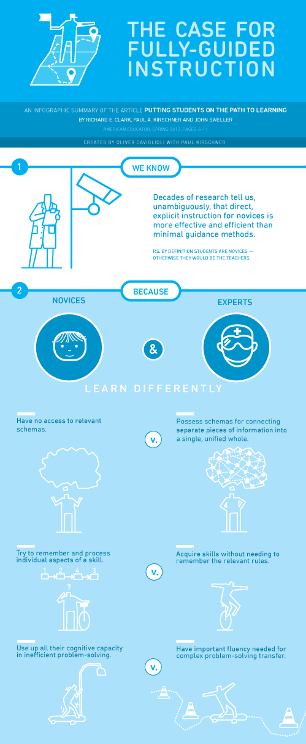
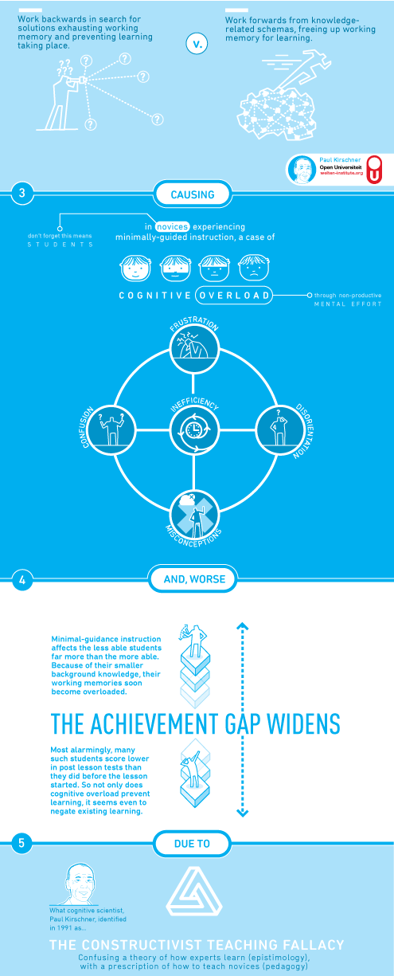
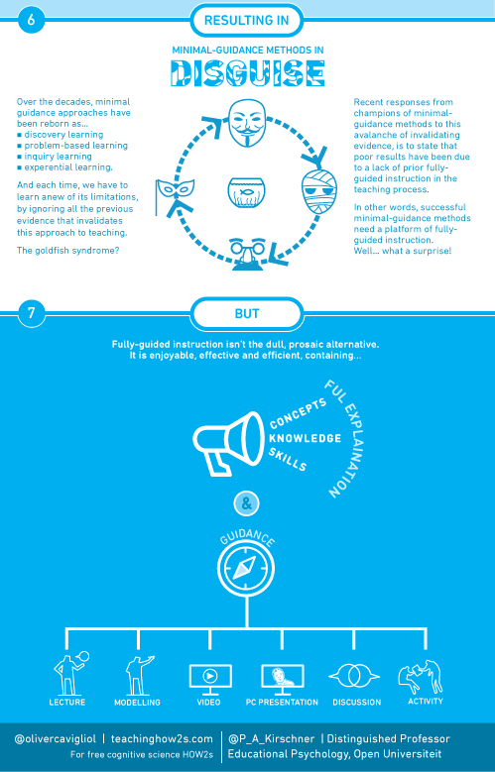
Page Break
Appendix 6.2
Bitesize Summary: What works best (Chapters 1 & 6)
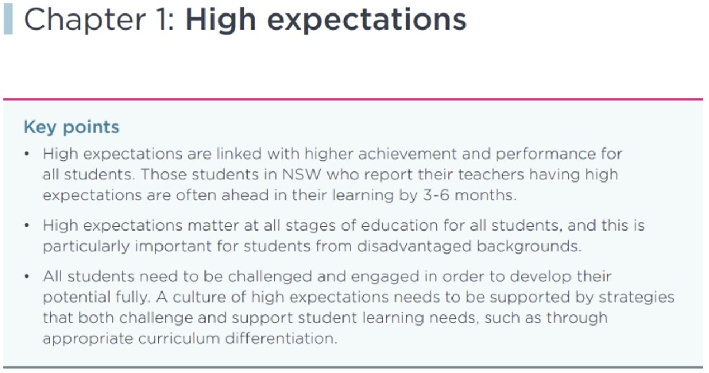
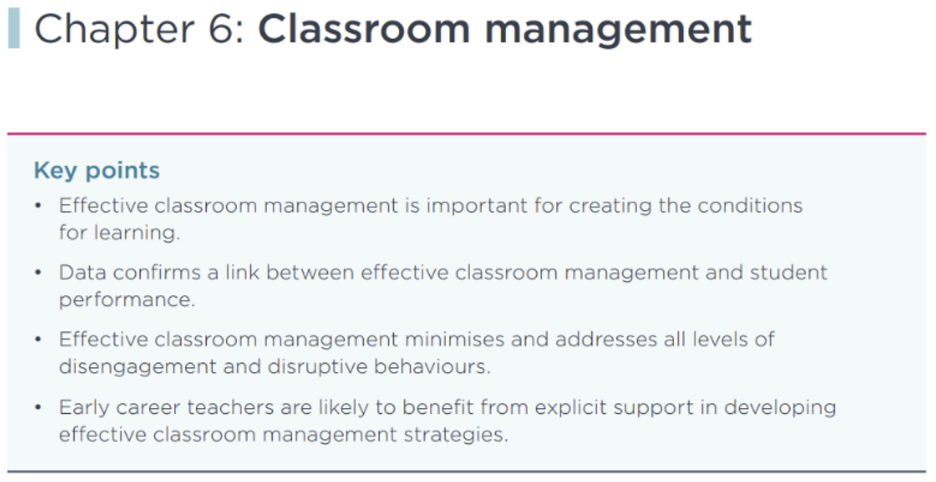

Appendix 6.3
Bitesize Summary: Teacher feedback to improve pupil learning.
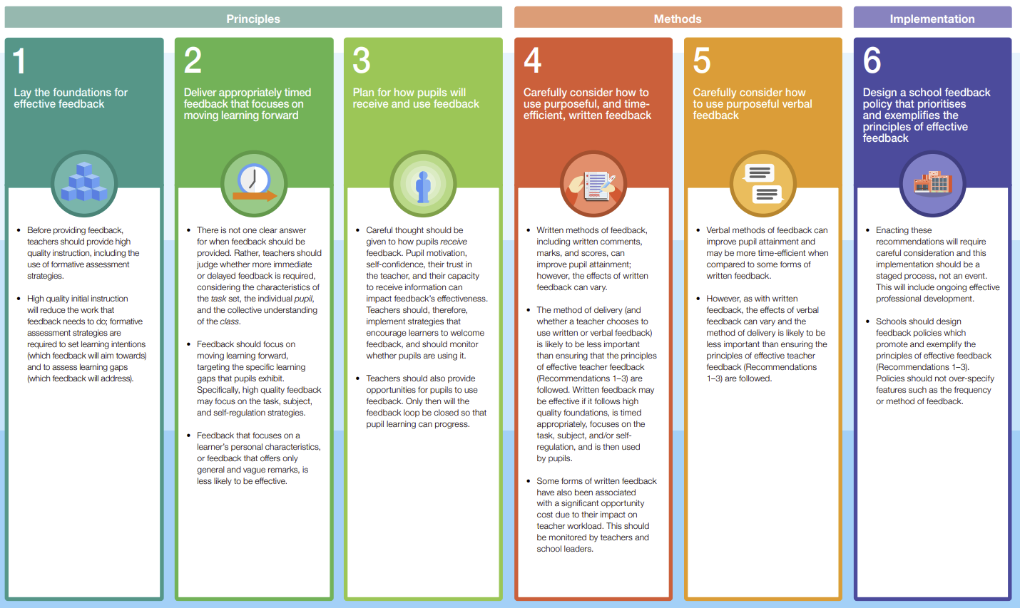

Appendix 6.4
Bitesize Summary: Working with parents to support pupil learning.
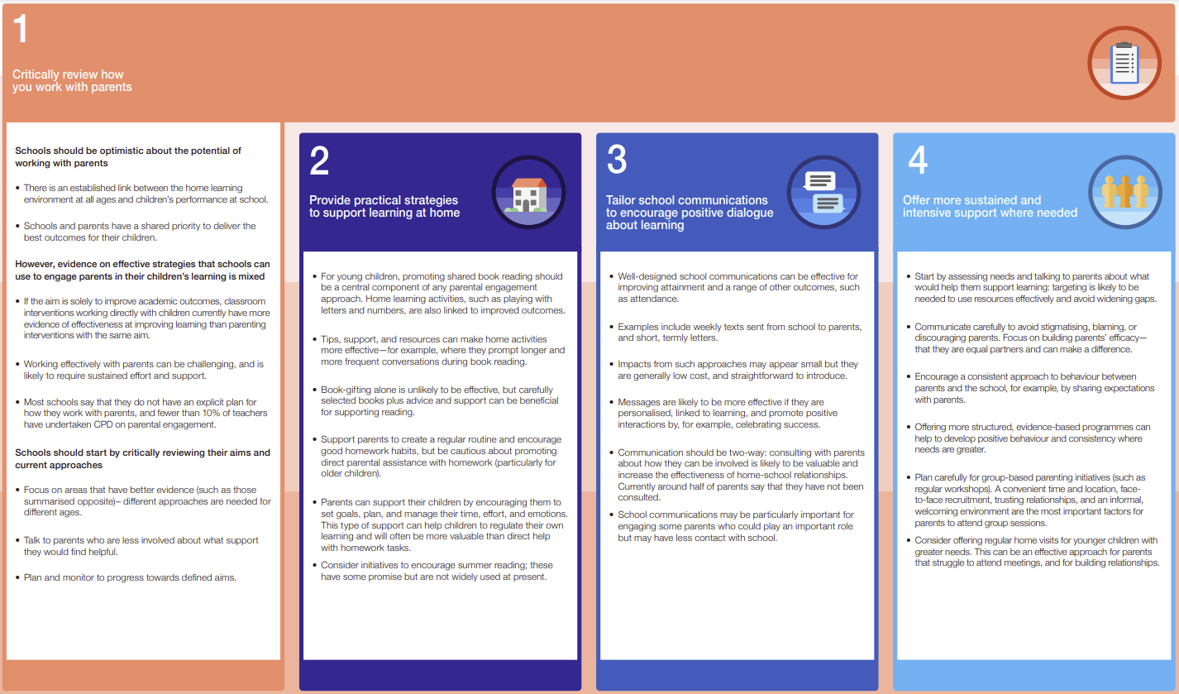

Appendix 6.5
Bitesize Summary: Making Best Use of Teaching Assistants
