Ben Newmark
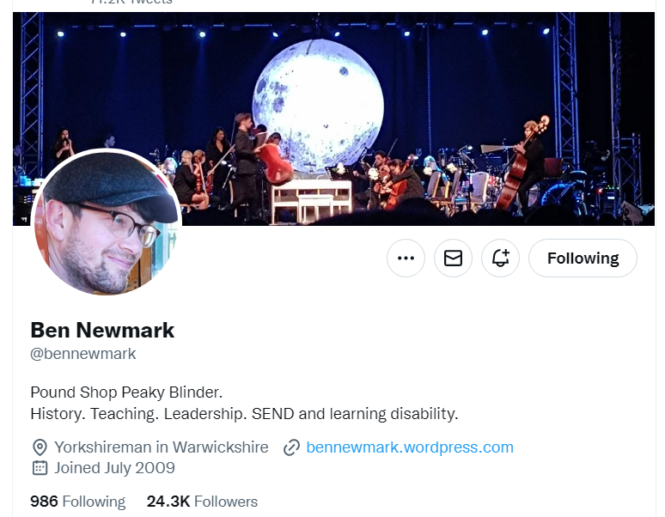
Twitter logo
Nov 25 • 20 tweets • 3 min read
Things that have worked for me.
Part 2.
1. Be iterative and granular about what *exactly* you expect children to do in a lesson. E g what does them listening to you look like? Check for understanding on this the same way you would on something you’d taught.
2. Be obsessive about *all* children doing what you have told them to do in exactly the way you have told them. Don’t let this slip. You can give options on how something is done but then these need to be *your* options. E g “spider diagram or bullet point list.”
3. Check work children have done regularly. Or at very least be seen to check. Look pleased if it’s pleasing. Look disappointed if it is disappointing. Know children well so you can make this judgement accurately.
4. Call and response is great for new words. For all years. Get over the awkwardness and make it part of your teaching. When they say it they feel more confident with it and it’s more likely to appear in their work.
5. Never allow shouting out. Not ever. It can be cute but it’s a wrecking ball and you’ll only understand how damaging after you stop allowing it altogether.
6. Give timings and display them. It doesn’t matter if your timing is a bit out. You can always finish early or add time but showing the time creates a sense of purpose and urgency.
7. Before each lesson know your floor and ceiling. What will all children leave knowing? What will those who learn fastest leave knowing? Both are important but the floor is most important.
8. Before any negative interaction with a child about their work consider what the outcome you want is and whether your words might be more about you than about what’s best for them. Then do it.
9. Give specific praise. Do not give generic praise. Children know this is insincere.
10. When you find yourself exasperated by children not getting something frame it as in interesting problem and lean into it.
11. Develop little micro-scripts like “no talking once you’re in my classroom” and say them so often they sound like ancient laws. Give the same instructions in the same way. Children respond well to this sort of consistency.
12. One Voice in the classroom unless you’ve asked them to talk. No exceptions.
13. For every task you get pupils to do find ways to make them think hard about the right stuff. Eliminate time filler tasks. E g for notetaking insist that students do this without using their resources and then check them. No copying.
14. Make sure you teach what you want children to remember most again and again and again. Test them on it again and again and again.
15. Always have something you’re working on to improve your teaching. One thing is enough. And if you’re in charge of it it’s fun.
16. Have students you are “working on”. This works best if it comes from you – who do you have a hunch could do much better? You can’t do this for all but you can do it for some. And you should.
17. Have an area of your subject you are learning more about. Don’t try to tie this to what you’re teaching next week. This is a perk and it’s for you. Follow your interest. In the end it’ll be a jigsaw piece in a picture you can’t see yet.
18. Give clear feedback kindly when student is just plain wrong. Don’t confuse them with “that’s sort of right.” Say “That isn’t right because..” Then check they’ve got it with a question.
19. Remember that Y7s are really, really small and scared a lot of the time. Make them feel safe.
20. Remember that Y11s are really, really small and scared a lot of the time. Make them feel safe. Remember a that the people you work with are really, really small and scared a lot of the time. Make them feel safe.
TASK
- Highlight 5/6 you find interesting … things you might want to do/ consider or develop even further this year.

- Now distil your list to 4
Number I might develop this by ….
Number I might develop this by ….
Number I might develop this by ….
Number I might develop this by ….

