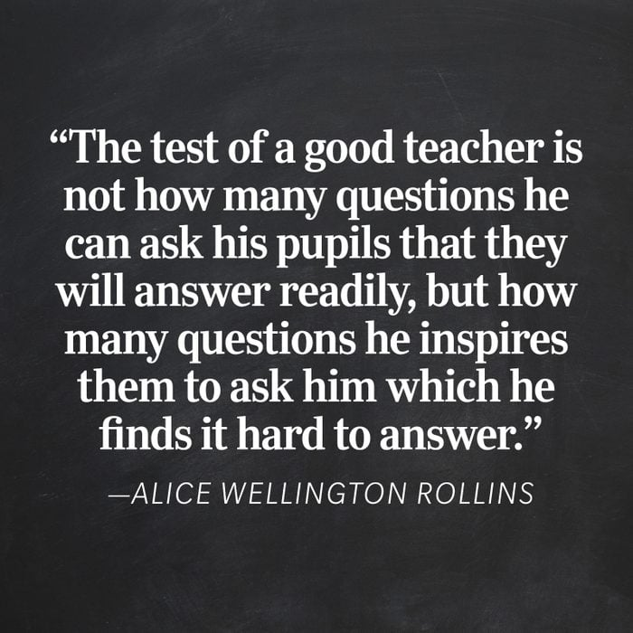

Spring 2
Primary
Trainee Essentials – Spring 2
Assigned Reading Spring 2

Assigned Reading – Week 1

PGCE Reading – See Trinity Reading List
EYFS Best start in life part 1: setting the scene - GOV.UK (www.gov.uk)
Science Children's existing ideas: building blocks or barriers to learning in science? (chartered.college)
English English and other languages: Is it really a world of difference? : My College (chartered.college)

Assigned Reading – Week 2

PGCE Reading – See Trinity Reading List
Music Making time for music: Advocating a place for music in the curriculum (chartered.college)
Assigned Reading – week 3

PGCE Reading – See Trinity Reading List

MFL Effective strategies to support novice and expert learners in MFL: The power of modelling : My College (chartered.college)
Assigned Reading – week 4

PGCE Reading – See Trinity Reading List

Art Cognitive Load Theory explored through modelling in the practical classroom (chartered.college)
Assigned Reading - Week 5

PGCE Reading – See Trinity Reading List
Feedback - EEF_Feedback_Recommendations_Poster.pdf (d2tic4wvo1iusb.cloudfront.net)
Post training task – EAL / Diversity
EAL / Diveristy - What new ideas did you learn today? This can be specific to computing, or general techniques or resources you can apply to other subjects. Make sure you link your answers to the Areas of Focus.
- Setting high expectations and managing behaviour ( AOF 1 )
- How pupils learn and classroom practice ( AOF 2 ) |  |  |  | Building on prior knowledge |  |  |  |  | Modelling / Scaffolding
Checking understanding | Repeated practice |  | Questioning |  |  |  |  | Small steps
- Subject and curriculum - engaging the learner ( AOF 3 ) |  |  |  |  | Resources to engage |  |  | Curriculum / Activities to engage
- Adaptive Teaching ( AOF 2 ) |  | Identify potential barriers to learning |  |  |  |  | Differentiate to allow all pupils to achieve
- Assessment ( AOF 5 ) | Assessment during the lesson |  |  |  |  | Assessment after the lesson
Did anything in today’s training make you aware of any knowledge or skill gaps you might still have? Discuss this with your mentor and agree on target(s) which will help bridge these gaps going forward. Make sure you also record this in your Reflective Journal so that you can evaluate your success later on.
Post training task – Music
Music - What new ideas did you learn today? This can be specific to computing, or general techniques or resources you can apply to other subjects. Make sure you link your answers to the Areas of Focus.
- Setting high expectations and managing behaviour ( AOF 1 )
- How pupils learn and classroom practice ( AOF 2 ) |  |  |  |  | Building on prior knowledge |  |  |  |  | Modelling / Scaffolding
Checking understanding | Repeated practice |  |  | Questioning |  |  |  |  | Small steps
- Subject and curriculum - engaging the learner ( AOF 3 ) |  |  |  |  |  | Resources to engage |  |  | Curriculum / Activities to engage
- Adaptive Teaching ( AOF 2 ) |  |  | Identify potential barriers to learning |  |  |  |  | Differentiate to allow all pupils to achieve
- Assessment ( AOF 5 ) |  | Assessment during the lesson |  |  |  |  | Assessment after the lesson
Did anything in today’s training make you aware of any knowledge or skill gaps you might still have? Discuss this with your mentor and agree on target(s) which will help bridge these gaps going forward. Make sure you also record this in your Reflective Journal so that you can evaluate your success later on.
Post training task – MFL
MFL - What new ideas did you learn today? This can be specific to computing, or general techniques or resources you can apply to other subjects. Make sure you link your answers to the Areas of Focus.
- Setting high expectations and managing behaviour ( AOF 1 )
- How pupils learn and classroom practice ( AOF 2 ) |  |  |  |  | Building on prior knowledge |  |  |  |  | Modelling / Scaffolding
Checking understanding | Repeated practice |  |  | Questioning |  |  |  |  | Small steps
- Subject and curriculum - engaging the learner ( AOF 3 ) |  |  |  |  |  | Resources to engage |  |  | Curriculum / Activities to engage
- Adaptive Teaching ( AOF 2 ) |  |  | Identify potential barriers to learning |  |  |  |  | Differentiate to allow all pupils to achieve
- Assessment ( AOF 5 ) |  | Assessment during the lesson |  |  |  |  | Assessment after the lesson
Did anything in today’s training make you aware of any knowledge or skill gaps you might still have? Discuss this with your mentor and agree on target(s) which will help bridge these gaps going forward. Make sure you also record this in your Reflective Journal so that you can evaluate your success later on.
Post training task – Art and Design
Art and Design - What new ideas did you learn today? This can be specific to computing, or general techniques or resources you can apply to other subjects. Make sure you link your answers to the Areas of Focus.
- Setting high expectations and managing behaviour ( AOF 1 )
- How pupils learn and classroom practice ( AOF 2 ) |  |  |  |  | Building on prior knowledge |  |  |  |  | Modelling / Scaffolding
Checking understanding | Repeated practice |  |  | Questioning |  |  |  |  | Small steps
- Subject and curriculum - engaging the learner ( AOF 3 ) |  |  |  |  |  | Resources to engage |  |  | Curriculum / Activities to engage
- Adaptive Teaching ( AOF 2 ) |  |  | Identify potential barriers to learning |  |  |  |  | Differentiate to allow all pupils to achieve
- Assessment ( AOF 5 ) |  | Assessment during the lesson |  |  |  |  | Assessment after the lesson
Did anything in today’s training make you aware of any knowledge or skill gaps you might still have? Discuss this with your mentor and agree on target(s) which will help bridge these gaps going forward. Make sure you also record this in your Reflective Journal so that you can evaluate your success later on.
Evidence Summary – Standard 4
Evidence to meet Standard 4
4 - Plan and teach well-structured lessons
- impart knowledge and develop understanding through effective use of lesson time
- promote a love of learning and children’s intellectual curiosity
- set homework and plan other out-of-class activities to consolidate and extend the knowledge and understanding pupils have acquired
- reflect systematically on the effectiveness of lessons and approaches to teaching
- contribute to the design and provision of an engaging curriculum within the relevant subject area(s).

Briefly describe your evidence ( Maximum 500 words in total )
Context

Intent

Impact

PT ___________________________ Mentor ___________________________

Evidence Summary – Standard 8
Evidence to meet Standard 8

8 - Fulfil wider professional responsibilities

- make a positive contribution to the wider life and ethos of the school
- develop effective professional relationships with colleagues, knowing how and when to draw on advice and specialist support
- deploy support staff effectively
- take responsibility for improving teaching through appropriate professional development, responding to advice and feedback from colleagues
- communicate effectively with parents with regard to pupils’ achievements and well-being.

Briefly describe your evidence ( Maximum 500 words in total )
Context

Intent

Impact

PT ___________________________ Mentor ___________________________

Evidence Summary – Part 2
Evidence to meet Part 2
PART TWO: PERSONAL AND PROFESSIONAL CONDUCT
Teachers uphold public trust in the profession and maintain high standards of ethics and behaviour, within and outside school, by:
- treating pupils with dignity, building relationships rooted in mutual respect, and at all times observing proper boundaries appropriate to a teacher’s professional position
- having regard for the need to safeguard pupils’ well-being, in accordance with statutory provisions
- showing tolerance of and respect for the rights of others
- not undermining fundamental British values, including democracy, the rule of law, individual liberty and mutual respect, and tolerance of those with different faiths and beliefs
- ensuring that personal beliefs are not expressed in ways which exploit pupils’ vulnerability or might lead them to break the law.

Teachers must have proper and professional regard for the ethos, policies and practices of the school in which they teach, and maintain high standards in their own attendance and punctuality.
Teachers must have an understanding of, and always act within, the statutory frameworks which set out their professional duties and responsibilities.

Briefly describe your evidence ( Maximum 500 words in total )
Context

Intent

Impact

PT ___________________________ Mentor ___________________________

