Self Audit
Complete the following audit of your skills and understanding in this subject area. Choose one box for each area and rate this (Grey, Amber, Green , Purple):
Grey : no knowledge /confidence in this area and/or no experience.
(Only grade yourself grey if you have no experience whatsoever of a particular aspect).
Amber: some knowledge in this area and/or limited experience and in need of further development
Green : good knowledge in this area and /or some experience
Purple : totally confident in my knowledge of this area and/or lots of experience.

The completed audits will be reviewed with your Mentor and used to create your Individual Training Plan

Subject Area: |  | Geography |  | Baseline |  | Summer
Subject Knowledge
Geo1 | Do you have any educational background in Geography as a subject?
Geo2 | Could you use geographical language and symbols to draw maps?
Geo3 | How would you rate your knowledge of significant places and environments in the UK?
Geo4 | How would you rate your knowledge of significant places and environments in the world?
Geo5 | Are you aware of how physical and human processes can cause changes to places and environments?
Knowledge of Pedagogy
Geo6 | Do you understand the importance of using cross curricular links in Geography e.g. Computing?
Geo7 | How confident would you feel in teaching Literacy through Geography?
Geo8 | How would you rate your knowledge of the aspects of progression in Geography?
Geo9 | How would you rate your understanding of National Curriculum assessment levels in Geography?
Pupil Development
Geo10 | Do you have any knowledge of pupil development in relation to National Curriculum age related descriptors in Geography?
Geo11 | Are you aware of the age related attainments at the end of Key Stage 1 and Key Stage 2 in Geography?
Geo12 | How do you rate your understanding of differentiation within Geography to allow all children of diverse needs to access it appropriately? (SEN/GT/EAL)
Motivation / Attitude
Geo13 | If you were required to teach a Geography lesson early on in this programme, how confident would you be to do this?
Geo14 | Are you confident in your understanding of why Geography should be part of the primary school curriculum?
Geo15 | If you were unsure of a topic you had to teach, do you know where to carry out the research before delivering lessons to children?

- Once the audit is complete, please carry out the pre-course task (before starting your training course).
- Pre training task(s) to be completed prior to the training day.
- Post training task(s) to be completed after the training day.

Notes:

Signed: ____________________________________ (Trainee) Date: _____________

Signed: ____________________________________ (Mentor) Date: _____________

Subject Area: | Geography | Knowledge and Understanding  Development Tasks

Pre-course Task

1. Use the National Curriculum (2014 updated version) or if using an electronic version of this document, follow the link below and select Geography.

https://www.gov.uk/government/publications/national-curriculum-in-england-geography-programmes-of-study

This will allow you to access the programmes of study for Key Stage 1 and Key Stage 2 Geography

Read this section of the document. (If you are using the electronic version, you will have to select Key Stage 1 then go back and select Key Stage 2)

In light of what you have read, can you identify your main strengths and main areas for development in relation to your knowledge, skills and understanding of the Geography curriculum.

Areas of Strength

Areas for development

Pre training Task - Lesson observation Geography

Date: |  | Class: |  | Topic:
What was the objective ?
How did the lesson link to Geography ?
What specific Geography vocabulary was used ?
What specific Geography resources were used to teach ?
What specific Geography resources were used to support the learning of the children ?
What specific Geography skills were used by the children ?
What did the children do, create or produce ?
What did the children learn ?

Post training task

Following your Geography training, reflect on how you could use the following core elements within your Geography teaching . . .
Setting high expectations and managing behaviour ( CCF 1 and 7 )
Describe what you need to consider to . .
- Develop a positive, predictable and safe environment aswell as a culture of respect and trust in the classroom within an Geography lesson ?
- Maintain high standards in an Geography lesson ?
How pupils learn and classroom practice ( CCF 2 & 4 )
Small steps | Questioning
Modelling / Scaffolding | Repeated practice
Checking understanding | Building on prior knowledge
Subject and curriculum - engaging the learner ( CCF 3 & 4 )
Curriculum / Activities to engage |  |  |  | Resources to engage
Adaptive Teaching ( CCF 5 )
Identify potential barriers to learning |  |  | Differentiate to allow all pupils to achieve
Assessment ( CCF 6 )
Assessment during the lesson |  | Assessment after the lesson
Through discussion with your mentor, identify ongoing target(s) from your training ( Record these in your reflective journal as well )

Supplementary subject knowledge development materials

The following materials are not compulsory but support the subject knowledge of any trainee that feels they need direction and structure. Use the audits as a guide, choosing key, weaker areas and linking them to activities to support development in that area.

Task Bank

Look at this website, or if using an electronic version of this document click on the hyperlink below:

http://www.enchantedlearning.com/geography/glossary

Read through the geographical terminology on the website.

Sum up each term in a short concise sentence:

Feature

Patterns

Process

Locality

Environment

Global Citizenship

Sustainable
Development

This is vocabulary used throughout the National Curriculum. It is important that you have a personal understanding of these before teaching Geography to children.

Subject Area: | Geography | Knowledge and Understanding  Development Tasks

Task Bank

Either type the following website or if using an electronic version of this document, follow the hyperlink below:

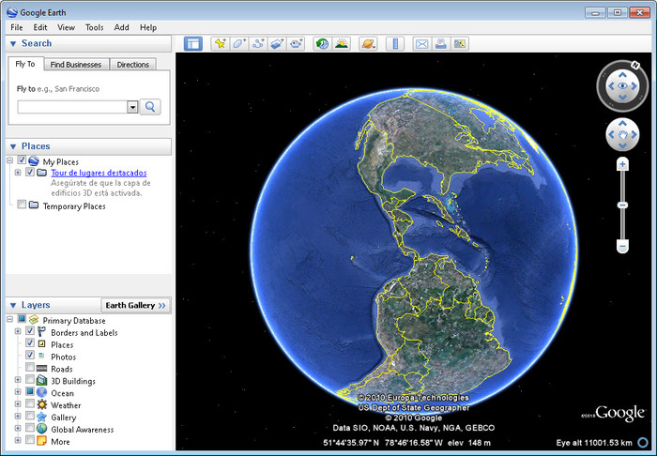
http://www.teachingtimes.com/kb/40/ict-in-geography.htm

This site gives some ideas on using ICT within Geography.
Read through the examples given.

Google Earth is a free resource that can be downloaded in schools and is easily accessible for Key Stage 1 and 2 children.

Write down three occasions where using Google Earth may enhance teaching and learning.

Subject Area: | Geography | Knowledge and Understanding  Development Tasks

Task Bank
Read through the Geography curriculum for Year 2 children and Year 6 children.

Year 2 Expectations
Read the National curriculum document and consider what these are?
Year 6 Expectations
Read the National curriculum document and consider what these are?

Consider the expectations of the year group(s) you are teaching in each placement

Discuss Geography with the Year 2 teacher and Geography with the Year 6 Teacher.
In Geography, a typical Year 2 child can:

In Geography, a typical Year 6 child can:

