Resource Library T & L / Leadership
Volume 4 April to August ‘23

A library of links to blogs/articles/research/podcasts/videos/threads/reflections on teaching and school leadership

Reflections on routines and classroom norms – Peps Mccrea:

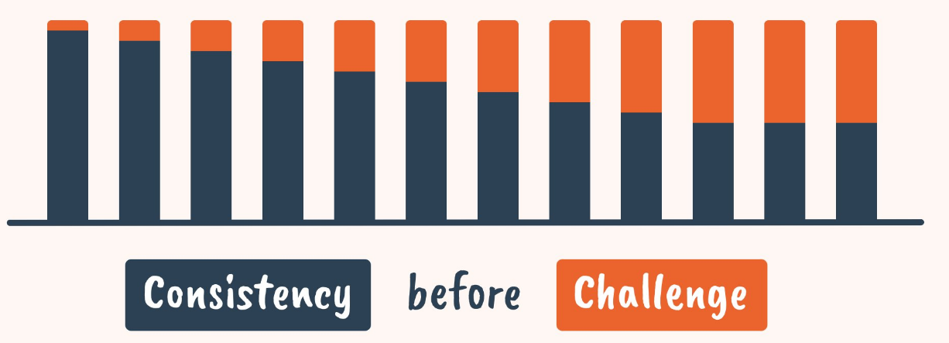
Consistency = the regularity of our execution of the routine.

Challenge = how ambitious we are with the mechanics of the routine itself.

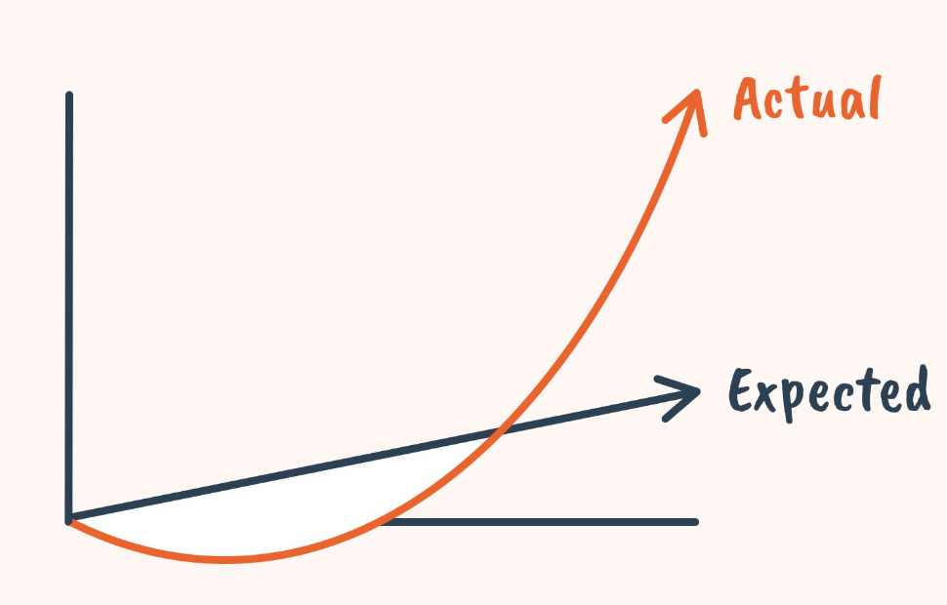

Norms play a huge role in school (bigger than formal rules). But how can teachers influence them?

We must *amplify desirable behaviour*

We can do this by:

1/ Highlighting individual action → Jem has got her book out and is working through the activity
2/ Narrating group activity → Almost everyone is tracking me and ready to listen
3/ Sharing stories → My other class asked me some tough questions about this.
SUMMARY

• Our perception of norms arises from the observation of others.
• The best way to influence norms is to raise the visibility of behaviours and attitudes we want others to emulate.
• This works best when we focus on what we want to happen (rather than what we don't).

You can sign up to free weekly ‘Evidence Snacks’ with Peps Mccrea…
https://snacks.pepsmccrea.com/

Contents
Element | Pages
Libraries /archives / further links | 2
General pedagogy | 3 - 4
Behaviour / routines / expectations | 4- 5
Explanation & Cognitive Load Theory | 6
Retrieval / recall | 6
Questioning/Formative assessment/Feedback | 6
Curriculum | 7
Leadership / Developing Professional Learning/Coaching | 7-11

Libraries/ archives … further links
​‘Evidence into Action’ – ​“Teaching reading: Developing fluency” SEN in mainstream and adapting teaching - EEF Podcast
https://evidenceintoaction.podbean.com/e/ep-18-special-educational-needs-and-disabilities/
Learn from unsung heroes – 160 essays on school leadership - Joe Kirby
https://joe-kirby.com/
Evidence Informed Practice – Blogs / articles – Mrs Pearce
https://mrspearce865924391.wordpress.com/
Ofsted Research Review Series - Summary of Research Reviews
https://simplebooklet.com/ofstedresearchreviewseriessummaryofallresearchreviews#page=3
Dropbox – Astrea Academy - T&L Manifesto based on TLAC Pillars & Technique
https://www.dropbox.com/sh/2dilvfut7bt8414/AACb2E5NI_XX0DELEzNCWuqaa?dl=0
Series of HT/SL Podcasts:
https://twitter.com/Headteacherchat/status/1693986522683556192?t=94y4iUdkThQxSmxr9fUPAA&s=09
Subject associations summary:
https://www.subjectassociations.org.uk/wp-content/uploads/2022/10/CfSA-Directory-2022.pdf
General pedagogy
Explaining why we’re doing what we’re doing in lessons – Claire Stoneman
https://birminghamteacher.wordpress.com/2023/04/11/explaining-why-were-doing-what-were-doing-in-lessons/
Thoughts on success in the classroom -Dr. Castelino
https://drcastelino.wordpress.com/2023/06/17/thoughts-on-success-in-the-classroom/
Novel experiences: do they help students learn? Sarah Cottingham
https://overpractised.wordpress.com/2023/05/08/novel-experiences-do-they-help-students-learn/
Explicit Instruction Stage 1: Retrieval Practice. 10 Minute writes – Tom Needham
https://tomneedhamteach.wordpress.com/2023/02/03/explicit-instruction-stage-1-retrieval-practice-10-minute-writes/
The Elements of Great Teaching – short videos – EBE
https://evidencebased.education/element-videos/?utm_content=256634503&utm_medium=social&utm_source=twitter&hss_channel=tw-2869283795&s=09
Learning in the brain – Efrat Furst
https://sites.google.com/view/efratfurst/learning-in-the-brain
How can educational research improve schools? Video (researchED Scandinavia 2023) Dylan Wiliams
https://www.youtube.com/watch?v=p6oukyR2F0Q
Conducting Exit Interviews with Students – Simon Beale
https://historyiseverystory.wordpress.com/2022/05/23/conducting-exit-interviews-with-students/
Short Thread – 7 takeaways about Teaching and Learning - Peps Mccrea
https://threadreaderapp.com/thread/1681816933639782400.html
CHRISTINE TORRES CRUSHES THE ‘HABITS OF DISCUSSION’ – Doug Lemov
https://teachlikeachampion.org/blog/christine-torres-crushes-the-habits-of-discussion/
9 QUESTIONS TO IMPROVE METACOGNITION – Inner Drive
https://blog.innerdrive.co.uk/9-questions-to-improve-metacognition?utm_campaign=Metacognition&utm_content=257132716&utm_medium=social&utm_source=twitter&hss_channel=tw-85885295&s=09
Just 18 minutes of teaching – Adam Boxer
https://achemicalorthodoxy.co.uk/2023/05/10/just-18-minutes-of-teaching/
One pagers - Download high-quality PDFs - Jamie Clark
https://www.jamieleeclark.com/graphics?s=09
Rush - Dr. Castelino
https://drcastelino.wordpress.com/2023/05/27/rush/
Why teaching academic vocabulary matters – Alex Quigley
https://www.theconfidentteacher.com/2022/09/why-teaching-academic-vocabulary-matters/
5 TEACHING & LEARNING STUDIES WE READ (OR RE-READ) THIS YEAR – Inner Drive
https://blog.innerdrive.co.uk/5-studies-we-read
Early adventures in Word Diagrams – Kristian Shanks
https://kristian-shanks.medium.com/early-adventures-in-word-diagrams-7465f30f9222
Are our resources useful and beautiful? Mary Myatt
https://www.marymyatt.com/blog/are-our-resources-useful-and-beautiful
THINKING AND PARTICIPATION RATIOS: MAXIMISING COGNITIVE ENGAGEMENT – Interview – Doug Lemov
https://blog.innerdrive.co.uk/thinking-and-participation-ratio?utm_campaign=Teacher%20CPD&utm_content=252362779&utm_medium=social&utm_source=twitter&hss_channel=tw-85885295&s=09
Supporting Spoken Language in the Classroom - University of Bristol
https://discovery.ucl.ac.uk/id/eprint/10173491/1/SSLiC%20Case%20Studies%20Plymouth%20Settings%202022-2023%20FINAL.pdf
Deliberate practice versus ‘just doing it’ - Thahmina Begum
https://tbeeblogs.wordpress.com/2023/09/10/deliberate-practice-versus-just-doing-it/

Behaviour / routines / expectations
Achieving 100% Student Attention: Why? – Pritesh Raichura
https://bunsenblue.wordpress.com/2023/04/08/achieving-100-student-attention-why/
Cultivating enthusiasm – Pritesh Raichura
https://edu.rsc.org/ideas/7-ways-to-motivate-your-students/4017342.article
Routines: how to achieve disruption free lessons - Thahmina Begum
https://tbeeblogs.wordpress.com/2023/02/27/routines-how-to-achieve-disruption-free-lessons/
How to build resilience in your students - Thahmina Begum
https://tbeeblogs.wordpress.com/2023/05/02/how-to-build-resilience-in-your-students/
They Probably Wouldn’t Behave For You Either… Sam Strickland
https://hwrkmagazine.co.uk/they-probably-wouldnt-behave-for-you-either/
The ‘Meet and Greet’: Passive and Active – Alex Gordon
https://mrgordonteacher.wordpress.com/2023/04/12/the-meet-and-greet-passive-and-active/
Norms bleed – Peps Mcrea
https://threadreaderapp.com/thread/1658170399279185921.html
Motivating the least confident students - Dr. Castelino
https://drcastelino.wordpress.com/2023/07/12/motivating-the-least-confident-students/
The What and Why of Routines in School Culture – James Dyke
https://researchschool.org.uk/bradford/news/the-what-and-why-of-routines-in-school-culture-3
VIDEO: Innovative solutions for disruptive student behaviour in classrooms – Australia – Lucy Kent
https://www.abc.net.au/news/2023-06-22/innovative-solutions-for-disruptive-student/102513604?utm_campaign=abc_news_web&utm_content=twitter&utm_medium=content_shared&utm_source=abc_news_web&s=09
10 things: Establishing expectations with a new class – Tom Sherrington
https://teacherhead.com/2023/08/25/10-things-establishing-expectations-with-a-new-class/
High-frequency checks for listening – Video - Pritesh Raichura
https://www.youtube.com/watch?v=wXZdLgpH2DQ
Securing 100% student attention – Video - Pritesh Raichura
https://www.youtube.com/watch?v=i-bC9AXpZ-0
All-Hands-Up Cold Call – Video - Pritesh Raichura
https://www.youtube.com/watch?v=8j4wjUzzZMc
THREE TOP TIPS FOR CLASSROOM MANAGEMENT - Amarbeer Singh Gill, Nick Pointer
https://chartered.college/2022/09/20/three-top-tips-for-classroom-management/

Explanation & Cognitive Load Theory
Using cognitive science to explain learning – Paul Moss
https://paulgmoss.com/2023/02/13/chunking-as-a-pedagogy/
Ask the Cognitive Scientist: Does Developing a Growth Mindset Help Students Learn? – Dan Willingham
https://www.aft.org/ae/winter2022-2023/willingham

Retrieval / recall
Knowledge Checkers – Lived not laminated – ‘GeogHod’
https://geoghod.com/2022/11/12/knowledge-checkers-lived-not-laminated/
10 Tips for Using Revision Guides – Alex Quigley
https://www.theconfidentteacher.com/2023/03/10-tips-for-using-revision-guides/
Reconstructing memory – Sarrah Cottingham
https://overpractised.wordpress.com/2023/02/27/reconstructing-memory/
TURNING UNDERSTANDING INTO MEMORY: STEVE KUNINSKY’S RETRIEVAL PRACTICE (Doug Lemov)
https://teachlikeachampion.org/blog/teaching-and-schools/turning-understanding-into-memory-steve-kuninskys-retrieval-practice/
PREDICTING OR RETRIEVING: WHICH HELPS STUDENTS LEARN BETTER? Inner Drive
https://blog.innerdrive.co.uk/predicting-vs-retrieving?utm_campaign=Teacher%20CPD%20Academy&utm_content=253699097&utm_medium=social&utm_source=twitter&hss_channel=tw-85885295

Questioning/Formative assessment/Feedback
Questioning for retrieval: five mistakes to avoid – Harry Fletcher-Wood
https://improvingteaching.co.uk/2023/04/23/questioning-for-retrieval-five-mistakes-to-avoid/
The Three Phases of Questioning – Bunsen Blue
https://bunsenblue.wordpress.com/2023/04/22/the-three-phases-of-questioning/
Sequencing Questions – GeogHod
https://geoghod.com/2023/04/23/principle-1-sequencing-questions/
HOW TO USE PSYCHOLOGICALLY RICH QUESTIONS IN THE CLASSROOM – Inner Drive
https://blog.innerdrive.co.uk/psychologically-rich-questions?utm_campaign=Teacher%20CPD&utm_content=253698953&utm_medium=social&utm_source=twitter&hss_channel=tw-85885295&s=09
GETTING ALL STUDENTS TO THINK HARDER WITH GOOD QUESTION DESIGN – Inner Drive
https://blog.innerdrive.co.uk/students-think-harder-with-question-design?s=09
BETH PEAKMAN COMBINES COLD CALL, WAIT TIME AND STRETCH IT WHILE READING WIND IN THE WILLOWS – Doug Lemov
https://teachlikeachampion.org/blog/beth-peakman-combines-cold-call-wait-time-and-stretch-it-while-reading-wind-in-the-willows/
How to make lesson feedback a conversation – Peter Foster
https://curriculumteamleader.wordpress.com/2023/07/09/how-to-make-lesson-feedback-a-conversation/
Why we need to ‘warm’ up cold call – Emily P
https://ep1008.wordpress.com/2023/07/27/why-we-need-to-warm-up-cold-call/

Curriculum
Narrating the Curriculum – ‘GeogHod’
https://geoghod.com/2022/03/13/narrating-the-curriculum/
Schemas determine what we learn – Sarah Cottingham
https://overpractised.wordpress.com/2022/02/26/schemas-determine-what-we-learn/?s=09

Leadership / Developing Professional Learning / Coaching
Why are we holding out for more professional development time (even though school leaders say they can’t manage it)? Prof Coe
https://evidencebased.education/why-are-we-holding-out-for-more-professional-development-time-even-though-school-leaders-say-they-cant-manage-it/?utm_content=257435540&utm_medium=social&utm_source=twitter&hss_channel=tw-2869283795
Four things I’ve learnt this year (HT) – Claire Stoneman
https://birminghamteacher.wordpress.com/2023/07/09/four-things-ive-learnt-this-year/
From the rabbit hole: a love letter to middle leaders – Claire Stoneman
https://birminghamteacher.wordpress.com/2017/08/28/from-the-rabbit-hole-a-love-letter-to-middle-leaders/
Stop Controlling And Start Leading: How Some Bosses Create An Army Of Mini-Mes - Forbes
https://www.forbes.com/sites/alexanderpuutio/2023/08/22/stop-controlling-and-start-leading-how-some-bosses-create-an-army-of-mini-mes/
Professional Development | Persistent Problems Pt.1/2/3 Entitlement and Suitability - Kat Howard
https://saysmiss.wordpress.com/author/saysmiss/
Poverty, shame and dignity – Claire Stoneman
https://birminghamteacher.wordpress.com/2023/08/07/poverty-shame-and-dignity/
Building school culture, especially as an incoming head: part one and part 2 – Jill Berry
https://jillberry102.blog/2023/08/03/building-school-culture-especially-as-an-incoming-head-part-one/
https://jillberry102.blog/2023/08/03/building-school-culture-especially-as-an-incoming-head-part-two/
Why do we see teacher expertise as needing knowledge, skill and judgement (even though most people seem to focus on just one of these)? - Prof Coe
https://evidencebased.education/why-do-we-see-teacher-expertise-as-needing-knowledge-skill-and-judgement/
New to middle leadership? Here’s what I wish I’d known…. @Danihus
https://blissful-dwalley1.wordpress.com/2023/08/16/new-to-middle-leadership-heres-what-i-wish-i-knew/
CPD and Protecting People’s Pie Charts – Nikki Sullivan
https://hwrkmagazine.co.uk/cpd-protecting-peoples-pie-charts/
MAKING MORE SENSE OF TEACHER COACHING – Prof. Rachel Lofthouse
https://www.leedsbeckett.ac.uk/blogs/carnegie-education/2023/08/making-more-sense-of-teacher-coaching/
Coaching – GCI Insights – 24 page e-booklet from Australia
https://online.flippingbook.com/view/60079183/
Flawed School Improvement Plans: Black Swans and Grey Rhinos – Joe Kirby
https://joe-kirby.com/2023/05/06/school-improvement-plans/
The Infinite Game: warding off warped fears – Joe Kirby
https://joe-kirby.com/2023/05/13/infinitegame/
Mammoth, Chimps and Octopi: evolutionary psychology and our battle to prioritise – Joe Kirby
https://joe-kirby.com/2023/06/03/evolutionary-psychology-prioritising/

Build Your CPD Around A Learning Model – Tom Sherrington
https://teacherhead.com/2022/08/16/build-your-cpd-around-a-learning-model/
Leveraging trust capacity to deliver effective professional development – Confederation of School Trusts
https://cstuk.org.uk/knowledge/guidance-and-policy/leveraging-trust-capacity-to-deliver-effective-professional-development/?s=09
Improve Teaching and Learning –Twitter thread – Adam Boxer
https://twitter.com/adamboxer1/status/1587195370546896896
The leadership illusion – Claire Stoneman
https://birminghamteacher.wordpress.com/2022/02/17/the-leadership-illusion/
Anatomy of a School Improvement Plan - Joe Kirby
https://joe-kirby.com/2023/05/27/school-improvement-plan/
This much I know about…improving teaching through attention to detail - John Tomsett
https://johntomsett.com/2023/07/06/this-much-i-know-about-improving-teaching-through-attention-to-detail/
What Makes An Effective Middle Leader? - Lindsay Galbraith
https://hwrkmagazine.co.uk/what-makes-an-effective-middle-leader/
Expert Teaching: what it is and how to get more of it – ResearchEd ’23 - David Weston
https://twitter.com/informed_edu/status/1701165927859925375?t=sdxVhAIpC74WO51lVK90Xw&s=09
ResearchEd ’23 presentation - Carl Hendrick
https://threadreaderapp.com/thread/1700874341896851709.html
Middle leaders – ‘the forgotten leaders?’ – Dani Waller
https://blissful-dwalley1.wordpress.com/2023/07/10/middle-leaders-the-forgotten-leaders/
What did Ofsted want schools to improve in 2021-2022? - Peter Foster
https://curriculumteamleader.wordpress.com/2022/09/06/what-did-ofsted-want-schools-to-improve-in-2021-2022/
Implementation matters: addressing disadvantage in schools with low numbers of pupils eligible for The Pupil Premium – Marc Rowland
https://researchschool.org.uk/unity/news/implementation-matters-addressing-disadvantage-in-schools-with-low-numbers-of-pupils-eligible-for-the-pupil-premium
10 Lessons learned about instructional coaching within a CPD programme – Tom Sherrington
https://teacherhead.com/2023/05/14/10-lessons-learned-about-instructional-coaching-within-a-cpd-programme/
The magic of models in teacher professional development - Harry Fletcher-Wood
https://improvingteaching.co.uk/2023/03/19/the-magic-of-models-in-teacher-professional-development/
Continuous improvement: a career long commitment - Thahmina Begum
https://tbeeblogs.wordpress.com/2023/06/26/continuous-improvement-a-career-long-commitment/

